Combined Series and Parallel Lab
Instructions: Construct each of the circuits below using the PhET Circuit Simulation. Each light bulb/resistor is 10 Ω by default. The battery has a potential difference of 9 V by default. Complete the RVIP charts mathematically and check your answers with the “Non-Contact Ammeter” and “Voltmeter.” Then answer the questions following each diagram.
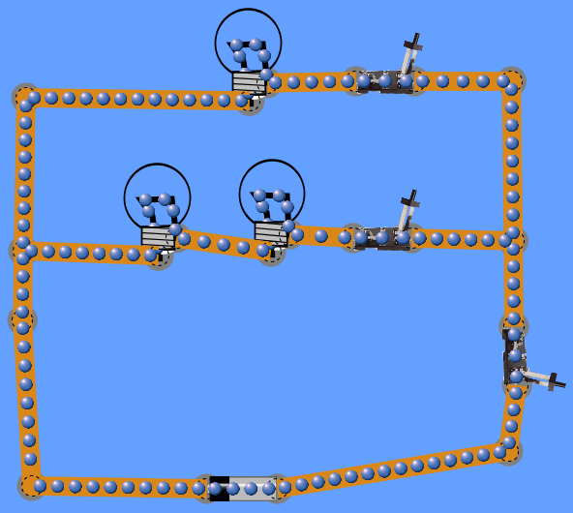
- Series Circuit in a Parallel Circuit
R₂
S₃
S₂
S₁
R₃
R₁
 | R (Ω) | V (V) | I (A) | P (W)
1 | 10 | 9 | 0.9 | 8.1
2 | 10 | 4.5 | 0.45 | 2.025
3 | 10 | 4.5 | 0.45 | 2.025
23 | 20 | 9 | 0.45 | N/A
battery | 20/3 | 9 | 1.35 | 12.15
*shaded portions are linked*
- On a separate sheet of paper, draw a schematic version of this circuit ( and 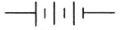) and then draw simplified versions to solve.

- Explain which part of the circuit is in series. Explain which part of the circuit is in parallel.
Resistors 2 and 3 are in series with each other because they exist on the same branch. Resistor 1 is parallel to Resistors 2/3 because it is on a separate branch.
- Compare the current in the top branch to the current in the middle branch. Explain why.
Current in the top branch is double the current in the middle branch because it has half the resistance. Therefore, the current loop for the top branch will be twice as strong.
- Rank the light bulbs in order of brightness. In terms of current flow and resistance. Explain why.
R₁ > R₂ = R₃ The top branch has less resistance than the middle branch, so it receives more current. Meanwhile, R₂ and R₃ have equal brightness because they have the same value of resistance and current.
- If bulb R₂ were removed (right-click to remove), explain what happens to the other two bulbs and why.
R₁ would stay on and would be the exact same brightness because its current loop was completely unaffected by R₂. However, R₃ would turn off because the current flow within the middle branch would come to a complete stop.
- Determine which bulbs are affected by each of the switches (S₁, S₂, S₃). Explain why.
S₁ only affects R₁. S₂ controls the current flow to R₂ and R₃. However, S₃ is adjacent to the battery, so it controls the current flow to all three resistors. If it was open, then the entire circuit would be off.

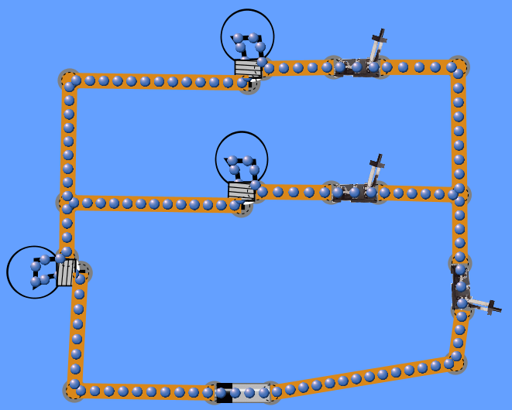
- Parallel Circuit in a Series Circuit
R₃
R₂
R₁
 | R (Ω) | V (V) | I (A) | P (W)
1 | 10 | 3 | 0.3 | 0.9
2 | 10 | 3 | 0.3 | 0.9
3 | 10 | 6 | 0.6 | 3.6
12 | 5 | 3 | 0.6 | N/A
battery | 15 | 9 | 0.6 | 5.4
*shaded portions are linked*
- On a separate sheet of paper, draw a schematic version of this circuit ( and ) and then draw simplified versions to solve.

- Explain which part of the circuit is in series. Explain which part of the circuit is in parallel.
R₁ and R₂ are parallel to each other because they are on separate branches. R₃ is connected in series with both R₁ and R₂, meaning that if R₃ were to be removed, the entire circuit would turn off.
- Rank the light bulbs in order of brightness. In terms of current flow and resistance, explain why.
R₃ > R₁ = R₂ R₃ receives all of the current coming out of the battery, while R₁ and R₂ have the current split between them.
- Compare the potential difference across R₃ to the potential difference across the other two bulbs. Explain why.
R₃ has twice the resistance of R₁/R₂ combined together; In a series circuit, the larger resistance draws more of the potential difference for itself. And since R₃ is twice the resistance, it receives the larger portion of the total potential difference.
- If R₃ were removed (right-click to remove), explain what happens to the other two bulbs and why.
The other bulbs would both turn off because R₃ controls the entire flow of electrons through the rest of the circuit.
- If R₂ were removed, what kind of circuit does this become?
Series Circuit
- After R₂ is removed, determine what happens to the brightness of each bulb and explain why. (Hint: Complete the chart if you get stuck.
 | R (Ω) | V (V) | I (A) | P (W)
1 | 10 | 4.5 | 0.45 | 2.025
3 | 10 | 4.5 | 0.45 | 2.025
battery | 20 | 9 | 0.45 | 4.05
Resistor 1 gets brighter because it no longer has to share any current with Resistor 2. Resistor 3 gets dimmer because the overall resistance of the circuit has increased so the value of the current has thereby decreased.

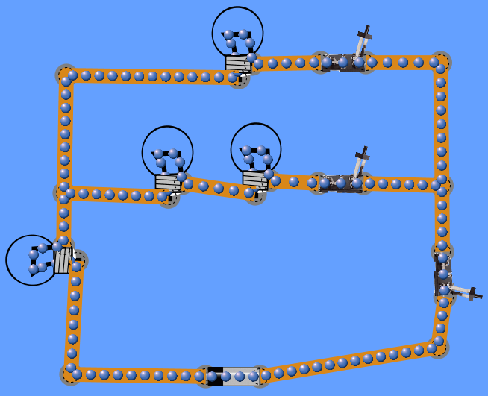
- Series Circuit in a Parallel Circuit in a Series Circuit (Bonus)
R₄
R₃
R₂
R₁
 | R (Ω) | V (V) | I (A) | P (W)
1 | 10 | 3.6 | 0.36 | 1.296
2 | 10 | 1.8 | 0.18 | 0.324
3 | 10 | 1.8 | 0.18 | 0.324
4 | 10 | 5.4 | 0.54 | 2.916
23 | 20 | 3.6 | 0.18 | N/A
123 | 6.67 | 3.6 | 0.54 | N/A
battery | 16.67 | 9 | 0.54 | 4.86
*shaded portions are linked*
- On a separate sheet of paper, draw a schematic version of this circuit ( and ) and then draw simplified versions to solve.

- Explain which parts of the circuit are in series. Explain which part of the circuit is in parallel.
R₂ and R₃ are connected in series, while the entire middle branch is connected in parallel with R₁. The two branches are connected in series with R₄.
- Rank the light bulbs in order of brightness. In terms of current flow and resistance, explain why.
R₄ > R₁ > R₂ = R₃ R₄ receives all of the current from the battery, which is then split between the two branches. And the top branch has less resistance, so it receives a larger portion of the split current.

