Combined Series and Parallel Lab
Instructions: Construct each of the circuits below using the PhET Circuit Simulation. Each light bulb/resistor is 10 Ω by default. The battery has a potential difference of 9 V by default. Complete the RVIP charts mathematically and check your answers with the “Non-Contact Ammeter” and “Voltmeter.” Then answer the questions following each diagram.
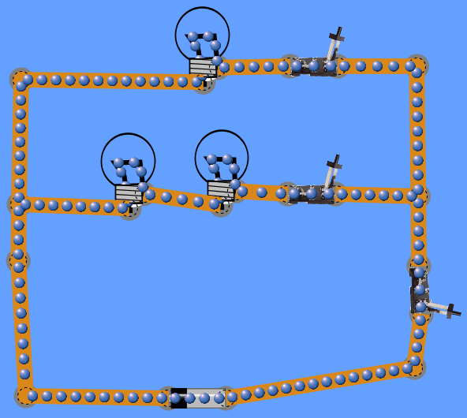
- Series Circuit in a Parallel Circuit
R₂
S₃
S₂
S₁
R₃
R₁
 | R | V | I | P
1
2
3
23
battery

- On a separate sheet of paper, draw a schematic version of this circuit ( and 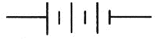) and then draw simplified versions to solve.

- Explain which part of the circuit is in series. Explain which part of the circuit is in parallel.
- Compare the current in the top branch to the current in the middle branch. Explain why.
- Rank the light bulbs in order of brightness. In terms of current flow and resistance, explain why.
- If bulb R₂ were removed (right-click to remove), explain what happens to the other two bulbs and why.
- Determine which bulbs are affected by each of the switches (S₁, S₂, S₃). Explain why.

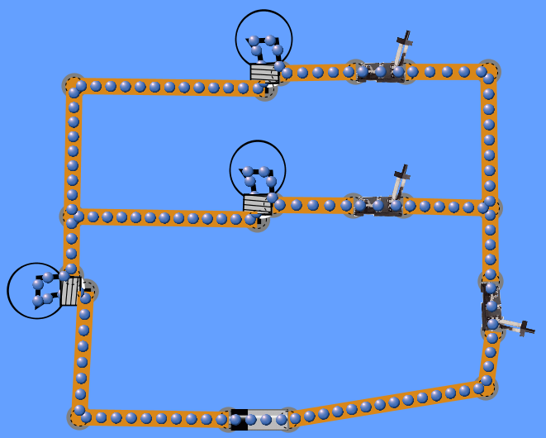
- Parallel Circuit in a Series Circuit
R₃
R₂
R₁
 | R | V | I | P
1
2
3
12
battery

- On a separate sheet of paper, draw a schematic version of this circuit ( and ) and then draw simplified versions to solve.

- Explain which part of the circuit is in series. Explain which part of the circuit is in parallel.
- Rank the light bulbs in order of brightness. In terms of current flow and resistance, explain why.
- Compare the potential difference across R₃ to the potential difference across the other two bulbs. Explain why.
- If R₃ were removed (right-click to remove), explain what happens to the other two bulbs and why.
- If R₂ were removed, what kind of circuit does this become?
- After R₂ is removed, determine what happens to the brightness of each bulb and explain why. (Hint: Complete the chart if you get stuck.
 | R | V | I | P
1
3
battery

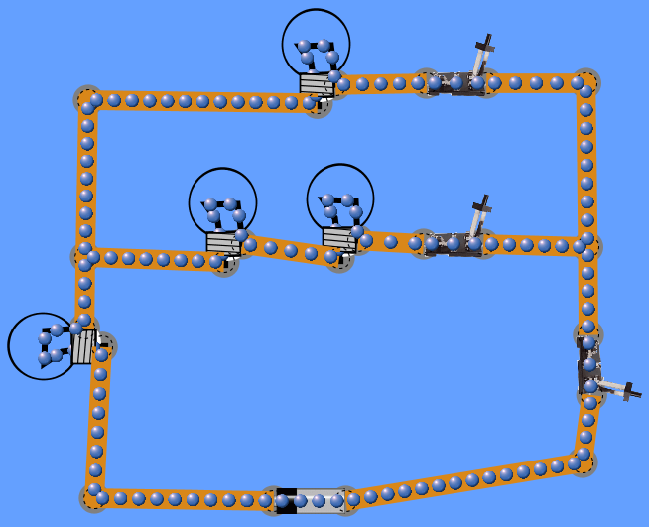
- Series Circuit in a Parallel Circuit in a Series Circuit (Bonus)
R₄
R₃
R₂
R₁
 | R | V | I | P
1
2
3
4
23
123
battery

- On a separate sheet of paper, draw a schematic version of this circuit ( and ) and then draw simplified versions to solve.

- Explain which parts of the circuit are in series. Explain which part of the circuit is in parallel.
- Rank the light bulbs in order of brightness. In terms of current flow and resistance, explain why.

