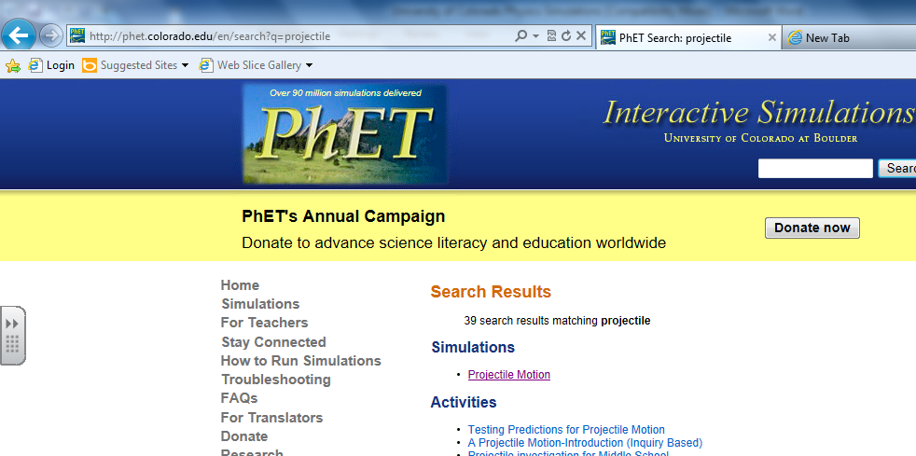
Using PhET Interactive Simulations Name(s): Date:
- Type “PHET” in the search engine. Select University of Colorado web page.
- Type “projectile” into the search engine on the web site. Select “projectile motion”.

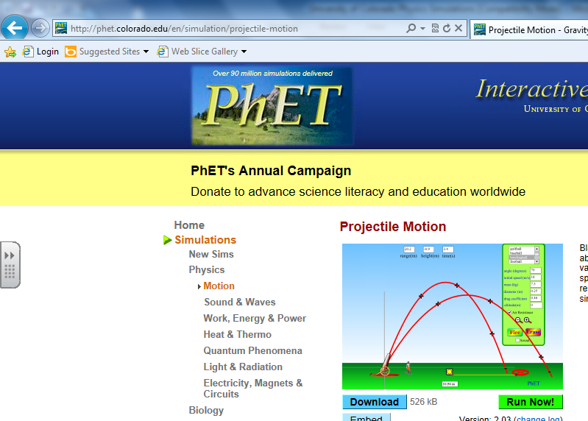
- Select “Run Now”.

- Copy the default settings for angle, initial speed and mass.

- Look at the top of the screen. Which variables are calculated by the program?

- What variables can be changed by the user?

- List the different objects that can be fired from the cannon.

- Launch the cannon ball at a speed of 10 m/s at an angle of 35º. Launch the cannon ball after changing the mass from the default setting of 2 kg to 6 kg and then 8 kg. Record the range each time. What effect does the change in mass have on the range of the projectile?

- Find the angle of launch that gives the greatest range. Record that angle here.

- Launch an object at 15 m/s, 65º. Record the height upon landing. If the height is negative, give an explanation for this.

- Use the tape measure to measure the height of the projectile in #10 at its highest (maximum) point. Record the maximum height here.

- Look at your “Solving projectile problems” page of notes. What equation can be used to calculate the horizontal displacement of a non-horizontally launched projectile?

- On the PHET program, what is the horizontal displacement called?

- Look at your “Solving projectile problems” page of notes. What equation can be used to calculate the vertical displacement of a non-horizontally launched projectile?

- On the PHET program, what is the horizontal displacement called?

- Drag the cannon up to a height of around 10m. Use the tape measure to set the height. Set the angle to 0º. Choose a launch speed and an object. Sketch your set up and include the speed in your sketch. Launch the object and record the range in your sketch.

- Since you cannot use the parallelogram method to determine the components of the initial velocity vector, what 2 equations do you use to determine the x and y velocity components of a projectile?

- Drag the cannon back down to the ground level and select an angle for a launch. Choose an angle between 15 and 75^{o.}
  - Sketch your setup in the space below. Label your launch angle.
  - Launch the projectile you choose at an initial speed of 22 m/s.
  - Determine the vertical and horizontal components of the projectile.
  - Record the range of the projectile for the program.
  - Write down the equation used to solve for the range. Fill in the variables with numbers from the program.

- Drag the cannon up to a height of around 13m. (Use the tape measure to set the cannon height!) Choose an initial speed between 10 and 40 m/s. Make sure the angle is 0º.
  - Determine the horizontal and vertical components. Show your equations.
  - Calculate the range, height (distance) and time in the air. You must show your work
  - Check your work with the program.

- Drag the cannon back down and choose and initial speed between 5 m/s and 25 m/s. Choose a launch angle between 5 and 75 degrees.
  - Determine the horizontal and vertical components. Show your equations.
  - Calculate the range, height (distance) and time in the air. You must show your work
  - Check your work with the program.

