
Introduction to Ionic & Covalent Bonding

Pre-Lab Questions
- Define ionic bond:

- Define covalent bond:

- What types of atoms compose each type of compound – only metals, only nonmetals, or both?

Procedure, Part A (Macro Tab)

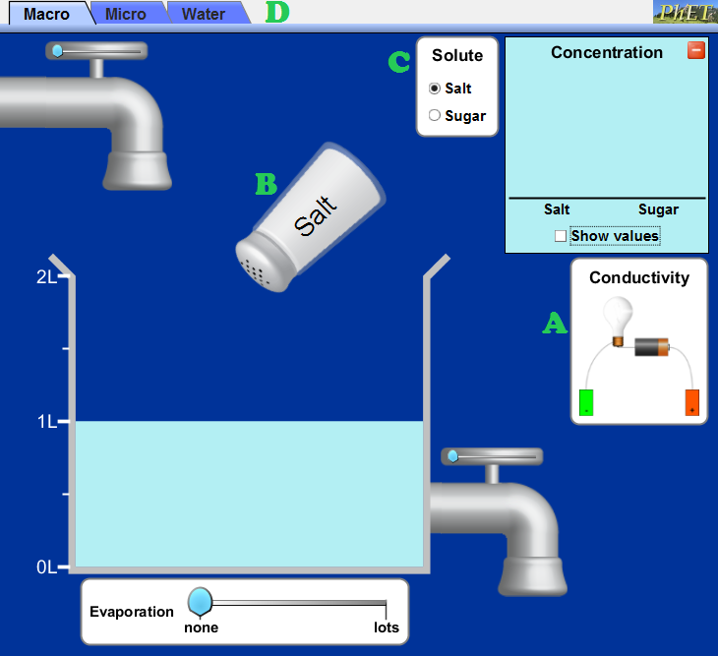

- Open the “Sugar and Salt Solutions” simulation on the PhET website by following the link below and clicking, “Run Now!”: http://phet.colorado.edu/en/simulation/sugar-and-salt-solutions
- Drag the conductivity tester, labeled A, into the beaker of water. Place the negative and positive electrodes into the water, but not touching the bottom of the beaker. When electricity is conducted by the solution, the light bulb will light up – the stronger the electric current, the brighter the bulb will glow. Record any observations.
- Click on the salt shaker, labeled B, and drag your mouse back and forth. This will “shake” the salt into the water. As you add salt, pay attention to the light bulb on the conductivity tester. Continue to add salt until the shaker is empty. Record observations. Then click the “Remove salt” button to reset the simulation
- Click the “sugar” bubble in the solute selector, labeled C, to switch from salt to sugar. Then repeat step 3, this time using the sugar shaker. Record observations.
- Click on the “Micro” tab at the top of the simulation, labeled D, to switch to a new simulation for part B.
Procedure, Part B (Micro Tab)

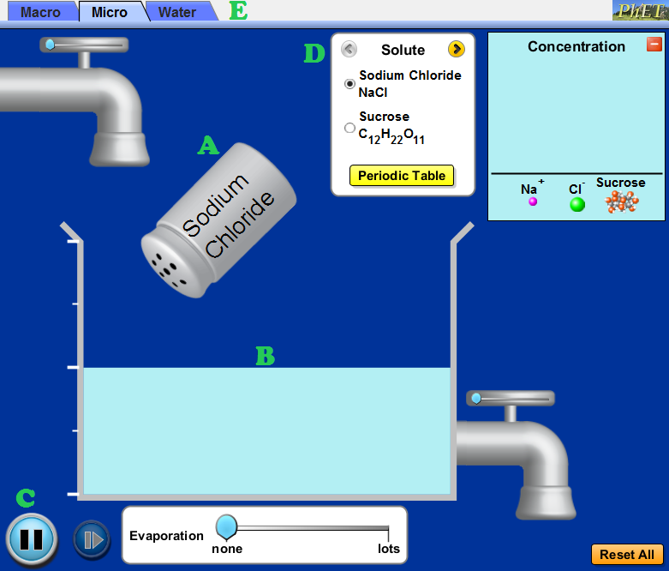

- Click on the salt shaker, labeled A, and drag your mouse back and forth. This will “shake” the salt into the water. Pressing pause, labeled C, will stop the salt crystals mid-air so you can see them before they dissolve.
- Observe how the crystal behaves once in the water. Record observations in the “Ionization in Water” section of the data table.
- Click the “sucrose” bubble in the solute selector, labeled D, to switch from salt to sugar. Then repeat steps 6 and 7, this time using the sugar shaker. Record observations.
- You can test other solutes by clicked the right arrow in the solute selector, labeled D.
- To get an even further “zoomed in” view, click on the water tab, labeled E and repeat the simulation by dragging salt and/or sugar into the water.

Procedure, Part C

- Use the Flinn MSDS search to locate the MSDS for “sodium chloride” (salt) and “sucrose” (sugar): http://www.flinnsci.com/msds-search.aspx
- Using the MSDS sheets for salt and sugar, locate their melting points. Record in the data table below.
- Using the MSDS sheets for salt and sugar, locate the information on solubility. Record in the data table below.

Data Table

Substance | Melting Point | Solubility in Water  (yes or no) | Electrical Conductivity  (yes or no) | Ionization in Water  (yes or no)
Pure Water  H₂O |  | N/A |  | N/A
Salt
NaCl
Sugar
C₁₂H₂₂O₁₁

Analysis Questions

- Based on their chemical formulas, state whether the substances tested above are covalent or ionic.

- A data table is provided below with information on substances not tested in the simulation. Complete any missing information by looking up the MSDS sheets for each chemical using the same link provided in step 11 of the procedures (for part C).
Substance | Phase at 20°C (solid or liquid) | Melting Point | Solubility in Water | Electrical Conductivity in Water | Type of Bond
potassium chloride  KCl | solid |  | Yes | Yes
benzoic acid  C₆H₅COOH | solid | 122.4°C |  | None detected | covalent
ethyl alcohol  C₂H₅OH | liquid |  | Yes | None detected
iron (III) sulfate  Fe₂(SO₄)₃ |  | 480°C |  | Yes | ionic
oleic acid  C₁₈H₃₄O₂ |  | 13.4°C | No | None detected
nitrogen  N₂ | gas | -210°C | Slightly | None detected

- Using the data you gathered during the simulation, as well as the data table from the previous question, what are some properties exhibited by covalent (molecular) compounds?

- What are some properties exhibited by the ionic compounds tested in the simulation and/or shown in the data table in question 2?

- Although both sugar and salt are soluble in water, the way in which they dissolve is not shown the same in the simulation. How is their dissolving process different? Explain why these differences exist.

- What would the simulation have shown if oleic acid was added to water? Would it look different than what was shown for sugar and/or salt? Explain.

- When some ionic compounds dissolve, not all of their bonds dissociate. What kind of conductivity would you expect such a solution to have? Explain.

- Based on the formula, predict whether each of the following compounds is primarily ionic or primarily covalent.
  - sodium iodide (NaI) d. ammonia (NH₃)

  - methane (CH₄) e. glucose (C₆H₁₂O₆)

  - calcium chloride (CaCl₂)

