Laboratory simulation: Refraction
Name:________________________________________________________________
  - Learning goals
- Familiarize with simulations of physical processes.
- Log raw data and plot graphs.
- Partially familiarize with the scientific method (phenomenon, prediction, experiment, conclusion).
- Derive the dependence of the angle of refraction on the angle of incidence and the index of refraction.
  - Simulation used
“Refraction of light” (“bending-light_el.jar”)
Additionally: Spreadsheet application (like Microsoft Excel or OpenOffice Calc)
  - Theory / Definitions
- Optical (or transparent) medium: ________________________________________________________________________
___________________________________________________________________________________________
___________________________________________________________________________________________
___________________________________________________________________________________________
- Index of refraction: ____________________________________________________________________
___________________________________________________________________________________________
__________________________________________
4. Denote the angles of incidence $i$ and refraction $r$.
__________________________________________
__________________________________________
- Refraction: _________________________________________
_________________________________________
__________________________________________
_________________________________________
___________________________________________________________________________________________

  - Experiment 1: Dependence of angle of refraction on the angle of incidence
Laser light falls from air to a transparent medium.
Prediction: What do we expect to happen to the angle of refraction as the index of refraction of the transparent medium increases? Explain.
___________________________________________________________________________________________
___________________________________________________________________________________________
___________________________________________________________________________________________
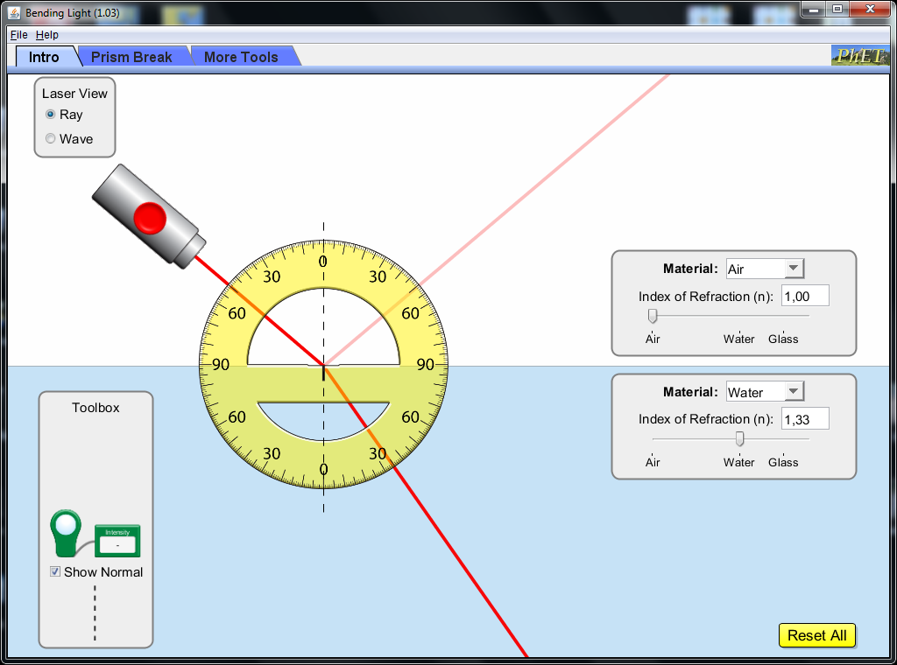
Set the angle of incidence at ${50}^{ο}$ and leave it unchanged
2
Vary from 1.00 to 1.60
Don’t change
1
Measure the angle of refraction $r$
The laser is placed so that the angle of incidence equals 50 degrees.
Graph 1: Angle of reflaction vs the index of refraction
Table 1: Angle of reflaction vs the index of refraction

Measurement | Index of refraction $n$ | Angle of refraction (degrees)
1
2
3
4
5
6
7

Conclusion compared to our prediction:
___________________________________________________________________________________________
___________________________________________________________________________________________

  - Experiment 2: Dependence of the angle of refraction on the angle of incidence
Predictions/Hypothesis: What do we expect to happen to the angle of refraction as the angle of incidence increases? Explain.
___________________________________________________________________________________________
___________________________________________________________________________________________
___________________________________________________________________________________________
Keep unchanged
1
Measure the angle of refraction
2
Vary the angle of incidence ($0^{ο} → {90}^{ο}$)

Graph 2: Angle of refraction vs angle of incidence
Table 2: Angle of refraction vs angle of incidence
Measurement | Angle of incidence (degrees) | Angle of refraction (degrees)
1
2
3
4
5
6
7
8

Conclusion compared to the prediction:
___________________________________________________________________________________________
___________________________________________________________________________________________
___________________________________________________________________________________________

  - Conclusion: Theory predictions versus the results of the 2 experiments.
A number of scientists between the 10th and the 17th centuries (Sahl, Snellius, Descartes) concluded that the following formula should relate the angle of incidence $i$ with the angle of refraction $r$:
$$sini=\frac{sinr}{n}$$
Explain if the results of the 2 simulated experiments above are compatible with the formula.
Experiment 1:
__________________________________________________________________________________________
__________________________________________________________________________________________
_________________________________________________________________________________________
___________________________________________________________________________________________
___________________________________________________________________________________________
Experiment 2:
___________________________________________________________________________________________
_________________________________________________________________________________________
___________________________________________________________________________________________
___________________________________________________________________________________________
___________________________________________________________________________________________
___________________________________________________________________________________________

