Title: Energy
Introduction:
In this activity you will investigate the relationships among kinetic, potential, thermal, and total energy. You will see how these energies are used and change through measuring a simulated skateboarder on a half-pipe. Then, you will see what happens to the energy levels of the skater when friction is an added factor.
- Click on the link: http://phet.colorado.edu/en/simulation/energy-skate-park-basics
This is a screen shot of the website:
This is a screen shot of the simulation: 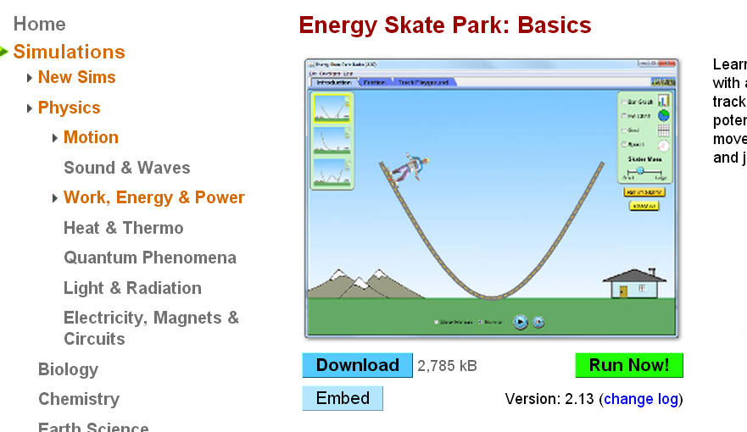
- When you see this screen you will then click on “Run Now!”
- Switch between this document and the simulation “Energy Skate Park: Basics” to complete this activity.
Exploration Phase #1:
- Make sure the simulation is on the tab Introduction.
- Check the speed and the pie chart application boxes.
- Click and drag the skater to the top of the ramp’s left side. Your screen should look like this.
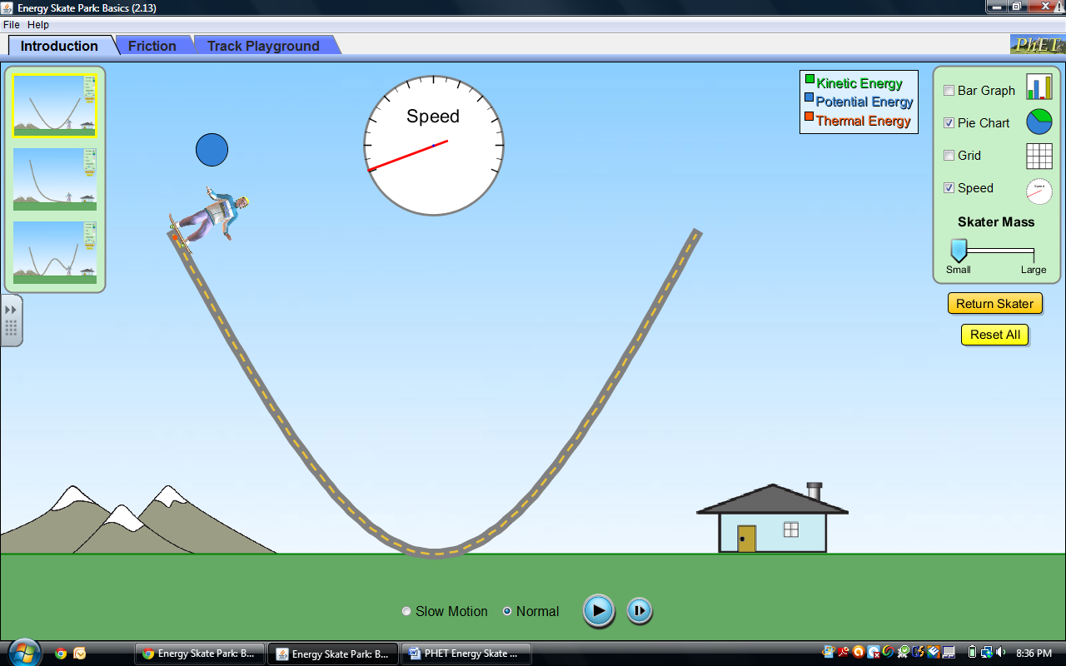
- Now release.
- Observe what is happening to the speed and energy levels of the skater in motion.
- Check the Grid box.
- Use slow motion and the pause/play button to help you fill in the following table:
The Skater’s Height in Meters | Is there more potential or kinetic energy?
5
4
3
2
1
0

When the skater is at the ___________ (top, bottom) of the ramp, potential energy is at its highest level.
Where is the skater at the ___________(top, bottom) of the ramp, kinetic energy is at its highest level.
What is the relationship between speed and the kinetic/potential energies of the skater?
Predict:
Will anything be affected by altering the mass of the skater? (Will it cause him to go faster? Slower? Will it alter his energy levels?)
If _____________ then ______________.
Explain:
- Reset all.
- Set skater mass to small.
- Click on bar graph application. Your screen should look like this: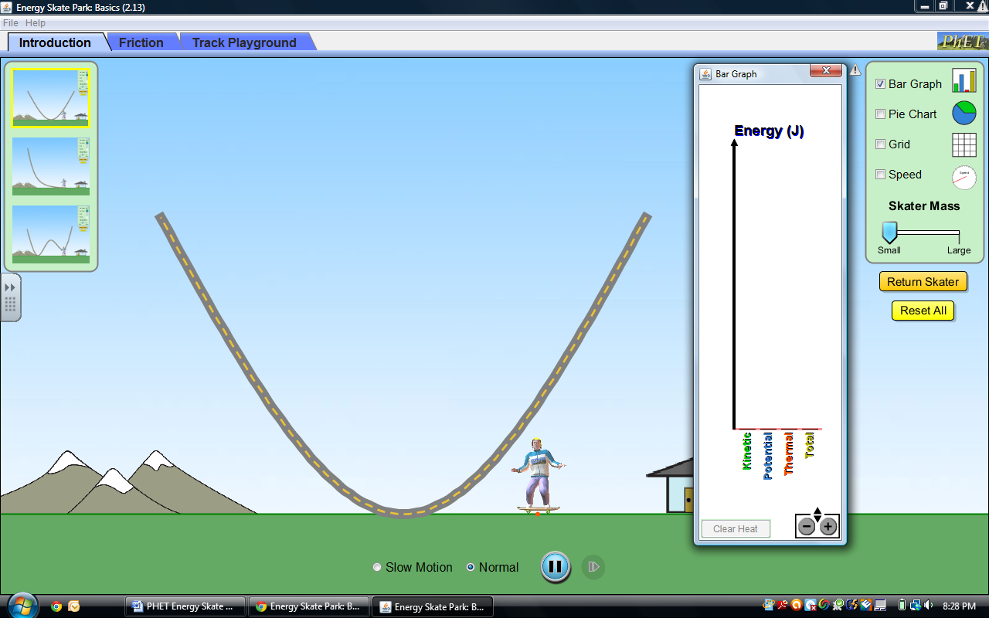
- Place skater on top of the ramp.
- Repeat for a medium mass and large mass skater.
The speed of the skater ________(increases, decreases, remains the same) when the skater’s mass increased.
The energy level of the skater _________ (increases, decreases, remains the same) when the skater’s mass increased.
What can you conclude about the relationship between the mass of the skater and the energy level?
Exploration Phase # 2:
- Click the “Friction” tab on the top of the simulation.
- Click “On” below Friction to add the element of friction to the ramp, make sure the friction level is set to “none”
- Check off the bar graph box
- Check the Grid Box. Your screen should look like this:
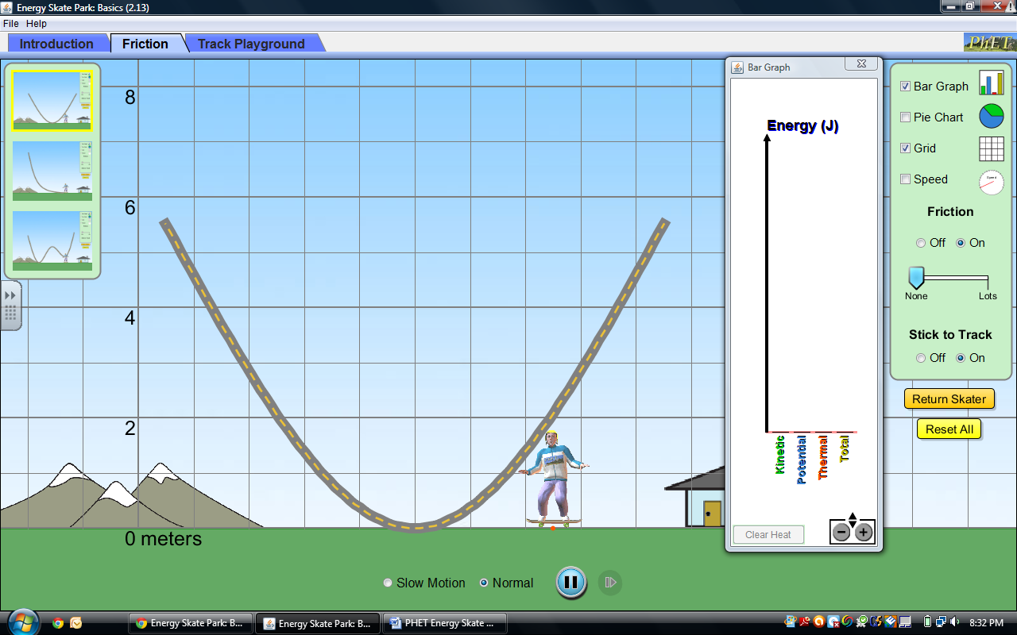
- Click and drag the skater to the top of the ramp, now release.
Is thermal energy present?
Prediction:
What will happen to the skater when friction is present? How will his energy levels be affected?
If ___________ then ___________.

Explain:
Fill in the table below. Every time you alter the friction level, reset all and check off the bar graph. (The first row is done for you)
Friction Level | Number of times Skater passes middle of the ramp until he stops | Highest point of Skater first time he goes to the right side of ramp? (Use red dot in middle of skateboard for your measurement) | What is happening to the energy levels?
None   | Infinite | approximately 5.5 meters | Total: remains the same  KE: increasing and decreasing oppositely than potential  PE: increasing and decreasing oppositely than kinetic  ThE: not present
Quarter way toward Lots   |  |  | Total:  KE:  PE:  ThE:
Half Way toward Lots  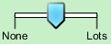 |  |  | Total:  KE:  PE:  ThE:
Three Quarters toward Lots   |  |  | Total:  KE:  PE:  ThE:
Lots   |  |  | Total:  KE:  PE:  ThE:

Questions
What is the relationship between friction and thermal energy?
Compare and Contrast Potential Energy with Thermal Energy:
If you were sitting on the couch and someone said, “You have no energy.” Would you agree or disagree with this statement? What might you say in response?
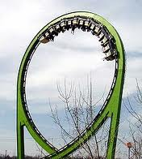
If you designed a rollercoaster, how might you design it? Would you have friction?
Application
Select the Track playground tab.
Design a rollercoaster to make a loop de loop.
The skater must be able to go completely around the
loop de loop.

Explain your design choice; you must use the following vocabulary:
Total Energy, Kinetic Energy, Potential Energy, Thermal Energy, Friction

