Title: Waves and Wavelengths

Introductions:
In this activity, you will get to investigate the concepts of waves and wavelengths. You will get to explore different sizes of oscillate waves and what factors have an effect on its height and length.

- Click this link: http://phet.colorado.edu/en/simulation/wave-on-a-string
- This is a screen shot of the website:
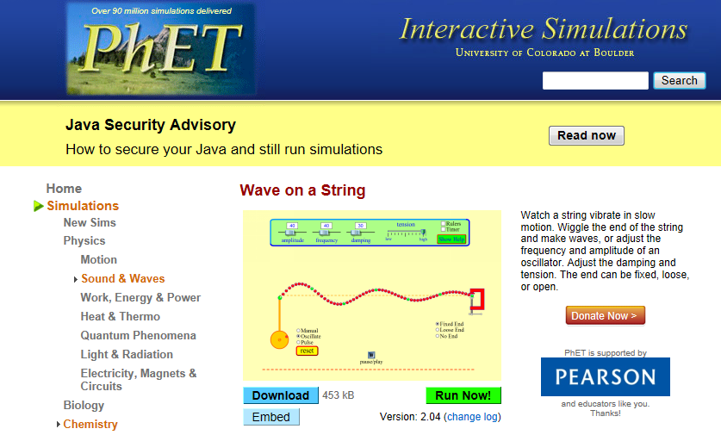
3. Click “Run Now!”
4. It will take some time to load and then this screen will appear:
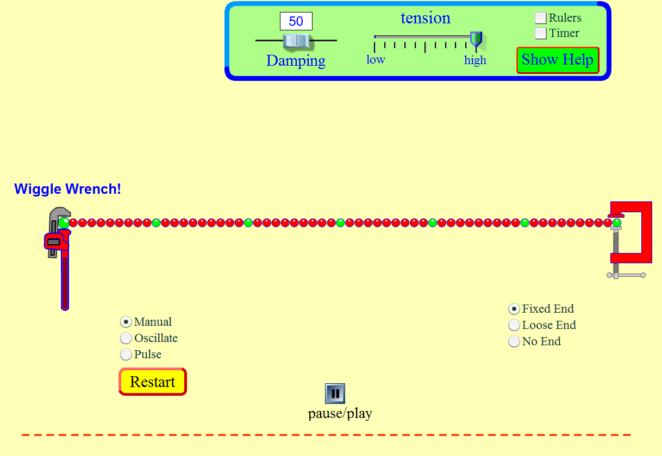
Switch between this document and the Sims to complete the activity.

Exploration Phase
- Freely explore the Sims for 2-3 minutes. (You can change the tension, the damping, the tool, and the ends of the string.)
- You can transition between Manual, Oscillate and Pulse. (*Hint: Don’t forget to wiggle the wrench up and down to see how waves on a string of beads move in the Manual option.)
- Try different tools like the ruler and the timer.
Your Ideas:
- What do you think the scientist’s definition of a wave is?

- How do you think scientists measure the length of a wave?

Explanation Phase

Aim: What is a wave? What has an effect on a wave’s amplitude and wavelength?

Vocabulary for the Mind:

- Wave: A pulse of energy to swing or move (something) back and forth or up and down
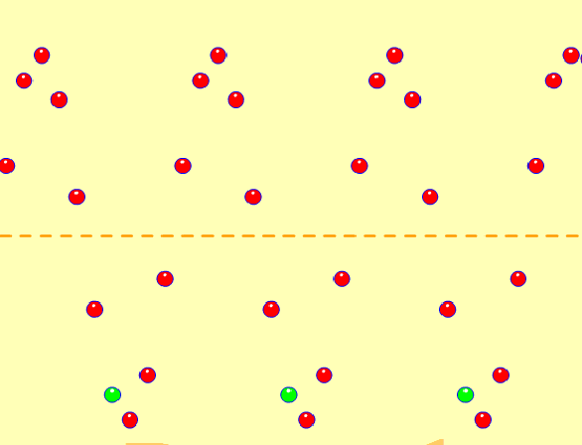
- Example: The image below is a wave created by moving a string with beads moving up and down.

- Oscillate: When a motion or mass moves back and forth in a regular rhythm that repeats itself at fixed locations. (Examples: a swing, a tidal wave, or a duck sitting still on a wavy pond.)

- Amplitude: the height of a wave when it reaches the highest point from the center.
- Example: The amplitude of the wave in the image below from the dotted line or center to the highest point is 18 cm.
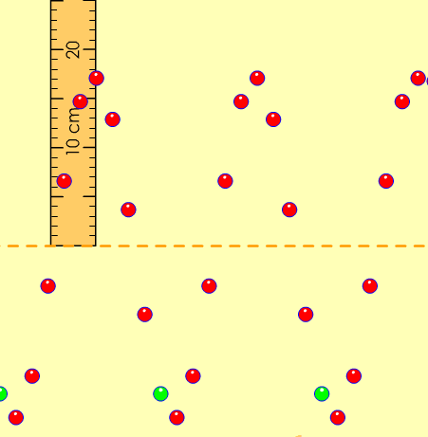

Amplitude
- Frequency: the speed of movement a wave is being created at a constant speed as it is moving side to side or up and down.

- Crest: The highest point of a wave.
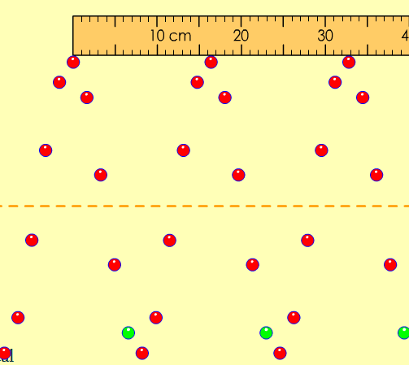
Crest

Trough

- Trough: The lowest point of a wave.

- Wavelength: The distance between one crest of a wave and the next crest or from one trough to the next trough. (Science Definition)
- Example: Look at the image below. The wavelength of the wave from one peak to the next is about 16.5cm.
l-- wavelength--l

Predictions:
- After exploring the Sims in the beginning, which one of the applications (damping, or tension) do you think will have the most effect on a wave’s amplitude (height) in “Oscillate”? Why?

- Which one of the applications (damping, or tension) do you think will have the most effect on a wavelength in “Oscillate”? Why?

Talk it out: Discuss with the person next to you about the predictions you made. (Take about 2-3 minutes)
Exploration: Now you will get to investigate to see if your predications are correct.

Part A: Damping
- Click on the “Oscillate” option. Click “Pause/Play” to stop the wave from moving.

- Keep the “Amplitude” and “Frequency” level to 50. Keep the “Tension” at the middle. Drag the slider for “Damping” to 0 or type it in the white box on top of it.

- Step 1: Click on the box next to “Timer” and “Ruler”. Use the rulers to help you measure the wave’s amplitude and length.

- Your screen should look similar to this:
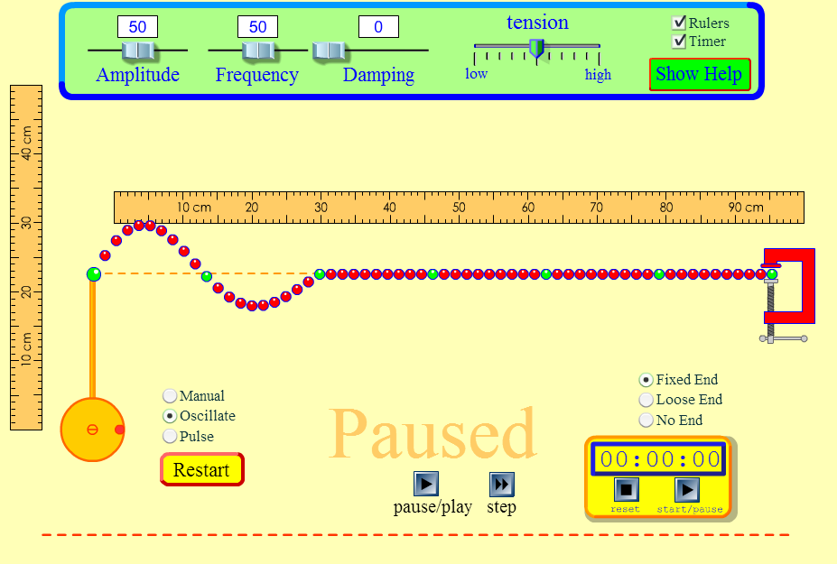

- Step 2: When you are all set up and ready, click “Restart” to start the wave. (You will know that the wave is being created when the red dot on the wheel is turning clockwise.)

- Step 3: Click “Pause/Play” to start the timer.

- Step 4: Click on “Pause/Play” to pause the wave when the timer reaches close to 30 seconds. If the timer does not stop, click the pause button on the timer. (Hint: It should show something similar to 00:30:00)
  - Use the “Step” button to view the wave moving slowly step by step. The timer will increase by 3 milliseconds every time you click on “Step”.

- Step 5: Measure the amplitude (height) and the wavelength. Record the data for the information on the table below. (Hint: Look at the definitions for the words “amplitude” and “wavelength” to see how you can measure a wave’s height and length.)

- Step 6: Use these questions to help guide you in filling in the description box for the table:
a) Describe the type of motion you see in the wave when you change the damping to 0.
b) What happens to the wave when you change the damping to 50?
c) What happens to the wave when you change the damping to 100?
(Use words like increase, decrease, constant, amplitude and wavelength in your description. Examples: The waves increase at a…and decrease…. The amplitude was … and the wavelength was….)

Table:

Type of Wave | Damping | Amplitude (Height)  (cm) | Length (cm) | Description
Oscillate | 0 |  |  | a)
Oscillate | 50 |  |  | b)
Oscillate | 100 |  |  | c)

- Step 7: Repeat Steps 2-4 after adjusting the sliders to the measurements from the table.

- Does changing the “damping” have any effect on the wave’s amplitude or the wavelength? _______

Part B: Tension
- Now keep the “Amplitude” and “Frequency” level at 50, and change the “Damping” to 50. Drag the slider for “Tension” all the way to the left, where it says “low”. Reset the “Timer”.

- Your screen should look similar to this:
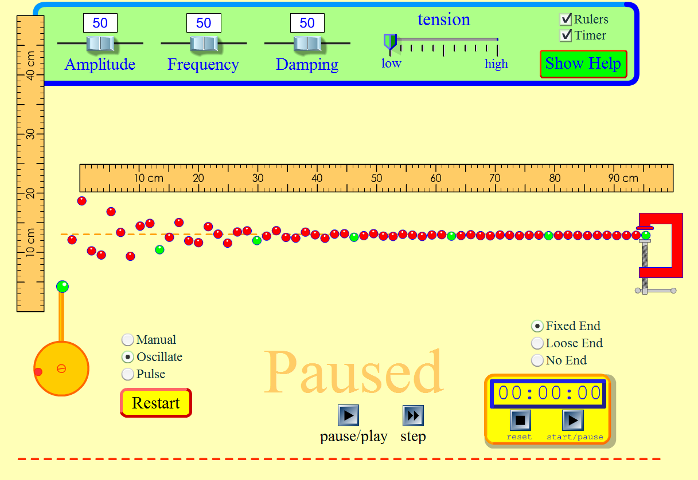

- Repeat Steps 2 to 5 from Part A.

- Step 6 : Use these questions to help guide you in filling in the description box for the table:
a) Describe the type of motion you see in the wave when you change the tension to low. (Hint: Look at the connection between each bead on the wave.)
b) What happens to the wave when you change the tension to the middle?
c) What happens to the wave when you change the tension to high?
(Use words like increase, decrease, constant, amplitude and wavelength in your description. Examples: The waves increase at a… and decrease…. The amplitude was ….and the wavelength was….)

Table:
Type of Wave | Tension | Amplitude (Height)  (cm) | Length (cm) | Description
Oscillate | Low |  |  | a)
Oscillate | Middle |  |  | b)
Oscillate | High |  |  | c)

- Repeat Step 7 from Part A.

- Does changing the tension have any effect on the wave’s amplitude or the wavelength? _______

Application Phase
Part C: Damping and Tension
- Click “Pause” so that the wave stops moving.

- Keep the “Amplitude” and “Frequency” level at 50. Set “Damping” to 0 and “Tension” to low. Reset the “Timer”. Uncheck the white box next to “Ruler” by clicking on it to remove the rulers.

- Your screen should look something like this:
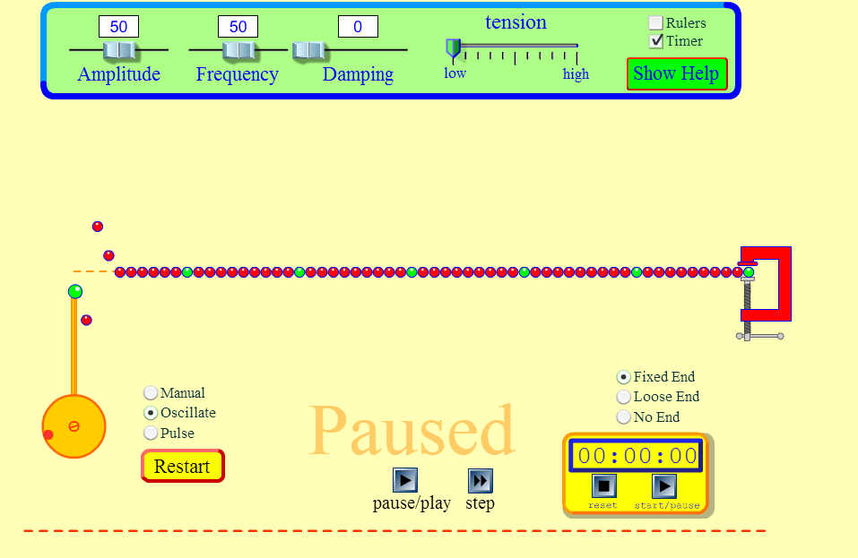

- Use only the “Damping” and “Tension” tools to help you complete the following information to make the information true based on the corresponding pictures and the time on each image. (Hint: Use the Step button to help you move the wave and increase the time slowly. This will help you get closer to the time on the image.)

- The goal is to figure out the amount of “Damping” and “Tension” to get as similar to the image as possible:
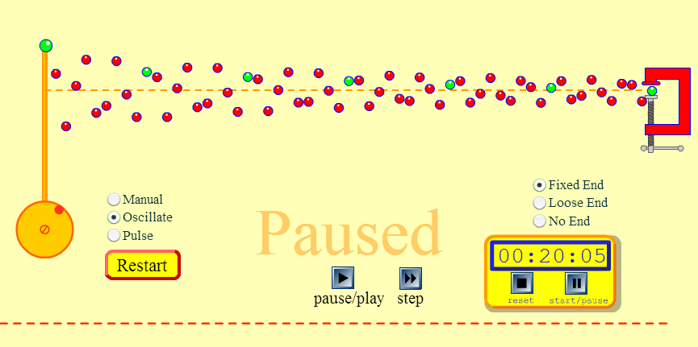

    - Amplitude: 50
    - Frequency: 50
    - Damping: ________
    - Tension: _________

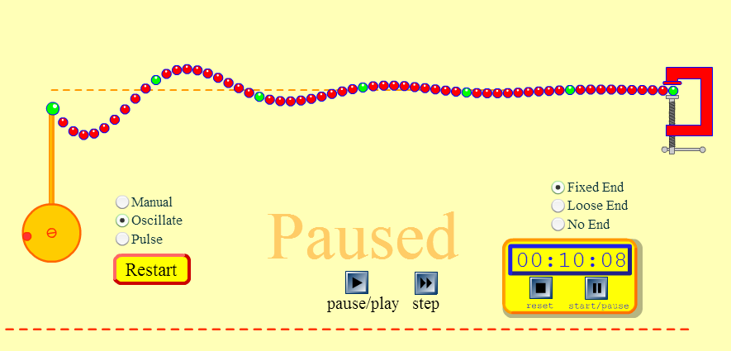

    - Amplitude: 50
    - Frequency: 50
    - Damping: ________
    - Tension: _________

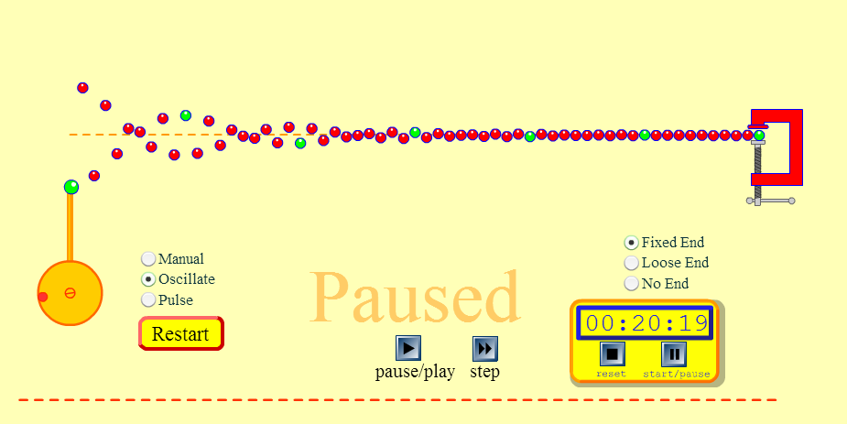

    - Amplitude: 50
    - Frequency: 50
    - Damping: ________
    - Tension: _________

Conclusions: Compare and Contrast your predictions with your findings from the table from Part A and Part B. Was any of the collected data similar or different to your predictions? What amazed or shocked you in your findings? Why? Is there anything that you would like to learn more about on waves and wavelengths?

Share: Turn to your partner and talk about your findings.


Finished: Congratulations, you can now do the wave! Use both of your arms or body and try to mimic the motion of a wave. (*Here’s a picture to get you started.)

