Title: Colors of Light
Introduction
In this activity you will investigate colors of light bulbs and how they determine the color a person will see.
1. Click this link: http://phet.colorado.edu/
This is a screen shot of the website:
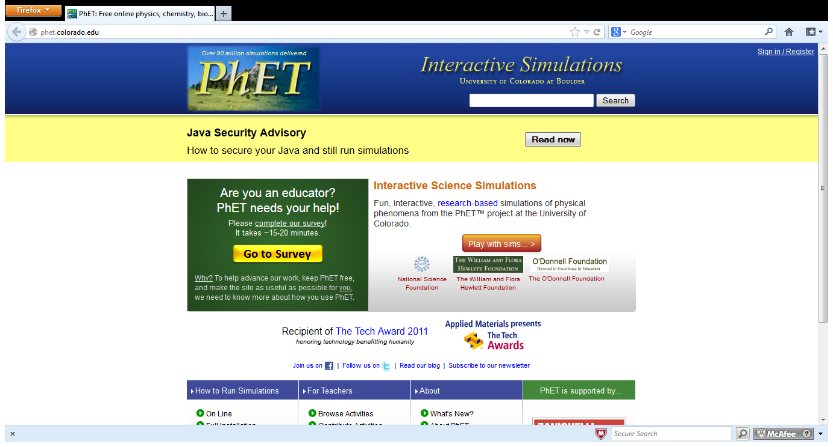

2. Click the “Play with sims” button.
3. Click “Physics” -> Click “Color Vision”->Click “Run Now!”
4. It will take time to load and then this screen appears: 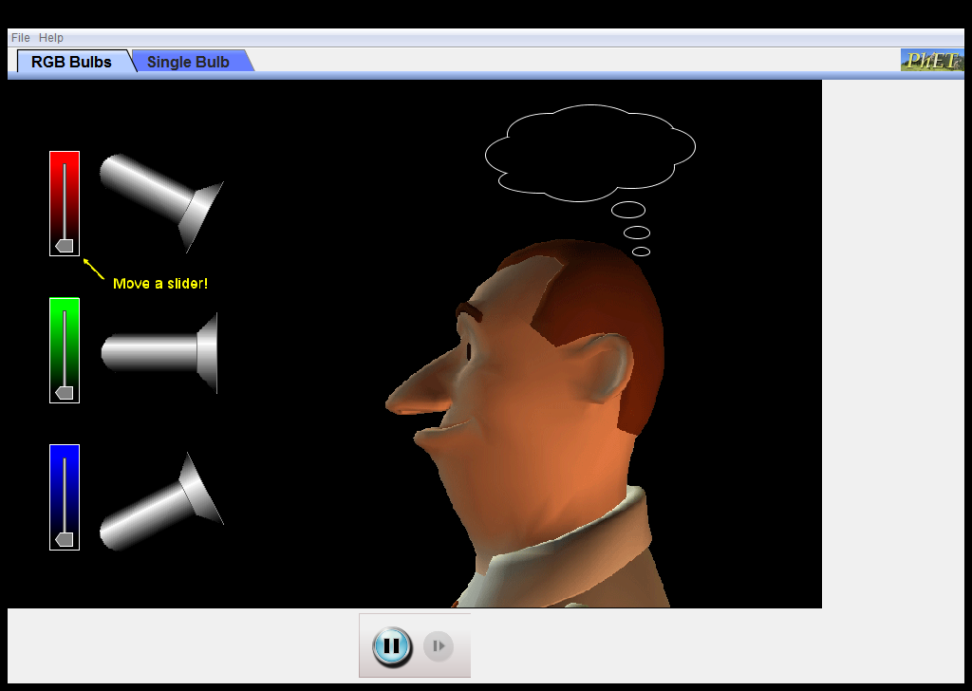

Switch between this document and the sim to complete the activity.

Explore
- Click on the “RGB Bulbs” tab.
- Move the slider to shine different amounts of light.
- Explore using different combinations of each light to discover the color a person sees.

Questions:
- What light has to be shined to make a person see red? What happens when you move the slider?
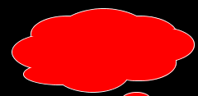
- What light has to be shined to make a person see green? What happens when you move the slider?
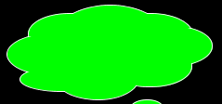
- What light has to be shined to make a person see blue? What happens when you move the slider?
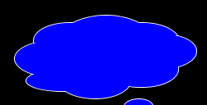

Explain
Aim: Determine what primary light bulb you need to make a person see certain colors.

Part 1:
Make predictions for the secondary color a person will see when two primary colored blubs are shined together (show the teacher your predictions before moving on):

Primary color | Color added | Predictions for the color a person sees
red | blue
blue | green
green | red

Move all of the sliders down so no light is coming out of the blubs. It should look like this:
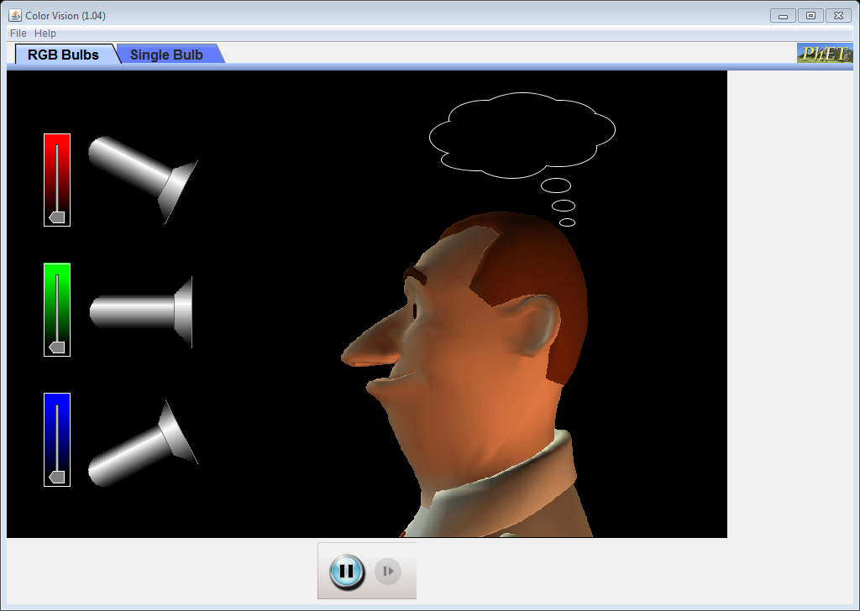
You already know that the sliders have to be up all the way up to make the person see the viberant version of each color.

Test your predictions by using the light sources. Make sure the slider is up as high as it can go when using the colored bulbs.

Primary color | Color added | Color a person sees  (secondary colors)
red | blue
blue | green
green | red

Talk to a partner about how your predictions were similar or different to your actual results.

Part 2:
Now that you have created the primary and secondary colors try to discover how to create white:
Color the man sees | Primary colors and slider location for each blub (top, middle, bottom)
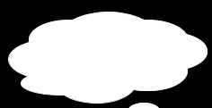 | red-  blue-  green-

Apply
Set the light bulbs so you create the three secondary colors from above. What primary color do you add to the secondary color to make the man see white?
Secondary color | Primary color added to make white (complimentary color)
magenta

yellow

cyan

Create rule using these words: White, Primary color, secondary color, complimentary color.

Now just have fun and try to discover how to get the man to see the colors in the table below:

Color the man sees | Primary colors and slider location for each blub (top, middle, bottom)
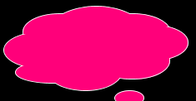 | red-  blue-  green-
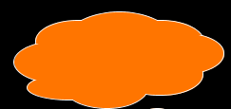 | red-  blue-  green-
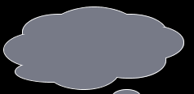 | red-  blue-  green-

