NSU Physics Experiment – Resistance and Resistivity (Using PhET Simulation) | 

Read the experiment and answer the following questions.

1. What are the factors affecting the resistance of an electrical conductor?

Click here to enter text.

2. If the length of a wire conductor were to double, how would the resistance change? Explain.

Click here to enter text.

3. Why is resistivity called a material property?

Click here to enter text.

4. If the Area of a wire conductor were to double, how would the resistance change? Explain. .

Click here to enter text.

I. INTRODUCTION AND OBJECTIVES

The resistance of an electrical conductor depends on several factors. Its physical shape is one factor. The type of conductor material is another, as might be expected. That is, two conductors with the same physical shape, but of different materials, have different resistances. This important material characteristic of resistance is expressed in terms of a quantity called resistivity.

Temperature is another factor affecting resistance. However, the temperature dependence of resistance is not investigated here. In the present experiment, the factors of shape or dimensions and resistivity will be considered.

After performing this experiment and analyzing the data, you should be able to:
1. Explain on what factors the resistance of a wire depends and why.
2. Distinguish between resistance and resistivity.
3. Describe how the resistivity of a material may be determined from a graph.

II. EQUIPMENT NEEDED

• PhET Simulation: http://phet.colorado.edu/en/simulation/resistance-in-a-wire
• Logger Pro from Vernier Software

III. THEORY

The resistance of an electrical conductor depends on several factors. Consider a wire conductor. The resistance, of course, depends on the type of conductor material, and also on (a) the length, (b) the cross-sectional area, and (c) the temperature of the wire. As might be expected the resistance of a wire conductor is directly proportional to its length L and inversely proportional to its cross-sectional area A:

For example, a 4-m length of wire has twice as much resistance as a 2-m length of the same wire. Also, the larger the cross-sectional area, the greater the current flow (less resistance) for a given voltage. These geometrical conditions are analogous to those for liquid flow in a pipe. The longer the pipe, the more resistance to flow. But, the larger the cross-sectional area of the pipe, the greater the flow rate or the smaller the resistance to flow.

The material property of resistance is characterized by the resistivity ρ, and for a given temperature,

(1)

Another name sometimes used for resistivity is specific resistance, indicating that it is specific for a given material.

To determine the resistivity of some hypothetical material, a PhET Computer Simulation called “Resistance in a Wire” will be used to generate data which can then be graphed using the Logger Pro program.

If we graph R vs L for a wire of cross-sectional area A, the slope of the resulting direct proportion graph will be the resistivity/area (see Eq 1). The resistivity the conductor can be calculated by multiplying the slope by the area.

If we graph R vs A for a wire of length L, the fit constant of the resulting inverse proportion graph will be the resistivity*length (see Eq 1). The resistivity the conductor can be calculated by dividing the fit constant by the length.
IV. EXPERIMENTAL PROCEDURE and DATA ANALYSIS

1. Load your Internet Browser and go to the following site:

http://phet.colorado.edu/en/simulation/resistance-in-a-wire

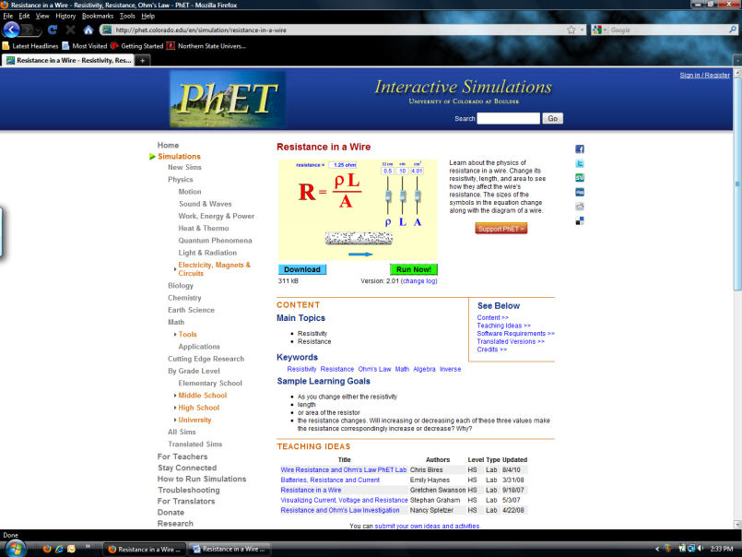

2. Click on the “Run Now” button and the Simulation screen should appear:

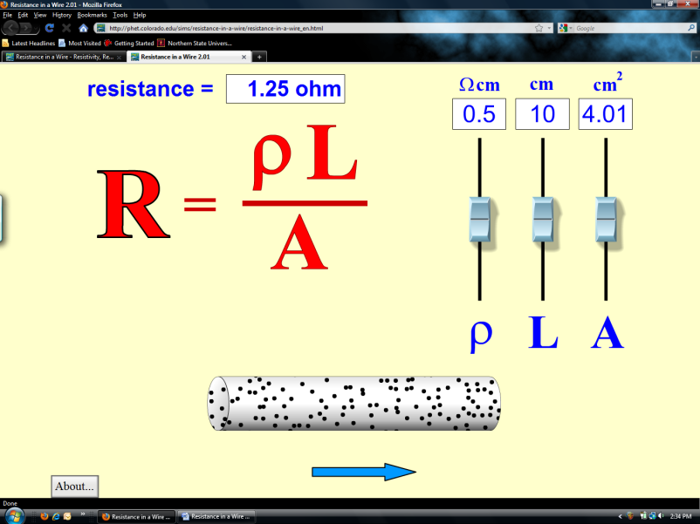

Leaving the ρ and A sliders at their default settings, Use the L slider to adjust the length of the wire to the values in data table 1, also recording the resulting wire resistances R.
Capture a screen of the simulation for L = 20 cm using the “PrtSc” key on your computer keyboard and paste this on the next page.

Simulation Screen Capture,ρ = 0.5 Ω cm, L = 20 cm



Data Table 1:

Wire Resistivity ρ = Click here to enter resistivity Ωcm

Wire Area A = Click here to enter Area cm²

L (cm) | R | L (cm) | R
2.0 |  | 12.0
4.0 |  | 14.0
6.0 |  | 16.0
8.0 |  | 18.0
10.0 |  | 20.0

Slope of graph of R vs L = Click here to enter slope Ω/cm.

Slope times Area = Click here to enter slope time area Ωcm

% Error of Slope times Area with ρ = Click here to enter Percent Error %

3. Minimize your internet browser and start up Logger Pro. Download and extract the contents of http://www3.northern.edu/dolejsi/nsu_labs/Resistance_and_Resistivity_PhET.zip

Load the Experiment File: Resistance_and_Resistivity. Enter your data from Table 1 under Data Set 1. Perform a “linear fit” on the data. A sample graph is shown below:

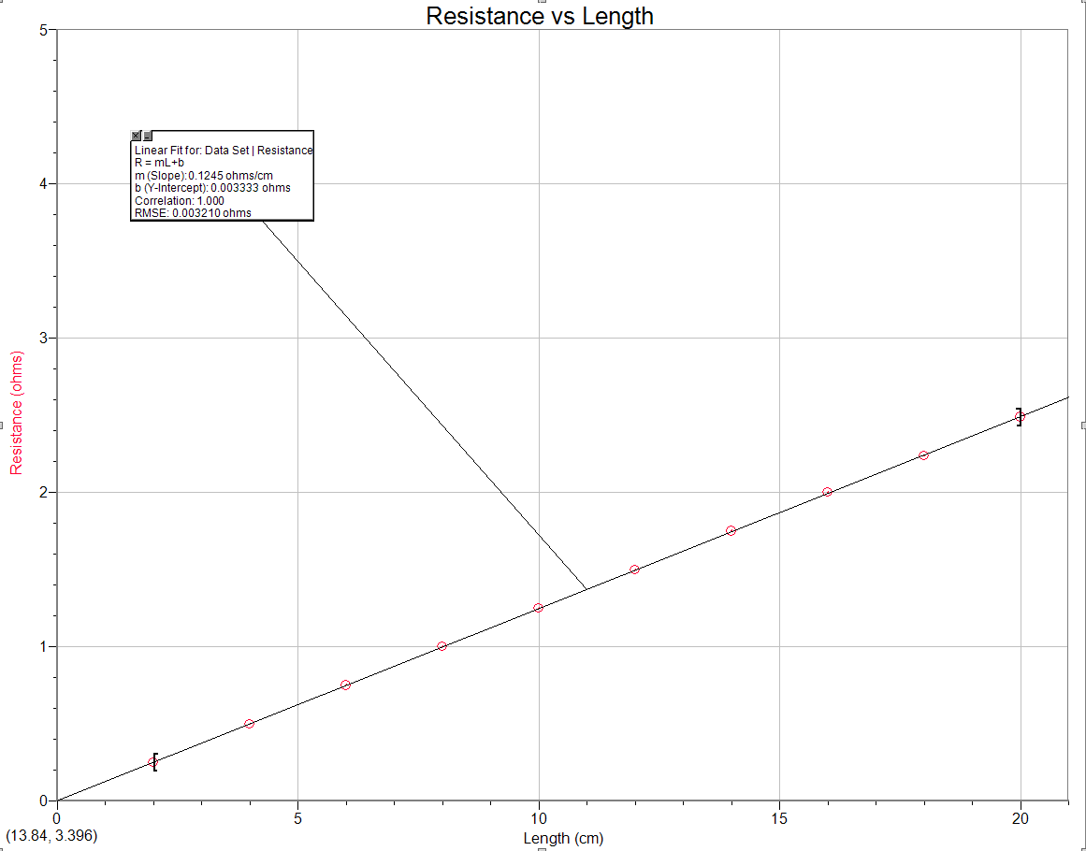

Record the slope of the graph below data table 1. Calculate the Resistivity of the wire by taking the slope of the graph times the area of the wire. Compare the slope times area value with the value of the resistivity set in the simulation by calculating a % error.

4. Return to the PhET simulation and move the ρ slider to 0.25 Ωcm, leaving the A slider in its default position. Use the L slider to adjust the length of the wire to the values in data table 2, also recording the resulting wire resistances R. Capture a screen of the simulation for L = 10 cm using the “PrtSc” key on your computer keyboard and paste this below.

Simulation Screen Capture,ρ = 0.25 Ω cm, L = 10 cm

Data Table 2:

Wire Resistivity ρ = Click here to enter resistivity Ωcm

Wire Area A = Click here to enter Area cm²

L (cm) | R | L (cm) | R
2.0 |  | 12.0
4.0 |  | 14.0
6.0 |  | 16.0
8.0 |  | 18.0
10.0 |  | 20.0

Slope of graph of R vs L = Click here to enter slope Ω/cm.

Slope times Area = Click here to enter slope time area Ωcm

% Error of Slope times Area with ρ = Click here to enter Percent Error %

5. Minimize your Internet Browser and Switch back to Logger Pro. Enter your data from Table 2 under Data Set 2. Perform a “linear fit” on the data. Record the slope of the graph below data table 2. Calculate the Resistivity of the wire by taking the slope of the graph times the area of the wire. Compare the slope times area value with the value of the resistivity set in the simulation by calculating a % error.

6. Repeat Steps (4.) and (5.) with the resistivity slider set to 1.0 Ωcm, recording the results in Table 3 and Data Set 3. Capture a screen of the simulation for L = 2 cm using the “PrtSc” key on your computer keyboard and paste this on the next page.

Simulation Screen Capture,ρ = 1.0 Ω cm, L = 2 cm

Data Table 3:

Wire Resistivity ρ = Click here to enter resistivity Ωcm

Wire Area A = Click here to enter Area cm²

L (cm) | R | L (cm) | R
2.0 |  | 12.0
4.0 |  | 14.0
6.0 |  | 16.0
8.0 |  | 18.0
10.0 |  | 20.0

Slope of graph of R vs L = Click here to enter slope Ω/cm.

Slope times Area = Click here to enter slope time area Ωcm

% Error of Slope times Area with ρ = Click here to enter Percent Error %

Paste the resulting graph with all three data sets and fits showing:

Does a linear Function work well with all three data sets of R vs L data?
Click here to enter answer.

7. Switch back to the PhET simulation. Return the Resistivity Slider to 0.5 Ωcm and the Length slider to 10 cm. Now we will use the A slider to vary the Area of the wire. Fill in table 4 with your data:

Capture a screen of the simulation for A = 10 cm² using the “PrtSc” key on your computer keyboard and paste this on the next page.

Simulation Screen Capture,ρ = 0.5 Ω cm, L = 10 cm, A = 10 cm²

Data Table 4:

Wire Resistivity ρ = Click here to enter resistivity Ωcm

Wire Length L = Click here to enter length cm

A (cm²) | R | A (cm²) | R
1.0 |  | 6.0
2.0 |  | 7.0
3.0 |  | 8.0
4.0 |  | 9.0
5.0 |  | 10.0

Fit Constant of graph of R vs A = Click here to enter constant Ωcm².
Fit Constant divided by wire length = Click here to enter constant/length Ωcm
% Error of Fit Constant divided by wire length with ρ
= Click here to enter Percent Error %

8. Switch to Logger Pro. Go to page 2 on the Logger Pro display. Enter your Resistance and Area values from Table 4 in Data Set 4.

9. Using Curve Fit, try fitting this data to an “Inverse” function. Paste this graph with the fit showing.

Calculate the Resistivity of the wire by taking the Inverse fit constant divided by the length of the wire. Compare this computed value with the value of the resistivity set in the simulation by calculating a % error.

Does an inverse function provide a good fit to your data? Click here to answer.

11. Do the experimental data confirm that the resistance of a conductor is (a) directly proportional to its length and (b) inversely proportional to its cross-sectional area? Which graphs support your answers?

Click here to enter answers.

Conclusion

After group discussion, write a one paragraph conclusion which summarizes the results of this experiment.

Click here to enter conclusion.

