Name: _______________________________ Section: ______________ Date: ______________
Plate Tectonics
Learning Objectives:
- Describe the differences between oceanic and continental crust, including their respective properties of density, composition, temperature and thickness.
- Predict how changes in composition and temperature change crust density and buoyancy.
- Predict tectonic movement based upon compositional and physical characteristics of each plate.
Part 1: Describing differences between oceanic and continental plates
- Open the Plate Tectonics simulation by clicking on the icon on your desktop.
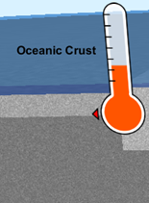
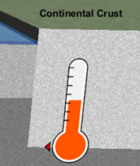
- Play with the sim (both tabs) for 5 minutes. Move all dials and buttons!
Crust Tab
- Describe the differences in the temperatures in the two pictures.
- What do you think causes the difference in temperature between the 2 types of crust?

- List all the ways you can change oceanic crust into continental crust using the sliders.

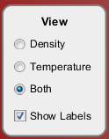
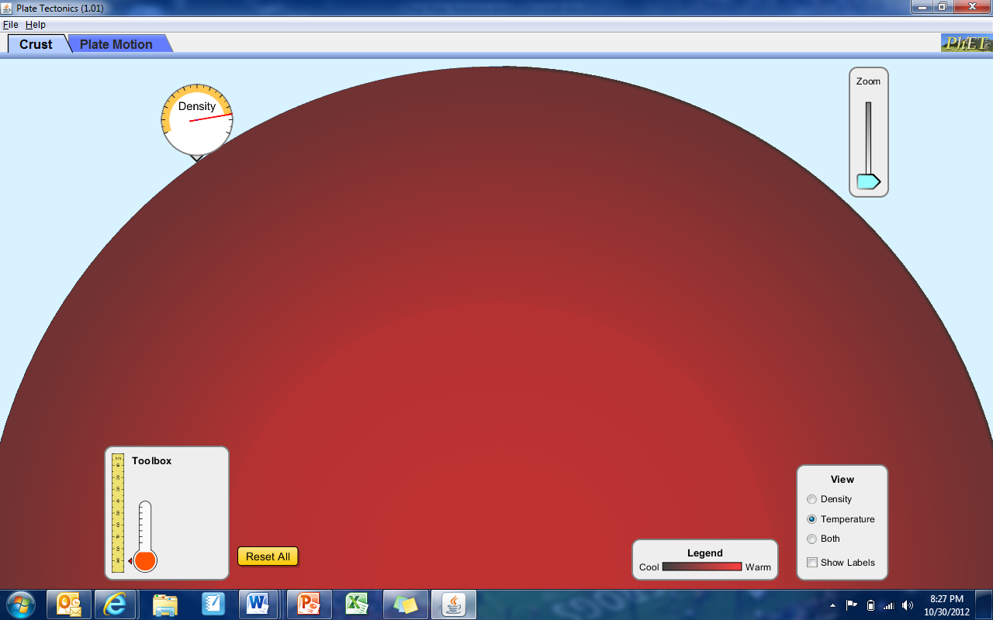
d. Zoom all the way out like this… and make your View Box look like this.
Name of Layer | How does this layer’s density compare to the picture? | Why?
- Greater Than
- Less Than
- Equal to
- Greater Than
- Less Than
- Equal to
- Greater Than
- Less Than
- Equal to
Now switch to the “Plate Motion” Tab. Always view “Both”, “Show Labels”, and “Show Seawater” (when possible).
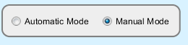Click on “Manual Mode”. Complete the table below using only Manual Mode.
*Note: To see the same action happen again click “Rewind” to change the plates completely click “New Crust”.

Example 1: Drag 1 oceanic crust (either young or old) & 1 continental crust onto the screen. Drag the plate in the direction of the GREEN arrow.
Draw it! | Type of Boundary?  - Convergent  - Divergent  - Transform |  | What is the effect/outcome of this plate movement?
Follow Up Question: What causes the oceanic crust to subduct, or go under the continental crust?

Example 2: Drag 2 old oceanic crusts onto the screen. Drag the plate in the direction of the RED arrow.
Draw it! | Type of Boundary?  - Convergent  - Divergent  - Transform |  | What is the effect/outcome of this plate movement?
Follow Up Question: Where does the “New Crust” come from? Where does the “old crust” go?

Example 3: Drag an oceanic (either young or old) crust and continental crust onto the screen. Drag the plate in the direction of the GREEN arrow.
Draw it! |  | Type of Boundary  - Convergent  - Divergent  - Transform |  | What is the effect/outcome of this plate movement?
Follow Up Question: Why do you think you aren’t able to make a divergent oceanic/continental boundary?

- Click “Automatic Mode”. Create as many plate boundaries and timelines as you wish!
Record any interesting observations here:

