Forces Virtual Lab:
Go to http://phet.colorado.edu/en/simulation/ramp-forces-and-motion
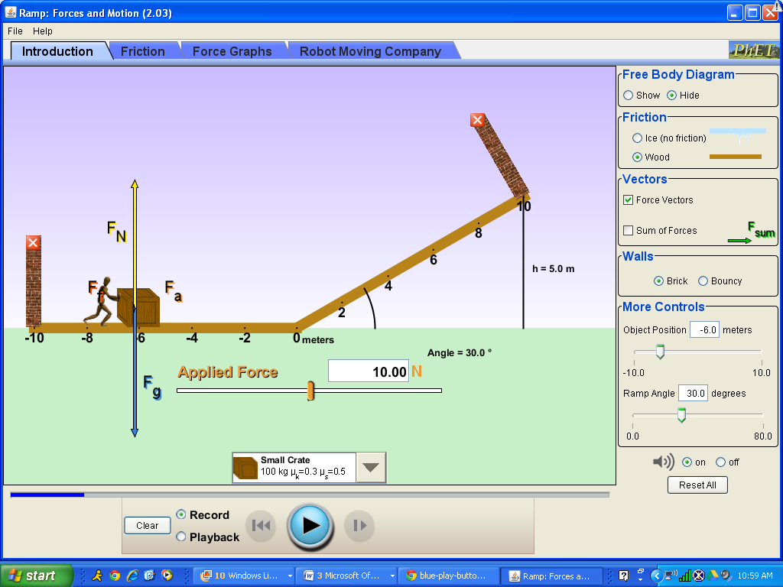

You will be starting with a crate that has a mass of 100 kg and a coefficient of sliding friction of 0.3 and a coefficient of static friction of 0.5

1. Draw the Free Body Diagram (a picture showing the forces on the crate) before you apply any force.

2. Add 10 N of applied force, and push the  button and record what happens. Include a free body diagram showing all the forces.

3. Add 100 N of applied force and push the button. What changed?

4. Use the friction equation to calculate how much force would be required to get it moving. Show your work here….. Try it out. What happened? How did you fix the problem to get it moving?

5. What happened as the crate moved up the ramp? Show the free body diagram while the crate is on the ramp. What force is working against your applied force?

6. Reset all. Predict what you think would happen if you increased the angle. What actually happened? Explain why you saw what you saw.

7. Reset all. Predict what you think would happen if you decreased the angle. Try it out. Why?

8. Place the crate on the ramp with the angle at 20º. What is true about the parallel force and the friction force if the crate does not go down the ramp? Slowly increase the angle until the block JUST starts to move. Use the angle to calculate μ_{s} and compare to the given value for μ_{s} for the crate.

9. Calculate how much force you would have to apply to the crate to get it to go at constant speed up the 30º ramp. Show your work below and record your answer to the tenth of a Newton (Hint: Remember it’s moving now, so which μ do you need to use?)

10. Go to the “Forces Graph” tab. Reset all. Input your applied force and push play. Stop the crate before it crashes into the wall. Is your net force = 0 (F_{sum} )? What does that tell you about the motion of the crate?

11. Place the block at the top of the 30º ramp (Position = 8.9 m). What is the net force on the block down the ramp? (Show your calculation below). What is the acceleration of the block down the ramp? (Include in your calculation). What would be the final velocity of the block at the bottom of the ramp?

12. What force is acting on the crate once it hits the flat part at the bottom of the ramp? What is the magnitude and direction of that force?

13. What will be the acceleration of the crate on the flat part at the bottom of the ramp?

14. Calculate how far the crate should slide at the bottom. Try it out. How did your calculation compare to the applet result?

Turn in this page only: Name _____________________ Block _____

15. Change your object to the “Mystery Object” and reduce your angle. Using what you learned above, calculate the mass, μ_{s} and μ_{k} for the Mystery Object. Show all your measurements and your work. Be careful to state whether your measurement is on the ramp or on the flat part. (Hint: Start by finding μ_{s} first with the ramp raising). You may need to reset all occasionally.

Flat Part Calculations/Measurements Ramp Calculations/Measurements

