
UTeach Outreach The University of Texas at Austin

Natural Selection (PhET Simulation)

Lesson created by: UTeach Outreach
Date of Lesson: Spring 2012
Description of class: 7th grade
Length of lesson: 50 minutes
Resources used: http://evolution.berkeley.edu/evolibrary/article/evo_25
http://www.fossilmuseum.net/Evolution/DarwinsFinches.htm
http://people.rit.edu/rhrsbi/GalapagosPages/DarwinFinch.html#anchor725315
http://archives.focus.hms.harvard.edu/2006/090106/genetics.shtml
http://www.truthinscience.org.uk/tis2/index.php/component/content/article/127.html
http://www.news.harvard.edu/gazette/2006/08.24/31-finches.html

PhET simulation on natural selection – from the University of Colorado at Boulder
http://phet.colorado.edu/en/simulation/natural-selection
http://encyclopedia.kids.net.au/page/na/Natural_selection
http://www.utm.edu/departments/cece/ecology/I2.shtml
http://magma.nationalgeographic.com/ngexplorer/0211/articles/mainarticle.html
http://kids.discovery.com/tell-me/animals/mammals/why-do-squirrels-have-bushy-tails
TEKS addressed:
§112.19. Science, Grade 6, Beginning with School Year 2010-2011.
(2) Scientific investigation and reasoning. The student uses scientific inquiry methods during laboratory and field investigations. The student is expected to:
(E) analyze data to formulate reasonable explanations, communicate valid conclusions supported by the data, and predict trends.
(3) Scientific investigation and reasoning. The student uses critical thinking, scientific reasoning, and problem solving to make informed decisions and knows the contributions of relevant scientists. The student is expected to:
(B) use models to represent aspects of the natural world such as a model of Earth's layers;
(C) identify advantages and limitations of models such as size, scale, properties, and materials;
(12) Organisms and environments. The student knows all organisms are classified into Domains and Kingdoms. Organisms within these taxonomic groups share similar characteristics which allow them to interact with the living and nonliving parts of their ecosystem. The student is expected to:
(E) describe biotic and abiotic parts of an ecosystem in which organisms interact; and
§112.19. Science, Grade 7, Beginning with School Year 2010-2011.
(2) Scientific investigation and reasoning. The student uses scientific inquiry methods during laboratory and field investigations. The student is expected to:
(E) analyze data to formulate reasonable explanations, communicate valid conclusions supported by the data, and predict trends.
(3) Scientific investigation and reasoning. The student uses critical thinking, scientific reasoning, and problem solving to make informed decisions and knows the contributions of relevant scientists. The student is expected to:
(B) use models to represent aspects of the natural world such as human body systems and plant and animal cells;
(C) identify advantages and limitations of models such as size, scale, properties, and materials;
(11) Organisms and environments. The student knows that populations and species demonstrate variation and inherit many of their unique traits through gradual processes over many generations. The student is expected to:
(B) explain variation within a population or species by comparing external features, behaviors, or physiology of organisms that enhance their survival such as migration, hibernation, or storage of food in a bulb; and
(C) identify some changes in genetic traits that have occurred over several generations through natural selection and selective breeding such as the Galapagos Medium Ground Finch (Geospiza fortis) or domestic animals.

NSES (1996) Grades 5-8 – Content Standard A
- Use appropriate tools and techniques to gather, analyze, and interpret data.
- Develop descriptions, explanations, predictions, and models using evidence.

NSES (1996) Grades 5-8 – Content Standard C
- An organism's behavior evolves through adaptation to its environment. How a species moves, obtains food, reproduces, and responds to danger are based in the species' evolutionary history.
- The number of organisms an ecosystem can support depends on the resources available and abiotic factors, such as quantity of light and water, range of temperatures, and soil composition. Given adequate biotic and abiotic resources and no disease or predators, populations (including humans) increase at rapid rates. Lack of resources and other factors, such as predation and climate, limit the growth of populations in specific niches in the ecosystem.
- Biological evolution accounts for the diversity of species developed through gradual processes over many generations. Species acquire many of their unique characteristics through biological adaptation, which involves the selection of naturally occurring variations in populations. Biological adaptations include changes in structures, behaviors, or physiology that enhance survival and reproductive success in a particular environment.

Assumptions
- Students have a basic understanding of traits, adaptations and mutations.
- Students can distinguish between the terms population, species, individual and generation.

I. Overview
The basics of natural selection will be highlighted using the Natural Selection PhET simulation where students complete a series of challenges. As a result of this experience, students will be able to explain how mutations, limiting factors, abiotic and biotic parts of ecosystem interact and contribute to the survival of a species. Students will come to understand how this simulation mimics natural selection through using and exploring the simulation. By considering real events in an ecosystem, students will understand limitations of the model and modifications that can be made to the simulation to more closely demonstrate real life. Students will also evaluate the process of adaptive radiation, as applied to the finches of the Galapagos Islands.

II. Objectives
Students will be able to
- Understand how adaptations help organisms survive by interpreting line graphs of the population of a species over time.
- Develop conceptual understanding of natural selection by exploring how limiting factors, abiotic and biotic parts of an ecosystem and mutations interact and contribute to the survival of a species.
- Define positive, negative and neutral mutations and give examples.
- Assess the usefulness of models in scientific investigations.
- Propose modifications to a model by considering how it mimics a real world event.

III. Resources, materials, and supplies
Per pair
- One computer

IV. Advanced Preparation
Students will be using computers to run the PhET simulation. Java must be installed on all computers prior to running the simulation. If students have access to the Internet, the link should be written on the board for the students to enter in the address bar. Students should click “Run Now!” to begin the simulation.

Teachers also have the option of downloading the simulation prior to the lesson and loading the simulation onto the students’ computers using a flash drive, eliminating a need for Internet access by the students.

Link: http://phet.colorado.edu/en/simulation/natural-selection

V. Supplementary worksheets, materials, and handouts
- Pictures of camouflaged animals for Engage
- Simulation Student Worksheet
- Vocabulary Sheet
- Galapagos Island and Finches Diagrams
- Show What You Know Student Evaluation

VI. Background Information

College Level

Natural selection is a concept that was proposed by Charles Darwin in the late 19th century. Natural selection is a mechanism of evolution carried out over time. Although the idea existed long before Darwin, he was the first to popularize the term and make it an acceptable idea for the scientific community and the general public.

The basic concept of natural selection is that nature selects for the best adaptations within a population in order to survive and reproduce. Environmental conditions play a vital role in natural selection because they are what determine an organism’s survival. Therefore, another definition could be, “Environmental conditions determine how well particular traits of organisms can serve the survival and reproduction of an organism.” Darwin also realized that Lamarck’s idea that the environment altered an individual’s shape and then those changes were inherited was incorrect. Lamarck was a botanist who studied evolution in the 18th century before Darwin. He had opposing ideas that animals were able to choose their evolutionary fate. For example, Lamarck believed that giraffe’s necks became longer because they stretched them over successive generations. In reality, environmental factors select for variations of traits that already exists, it does not produce these variations.

Darwin also coined the term “survival of the fittest” after further research had been done on natural selection. The term is often misunderstood by many people who assume that “fittest” is synonymous with the adjectives strongest, fastest, or smartest but this is not always the case. Evolutionary terms classify fittest as the one with the combination of traits that can survive and produce more offspring that in turn survive to reproduce. Technically, the fittest organism could be weak, slow, and unintelligent. Fitness all depends on the environment at that current time and the traits that are more likely to flourish.

Selective breeding is the breeding of plants and animals for particular genetic traits done by humans. The most common types of selective breeding are done with domesticated species by a professional breeder. Once animals and plants are bred, they are called breeds and varieties or cultigens, respectively. Crossing two different breeds or varieties are called a crossbreed or hybrid. Selective breeding is also known as artificial selection and it is an indication of the benefits humans gain from understanding evolution.

Ecological selection occurs when survival is determined more by ecology then sexual reproduction. Sexual selection occurs when survival is determined more by sexual characteristics than ecology. Natural selection encompasses both types and does not distinguish between the two because it is only concerned with traits that give the individual reproductive advantages. When a particular variation makes an organism more “fit” then that organism’s offspring and its descendants are more likely to survive than organisms without the variation. The initial traits start to vanish as the more successful relatives replace the offspring with those traits.

Abiotic and biotic factors play an important role in deciding if a trait will succeed in its environment or not. Abiotic factors are comprised of the nonliving components in an environment and biotic factors include the living organisms. Species can become segregated by certain geographical barriers which can cause trait development along different paths because they face different environments. The extent of this trait development along different paths can eventually cause the two species to lose their ability to interbreed. Due to this fact, Darwin suggested that all species today have evolved from a common ancestor, which is also known as descent with modification.

In addition, scientists have theorized that organism with adaptations that aren’t advantageous will still replace their competitors because the adaptation could be useful in the future. In the event of an environmental catastrophe, these organisms will be more varied and have a better chance of survival. This theory has been proposed as a reason for the rise of mammals.

Natural selection can be expressed as the following general law (taken from the conclusion of The Origin of Species):
- IF there are organisms that reproduce, and
- IF offspring inherit traits from their progenitor(s), and
- IF there is variability of traits, and
- IF the environment cannot support all members of a growing population,
- THEN those members of the population with less-adaptive traits (determined by the environment) will die out, and
- THEN those members with more-adaptive traits (determined by the environment) will thrive
The result is the evolution of species.

Natural selection cannot exist without genetic variation which is the concept that some individuals must be genetically different from others. There are three main sources of genetic variation which are mutations, gene flow, and sexual reproduction or genetic shuffling. A mutation is a random change in an organism’s DNA. Mutations can be positive, neutral, or negative to an organism. The cause of a mutation is unrelated to how useful it will be to an organism, hence why it is random. There are lots of places that mutations can occur but the only ones that are relevant to natural selection are in the germ line or reproductive cells. Gene flow is the movement of genes from one population to another and it can also be called migration. It has the biggest effects on evolutionary processes when genes are carried to a population that previously did not exist there. Gene shuffling can introduce new gene combinations in populations with every new generation. Like mutations, sexual reproduction can have good, bad, or neutral effects on an organism.

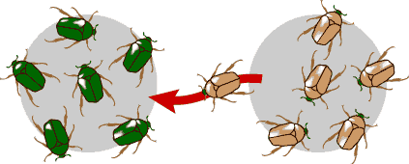
The brown beetle is migrating to a population where the gene for brown color did not previously exist. This is an example of gene flow.
http://evolution.berkeley.edu/evolibrary/article/0_0_0/evo_21

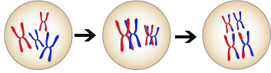
Genetic shuffling is a source of variation.
Example of gene shuffling.
http://evolution.berkeley.edu/evolibrary/article/0_0_0/evo_17

Darwin’s Finches
Darwin completed his research in the Galapagos Islands for his book The Origin of Species in the 1830’s and found a tremendous amount of information that illustrated his theories. The main theory that ‘Darwin’s Finches’ illustrated was adaptive radiation, which is that species from a common ancestor can successfully adapt to their environments through the process natural selection. All of the finches share similar coloration, habits and size but the trait that differed and caused Darwin to study them is the size and shape of their beaks. There are 13 different species of Darwin’s finches that are recognized on the Galapagos Islands, 14 if you count the one species found on Cocos Island. In short, beaks changed because the finches developed different tastes for fruits, insects or seeds when resources on the island were squeezed by interspecific competition. Therefore, the finches had to find new ecological niches that made them less susceptible to competition. Eventually, the birds evolved into separate species each with their own food preference, beaks, and habitats. The finches also represent another concept proposed by Darwin called allopatric speciation. This is the splitting of a population into two separate species that then undergo different natural selection pressures, i.e. evolution.

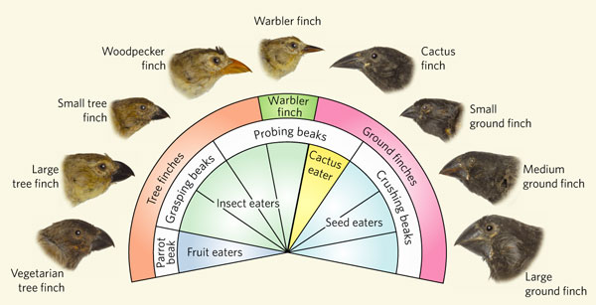
The picture shows how Darwin’s Finches differentiated due to the type of food they ate.
http://www.pbs.org/wgbh/evolution/library/01/6/image_pop/l_016_02.html

Peppered Moths
Peppered moths are a prime example of evolution at work. The typical peppered moth is white with black speckles on it and the rare form of the peppered moth is black with white speckles on it. The peppered moth resides on the underside of lichen covered branches where the typical form of the moth is camouflaged and the rare form stands out. In the 19th century, Britain became polluted with soot from the Industrial Revolution that killed lichen and blackened the bark on trees making the rare black form of the moths better camouflaged. Birds started eating more of the white moths and eventually the black moths became more common. However, after pollution acts were passes and the lichen grew back, the white moths became common again. Natural selection picked against the moths that could not camouflage themselves due to changes in the environment and caused evolution. Further studies on the peppered moth have shown that the story is oversimplified and that the evolution is only a small scale change. However, it is still a good model for basic comprehension of the concept.

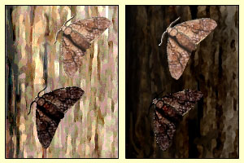
http://www.truthinscience.org.uk/tis2/index.php/component/content/article/127.html
The two variations of peppered moths on tree bark before and after the Industrial Revolution.
Today, genetics have been integrated into Darwinian observations to prove that natural selection is the mechanism of evolutionary change. For example, researchers at Harvard Medical School have proved that a protein called calmodulin is a regulator of the genes that shape the beaks in finches. The new approach allows us to evaluate natural selection as the differential survival and reproduction of genotypes, corresponding to particular phenotypes.

Middle School Level

The process of natural selection has to do with traits, random mutation, limiting factors, and populations. A characteristic that an organism has is referred to as a trait, i.e. a bunny having a long tail or short tail. Variations of traits in animals or plants arise from mutations, which cannot be controlled by that organism. Random mutations are spontaneous changes within an organism’s DNA. The environment determines if certain traits will help an organism adapt. Adaptations that help an organism to better survive and reproduce are called positive mutations. Certain traits that decrease or diminish an organism’s survival or reproduction are called negative mutations. Neutral mutations are traits that have neither a positive or negative effect on an organism’s adaptability. Limiting factors prevent a population from growing any larger due to the fact that death occurs in organisms before they are able to reproduce. A population is defined as all of the same species in a specific environment.

Concept of natural selection:

The natural environment affects the certain traits that help an organism survive. The organism with the best traits for survival is selected for, so we call this process “selection” or “survival of the fittest.” The organism with the “fittest” traits for its environment will not be selected against, and will then have a higher chance of passing on those traits. One example would be a bunny with a random genetic mutation that ends up with longer teeth. If having longer teeth helped the bunny to find food more easily, or if it could eat more types of food than the other bunnies, than this bunny would have a higher chance of survival because it has more food options. All the other bunnies with short teeth would not be able to eat things that require long teeth. The bunnies with short teeth would then have a harder time surviving because they have less food options. What if that type of food runs out? What will the bunnies with short teeth eat? The bunnies with the adaptation of longer teeth have an advantage of surviving over the bunnies with shorter teeth. In this example, food is the limiting factor. Over time, with changes in the environment, either both bunnies will survive and eventually create new species, or one type of bunny will undergo natural selection and no longer be able to survive without the best adaptation. In contrast, other bunnies with short teeth would have a harder time getting food; this would lead them to slowly die out. Then, over a long period of time, within a same or similar environment, through successive generations of reproduction and passing on long teeth trait to offspring, the longer-toothed bunnies would thrive. This results in an evolution of bunny from short teeth to longer teeth.

Different factors in an environment work together with each other in various ways. These different factors consist of biotic factors or living components and abiotic factors, or nonliving things. For example, a biotic factor in the previous bunny scenario would be the food.

Natural selection and evolution
Scientists have found evidence that trace the simplest living creatures on earth back to 400 million years ago. Today, we have many different varieties of complex organism that are both single cellular and multicellular. The mystery behind these transformations has puzzled scientist and researchers for centuries.

In the 19th century, a great naturalist named Charles Darwin made great discoveries through his detailed field observations with finches in the Galapagos Islands. Darwin’s findings convinced him that species gradually changed after each generation, in other words they evolved. The idea of evolution had been around long before Darwin but he was the first to find enough evidence able to prove the idea. Fossils also provided another key to evolution by showing relationships between prehistoric animals and today’s animals. Other fossil records made it possible to show how an individual organism could evolve into another and then be linked to today’s organisms. After proving that evolution was possible, the question of how it happened still remained. Darwin used a mix of his own ideas and others to propose that evolution took place by 'natural selection'. Therefore, it is important to understand that natural selection is a process that leads to evolution.
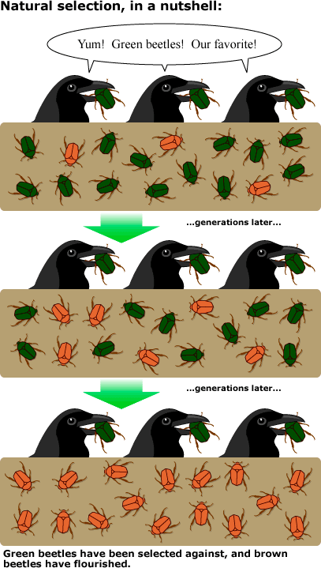
http://evolution.berkeley.edu/evolibrary/article/bergstrom_02

Steps of Natural Selection
- There are always pre-existing varieties (differences) within a species.
- Some varieties have traits that make them better able to survive and reproduce (adaptation)
- These individuals are likely to live longer , produce more, and pass their traits on to their offspring
- Since these individuals can produce more there will be more offspring with these traits in the population
- After several generations, individuals with the favorable character will become more common
- New varieties and species can evolve over king periods of time.
- If environmental conditions change then different characteristics may become favored, starting the process over again.

Below is a picture that summarizes the key terms relating to natural selection.
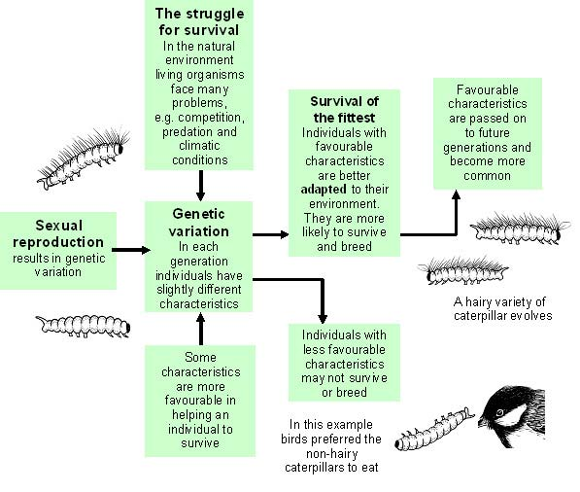
http://www.field-studies-council.org/urbaneco/urbaneco/introduction/evolution.htm

VII. Possible Misconceptions
- Adaptations occur at the individual level of an organism.
  - Adaptations describe the ability of a species to survive in a specific ecological niche. Mutations occur at the individual level, and can eventually lead to adaptations of the species. Adaptations occur at the population level, not the individual level. An example of an adaptation might be the specific size of a bird’s beak so it can better eat seeds from a thorny plant.
- All adaptations occur over a very short period of time.
  - Adaptations take generations to fully come into play. Reproduction is the main idea when it comes to natural selection and evolution. An individual with a newly acquired adaptation must still reproduce and create more offspring with that adaptation. With enough generations, and if the adaptation creates a strong advantage, then eventually the adaptation will be common within a species.
- Organisms choose to adapt. Students might think the organisms are able to choose particular physical outlook or ability.
  - The physical traits (phenotypes) of an individual are the products of genes being expressed. Every trait of the organism comes from its genes, and nothing changes until the genes do. Organisms cannot simply will themselves to mutate or develop a particular trait.
- Mutations can only be harmful to animals.
  - Most people think of radiation and humans sprouting third arms when they consider mutations, but mutations can be as small as changing one DNA nucleotide. Mutations in this context can be beneficial, and describe an organism that has a different DNA sequence from the majority of its species. Negative mutations often result in an individual dying early on in life, before being able to reproduce. Positive mutations help an organism to better survive and to better reproduce.
- Natural selection always results in the "best" characteristics.
  - Natural selection is an unbiased force in nature. It does not consider beauty or convenience necessarily when selecting the strongest organisms. Natural selection puts pressure on an organism to survive with the traits that it has. If it survives, then those genes are passed on during reproduction. If it doesn’t survive until reproduction, then those genes are not passed on. There is no “best” characteristic because traits that help an organism survive depend on the environment and circumstances the animal faces. If the environment or circumstances were to change, those originally good traits may no longer be favorable.

VIII. Vocabulary & Definitions

College Level
- Adaptation - process in which an animal population becomes better suited to its environment
- Trait - characteristic of an organism
- Inherited trait - characteristic that is passed on from parents to offspring via genes; something an organism is born with
- Mutation - a change to an organism’s DNA
- Limiting Factor – something that controls a process, such as a species reproducing
- Population – the number of all of the organisms that belong to the same species
- Natural Selection – a process in which organisms possessing certain traits that make them better adjusted to an environment tend to survive and reproduce
- Adaptive Radiation – the diversification of a group of organisms into forms filling different ecological niches
- Biotic – a living component of an ecosystem
- Abiotic – a nonliving component of an ecosystem

Middle School Level

Trait (rasgo) – a characteristic

Adaptation (adaptacion) - a process that helps an organism survive in its habitat

Inherited trait (rasgo heredado) - characteristic that is passed down from parent to offspring
- Mutation (mutacion) - a change to an organism’s DNA
- Limiting Factors (factor limitante)- things that prevent a population from growing any larger
- Population (población) – the number of species in a particular environment
- Natural Selection (la selección natural) - the process whereby organisms better adapted to their environment tend to survive and produce more offspring
- Adaptive Radiation (adaptación de radiación) - the diversification of a group of organisms into forms filling different ecosystems
- Biotic (bióticos) – a living component of an ecosystem
- Abiotic (abiótico)– a nonliving component of an ecosystem

IX. Safety Instructions
No immediate safety concerns. However, since students will be running the simulation directly from the internet, be sure that they do not get distracted by visiting other prohibited websites.

X. Question of the Day
How do certain factors influence an organism’s ability to survive in its habitat?

5-E Organization

Engagement |  | Time: 10 minutes
What the Teacher Will Do | Probing Questions | Student Responses  Potential Misconceptions
We are going to begin today’s class by looking at some images of animals. These animals all have one thing in common; they are all experts at hiding!  - Show camouflage slide show (3 images).  #1 Tartan Hawkfish image  I see red coral in this picture. Do you see any animal hiding in this picture?  Call on student volunteer to come up and point out the hidden animal.  See the eye? The Tartan Hawkfish is able to blend in with the coral!  #2 Chameleon image  Call on student volunteer to come up and point out the hidden animal.  The chameleon is famous for changing his appearance to match the surroundings!  - #3 Owl image  Call on student volunteer to come up and point out the hidden animal.  Great job everyone!  - Some animals have special features, which allow them to blend in with their surroundings.  - A good number of animals use camouflage to blend in with their environment. Other animals may not use camouflage, but still have other advantages that help them to survive in their habitat.  Today, we will be continuing our discussion on organisms and how they survive in their habitats by using a computer simulation involving virtual bunny rabbits. At the end of the lesson, you should be able to answer the question of the day we saw yesterday: “How do certain factors influence an organism’s ability to survive in its habitat?”  Post question under doc cam or write on the board. | - What do you notice about this picture?  - Now I see the bird in this picture, but where is the other animal?  - What do you see?  - Why do you think these animals look this way?  - What other animals use camouflage? | - There’s an animal hiding!  - On the branch!  - The owl in the tree!  - Hide from humans, hide from other animals, blend with their surroundings.  - Walking stick. White rabbit in the snow.

EXPLORATION Time: 30-45 minutes
What the Teacher Will Do | Probing Questions | Student Responses
Transition to computer simulation. All student computers should have simulation ready to go. Make sure simulation is projected in front of classroom.  Let’s see how different traits can help an animal survive in an environment.  You will be working with a partner to explore the simulation and complete a set of challenges. One of you will be the driver. The other partner will be the navigator. We will be switching roles throughout the investigation.  The driver will be responsible for the keyboard and mouse. The navigator will offer advice and direction to the driver.  Please work as a team to build your understanding together!  Divide students into pairs. Pass out computers and job cards.  You will be given five minutes to play with the simulation. After five minutes have passed, we will have a group discussion about what functions and controls you have discovered on your screen.  Give students five minutes to explore the simulation. Provide little direction, except to help with computer errors. Note students that discover the following options, as these will be the students you can select to “share out,”:  1. Add a friend function  2. Add Mutation (must be selected AFTER “Add a friend” for the mutation to happen)  3. Selection Factors  4. What the graph represents (axes titles)  5. Environment  6. Time for next generation  7. The “fast forward” control  Now that we have all explored the simulation, I am going to select a few students to “share out” what they have observed.  Select a few students to come to the front of the class to share what they have observed using the simulation, which is projected in front of the class. Focus on the controls of the simulations and not conclusions that can be formed based on these controls.  Now, we are going to complete our investigation for today. You will be given 30-45 minutes to complete your activity sheet. Remember to take turns with your partner with the simulation. Ready to see what happens to your virtual bunnies? You may begin!  Allow students 20-30 minutes to complete their investigations. Remember to give a 5, 10 and 15 minute warning to keep the students on task. Don’t forget to have the students switch roles between driver and navigator!  Possible Probing Questions include: | - What does the driver of a car do?  - Using computers, what do you think the driver will do?  - Where have you heard the word navigate?  - What do you think a navigator will do with our assignment today?  - What are a few differences between the two possible environments?  - Why do you think the wolves eat the white bunnies in the equator environment?  - What does the simulation not consider?  - How would you change the simulation to make it seem like a true ecosystem?  - Based on what you know, how would you explain natural selection?  - How do mutations alter a species?  - How do mutations affect an organism?  - What does the graph show?  - How do animals adapt in different seasons?  - What happens when you add the selection factor of Food, versus having No Factors?  - Why do you think more bunnies die each generation with food, than without food?  - How does the simulation environment differ from a real wilderness environment?  - What parts of the simulation are living?  - What parts of the simulation are not living?  - How do the bunnies in the simulation differ from bunnies in a real wilderness environment?  - How would you summarize what you did to answer challenge one-three?  - What strategies did you use to answer the challenges?  - If you were a scientist, when would a computer simulation be useful?  - Why do you think scientists study adaptations/natural selection/mutations, etc.? | - Use the steering wheel and pedals.  - Control the computer.  - Sailing ships. GPS.  - Show the driver where to go.  - Surroundings, weather, sunlight, etc.  - Because they can see the white bunnies, whereas the brown bunnies blend in with the surroundings.  - Different predators, seasonal changes, different types of food.  - Include some of the limitations of the simulation.  - Natural selection has to do with animals surviving and reproducing. Note: guide the students using the simulation as a tool for developing understanding instead of correcting their responses.  - When you add a mutation, it shows up in the next generation.  - Some mutations help but others can hurt the individual or do nothing.  - The number of bunnies in a population, how many bunnies have each trait.  - Hibernate, shed fur, migrate.  - More bunnies die each generation.  - There is not enough available for all of them; they fight for food.  - Limits predators to only wolves. Doesn’t allow for both food and predators at the same time. Doesn’t have seasons and weather changes.  - The bunnies and their traits. The wolves. The food.  - Climate/sunlight/weather.  - Mutations can’t be chosen/picked. Mutated traits do not appear/occur so quickly.  - Trial and error, thinking about what we have done in science class before.  - Study one mutation at a time, wait lots of generations.  - To study things that are challenging to study in real life, to collect lots of data.  - To get a better understanding of how species evolve, to understand endangered species and resources needed, etc.

EXPLANATION Time: 20 minutes
What the Teacher Will Do | Probing Questions | Student Responses
After 20-30 minutes, call students’ attention back up to front of classroom to go over observations/worksheet answers. If students are using laptops, make sure screens are closed halfway so that students can focus on discussion. If using desktops, ask students to turn their chairs around for this portion of the lesson.  Before we discuss the results from our challenges, let’s go over a few vocabulary words that we can use to describe our experiences. Please fill out the following table, as we discuss the results of our investigations.  Pass out Vocabulary Words Sheet. Use Document Camera to project worksheet in front of class.  These are all examples of characteristics or traits that the bunnies possess. As terms are introduced fill out Vocabulary Words sheet on Document Camera.  Traits can be inherited or passed on from parents to offspring through genes or DNA. The next generation of bunnies inherited brown fur from their parents.  Inherited traits are examples of adaptations. Adaptations can also occur because of mutations to an organism’s DNA. An adaptation is a trait that helps an organism survive. Mutations are any change to an organism’s DNA.  Let’s discuss the different challenges that we just investigated and include the terms that we just reviewed/learned.  The wolves are an example of a limiting factor, as they were responsible for eating the white bunnies. A limiting factor is something that influences whether or not a species is able to reproduce.  Those are all excellent ideas! The bunnies were able to take over because the bunnies blended in with their environment by having brown fur. The wolves ate the white bunnies and this was seen by the white bunnies disappearing (on the graph and on the screen).  Be sure to fill out the “Examples from simulation” column on the Vocabulary Worksheet as examples are discussed.  That’s very interesting! What we discovered was that the teeth only affected how the bunnies ate the food so it didn’t matter what the environment was.  The bunnies blended in with their surroundings so the wolves, predators, did not eat the white bunnies.  There can be positive, negative and neutral mutations.  A positive mutation is when the adaptation produced is advantageous for the population. A negative mutation is when the adaptation produced is disadvantageous for the population.  Give students a few minutes to discuss with their partners. Then, have the students share their ideas.  Biotic factors are living component of an ecosystem.  Abiotic factors are factors which are nonliving.  Give students a few minutes to discuss with their partners. Then, have students share their ideas.  Natural selection is the process whereby organisms better adapted to their environment tend to survive and produce more offspring. We saw this in our investigations with the simulation.  Scientists use computers in a variety of ways. One reason scientists use computers is that computers can provide opportunities that aren’t available in the real world, such as, speeding up time to see what would happen over many generations.  The simulation could be improved by it being able to model some of its limitations. An ecosystem is much more complex than what the simulation shows. | - What could you change about the bunnies?  - What happened to the next generation of bunnies when you selected “brown fur”?  - What does that tell you about traits?  - What is an example of something you inherited from your parents?  - What are some examples of adaptations we seen today in class?  - In the simulation you were able to select mutations, what does that mean you were able to change?  - What happened to the bunnies after we added a friend?  - For challenge one, what did you select for the environment?  - What did you have as the selection factor?  - What happened to the white bunnies? What evidence did you have?  - Why do you think the bunnies were able to take over with this selection factor present, the environment selected as equator and the bunnies having brown fur?  - For challenge two, what mutation did you select?  - How would this mutation help the bunny?  - How does the mutation relate to the selection factor?  - What is another term that we just learned that we could use to describe “food”?  - What environment did you have? Did it matter what environment and fur color you selected?  - For challenge three, when the environment was the artic, how were the bunnies able to take over?  - Why was white fur a better trait to have than brown fur in the artic environment?  - How is this similar to something else we’ve discussed today?  - What do you think would happen, and some of you may have tried this, if there were brown bunnies in the artic and wolves were selected as the selection factor? Why?  - In your challenges what did you notice happened when you selected “long tail” as a mutation?  - What type of mutation do you think “long tail” for the bunnies is? Why?  - What do you think a positive mutation is? Negative?  - Give an example of when brown fur was a positive mutation.  - Give an example of when brown fur was a negative mutation.  - Biology is the study of living things. What do you think biotic factors are?  - What biotic factors were present in our simulation?  - Abiotic factors are the opposite of biotic factors. What do you think abiotic factors are?  - What abiotic factors were present in our simulation?  - The simulation was titled “Natural Selection.” Based on what you were able to do with the simulation, what do you think natural selection is? Turn to your partners and discuss.  - When would it be useful for a scientist to use a computer simulation?  - Based on the limitations of the simulation, how would you change the simulation? | - The color of the fur, if they had a long tail or teeth.  - The next generation of bunnies had brown fur.  - They can be passed down from generations.  - Color of my eyes, how tall I am.  - The camouflage of the animals in the beginning of class, on the simulation the color of fur, long teeth or tail.  - The bunnies’ DNA!  - The bunnies multiplied!  - Equator.  - Wolves.  - The wolves ate the white bunnies, fewer were on the screen (some students may say the graph).  - Because the bunnies blended in with the environment and the wolves didn’t eat them. The wolves ate the white bunnies.  - Long teeth.  - So that the bunnies could eat the food.  - The bunnies eat the food.  - Limiting factor!  - Equator or Artic. No, it did not matter because either way the bunnies with longer teeth were able to eat the food regardless of what color or environment they were.  - If the wolves were the selection factor.  - The bunnies were able to blend into the surroundings and not be eaten by the wolves.  - The camouflaged animals!  - The wolves would eat all the brown bunnies.  - Nothing.  - Neutral, because it didn’t change anything.  - Positive is when something good happens. Negative is when the opposite happens.  - When the environment was the equator and wolves were the selection factor. (Challenge one)  - When the environment was the artic.  - Living!  - The bunnies and their characteristics, the wolves.  - Nonliving things.  - The sun, climate, etc.  - Natural selection has to do with traits, populations, and selection factors.  - When scientists are trying to see what would happen in a population without actually studying the population.  - Have it incorporate the factors that were not present: weather, different predators, different types of food, etc.

ELABORATE Time: 30 minutes
What the Teacher Will Do | Probing Questions | Student Responses
Show the picture of the Galapagos islands on the doc projector.  In the early 1800s, Charles Darwin, a scientist from England, went on a five year voyage to survey and map coastlines around the world. On his journey, he kept detailed notes of his observations. One area that he was interested in was the Galapagos Islands. Here you can see a collection of the finches he was able to observe.  Show the students the finches on the doc projector and ask these Probing Questions:  All of these birds descended from one ancestral seed eating ground finch. With your groups, come up with a series of steps in which this could have happened. Write these steps on your butcher paper and be ready to share in 10 minutes.  Have students share their ideas, correcting them when necessary and asking students to correct their own ideas.  All of you have just described how Adaptive Radiation happens. Please write this on the top of your butcher paper. Adaptive Radiation explains the diversification of a group of organisms into forms filling different ecological niches. Remember a niche is a particular role an organism plays in its habitat. | - Describe the types of variation you see in the illustrations of Darwin's finches.  - Why do you think each species' variation makes it well adapted to its habitat?  - What features make the species' variation well adapted for its food supply?  - If a bird has a stronger beak, what would that help it do?  - What are some other examples of adaptive radiation? | - Each bird has a different shaped beak.  - Birds with beaks that are adapted to eat insects live on an island with an abundance of insects.  - Birds that had stronger beaks were able to better crush seeds and survive on islands with an abundance of seeds.  - Birds that had stronger beaks would be able to better crush seeds and survive on islands with an abundance of seeds (Ex. Large Ground Finch)  - Human skin color, bears, Hawaiian insects

EVALUATE Time: 10 minutes
What the Teacher Will Do | Probing Questions | Student Responses
We’ve learned so much today and everyone did such a fantastic job of analyzing the data from our computer simulation. We also learned new vocabulary like trait, adaptation, and mutation.

Now it’s time for you to show me what you know! Pass out student evaluation.

Pictures for Engage
Picture 1:
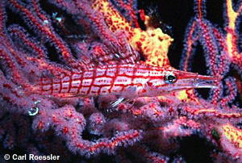

http://science.howstuffworks.com/environmental/life/zoology/all-about-animals/animal-camouflage1.htm

Picture 2:
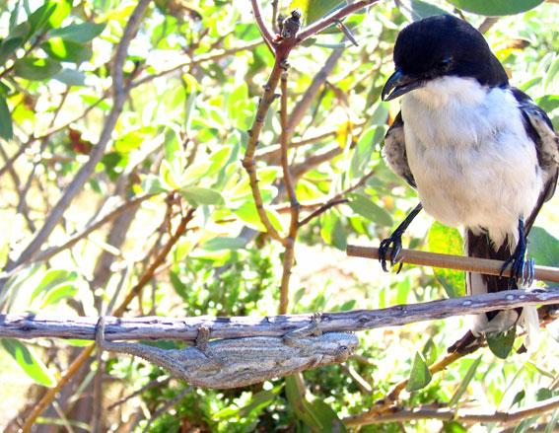

http://www.newscientist.com/article/dn13944-chameleons-finetune-camouflage-to-predators-vision.html

Picture 3:

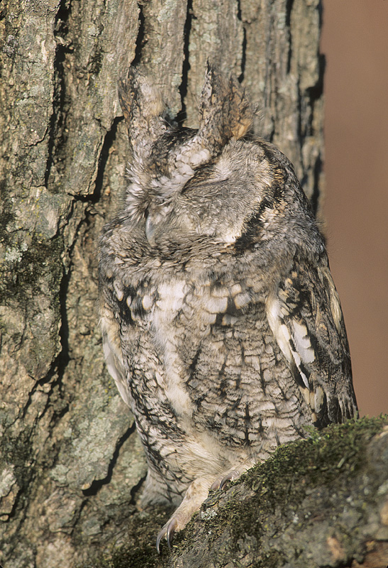
http://www.stevegettle.com/pages/2008/10/08/

Question of the Day:

How do certain factors influence an organism’s ability to survive in its habitat?

Name: ____________________

Natural Selection PhET Simulation

1) Play with the simulation for five minutes. Be prepared to share what you have found!

2) Fill in the table below with your observations.

How can you… | What did you change? | How many generations did it take?
…make more white bunnies?
…make 20 brown bunnies?

3) Challenge 1: Find a way to make the bunnies take over with brown fur! Fill in the table with your selections.

Mutation | Environment | Selection Factor | Observations


4) Challenge 2: Find a way to make 200 bunnies when food is a selection factor! Fill in the table with your selections.

Mutation | Environment | Selection Factor | Observations

5) Challenge 3: Find a way for the bunnies to take over when the environment is the artic! Fill in the table with your selections.

Mutation | Environment | Selection Factor | Observations
 | 

6) On your own: Simulations are useful for understanding how natural processes work but are not always representative of the real world. How does this simulation differ from what might happen in a true ecosystem?

________________________________________________________________________

________________________________________________________________________

________________________________________________________________________

________________________________________________________________________

________________________________________________________________________

________________________________________________________________________

________________________________________________________________________

7) On your own: What changes would you make the simulation to make it a better representation of a true ecosystem?

________________________________________________________________________

________________________________________________________________________

________________________________________________________________________

________________________________________________________________________

________________________________________________________________________

________________________________________________________________________

Name: ___________________

Vocabulary Words

Word | Definition | Examples from simulation
Trait
Adaptation
Mutation
Limiting Factor
Biotic
Abiotic
Natural Selection

Name: ____________________

Natural Selection PhET Simulation
KEY

1) Play with the simulation for five minutes. Be prepared to share what you have found!

2) Fill in the table below with your observations.

How can you… | What did you change? | How many generations did it take?
…make more white bunnies? | Click “Add a friend” | 1
…make more than 15 brown bunnies? | Click “Add a friend” and wait until second generation, click “Brown Fur” and wait two more generations | 3

3) Challenge 1: Find a way to make the bunnies take over with brown fur! Fill in the table with your selections.

Mutation | Environment | Selection Factor | Observations
 |  |  | The wolves eat all of the white bunnies, but the brown bunnies survive. You have to wait awhile but you can speed it up by pressing the “forwards” button. If the bunnies had a long tail it didn’t make a difference.

4) Challenge 2: Find a way to make 200 bunnies when food is a selection factor! Fill in the table with your selections.

Mutation | Environment | Selection Factor | Observations
 |  |  | The environment did not matter. It takes a few generations to make 200 bunnies. Eventually all the bunnies have long teeth. If the bunnies had a long tail it didn’t make a difference. Teacher Note: the bunnies cannot take over the world in this situation.

5) Challenge 3: Find a way for the bunnies to take over when the environment is the artic! Fill in the table with your selections.

Mutation | Environment | Selection Factor | Observations
None. |  |  | The white bunnies blend in with the snow, and the wolves do not eat them. The bunnies could have a long tail and it wouldn’t matter.

6) On your own: Simulations are useful for understanding how natural processes work but are not always representative of the real world. How does this simulation differ from what might happen in a true ecosystem?

In a true ecosystem, there may be other predators and different types of food. The bunnies would also have to interact with other organisms.

7) On your own: What changes would you make the simulation to make it a better representation of a true ecosystem?

The simulation could include some more controls, such as, adding additional organisms or changing the weather more than artic or equator.

Vocabulary Words
Key
Word | Definition | Examples from simulation
Trait | A characteristic | Fur color, long teeth, long tail
Adaptation | A trait that helps an organism survive | Bunny with brown fur in an equator environment
Mutation | A change to an organism’s DNA | Fur color, long teeth, long tail
Limiting Factor | Things that prevent a population from growing any larger | Food, wolves (predators)
Biotic | A living component of an ecosystem | Bunnies, food, wolves
Abiotic | A nonliving component of an ecosystem | Sunlight, weather
Natural Selection | The process by which organisms better adapted to their environment survive | The whole simulation!

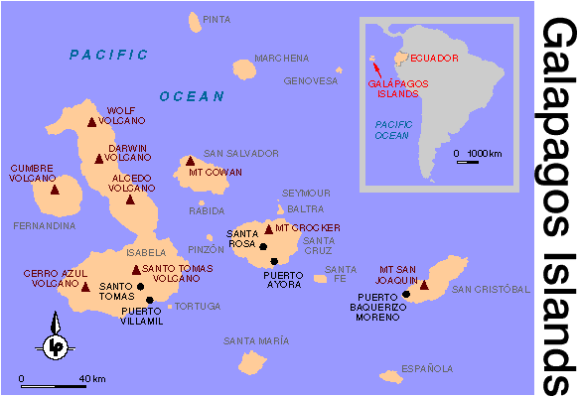

Galapagos Island Finches

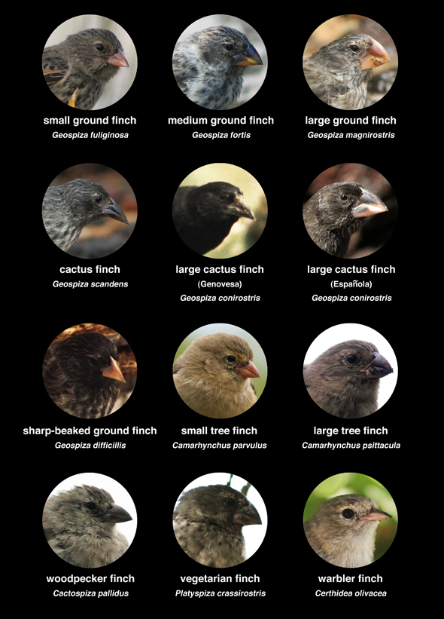

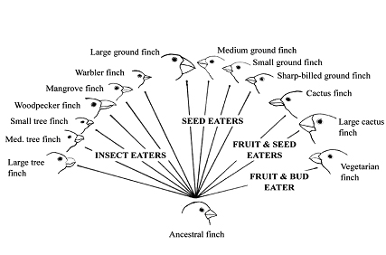

Name:____________________________________ Date:______________________

Show What You Know: Natural Selection

- Use the graph below to answer the following questions:
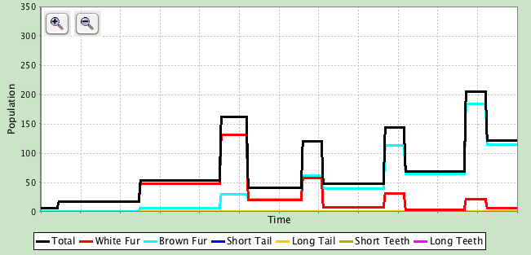
B
E
D
C

A

  - When do we first see more brown rabbits in the population than white ones? Circle the letter for the correct time point.

A B C D E

  - Which time point shows when predators (wolves) were first introduced in to the rabbit’s habitat? Circle the letter for the correct time point.

A B C D E

- Which of the following is an example of a limiting factor in an ecosystem?

  - Food
  - Number of predators
  - Amount of space
  - All of the above

- When the insecticide known as DDT was first introduced, it was highly effective. Which of these is the most likely reason that DDT became less effective as an insecticide?
  - rain caused DDT to be washed away in water runoff
  - insects resistant to DDT survived and reproduced successfully
  - biological magnification decreased the number of insect predators
  - changes in the types of crops grown caused changes in the types of pests

- A pack of wolves that normally live in warm weather experience a climate change that creates a new arctic environment. After many generations, the wolves develop many adaptations including sharper teeth and thicker fur. For surviving the colder climate, what types of mutations are those adaptations?
a. Sharper teeth and thicker fur are both positive mutations
b. Sharper teeth is a neutral mutation and thicker fur is a negative mutation
c. Sharper teeth is a negative mutation and thicker fur is a neutral mutation
d. Sharper teeth is a neutral mutation and thicker fur is a positive mutation

- Describe ways the simulation was limited in Challenge 2 (limited food for bunnies) and what are some modifications that can be made to the simulation so that it more closely resembles real life?

________________________________________________________________________

________________________________________________________________________

________________________________________________________________________

________________________________________________________________________

________________________________________________________________________

________________________________________________________________________

________________________________________________________________________

________________________________________________________________________

________________________________________________________________________

________________________________________________________________________

________________________________________________________________________

________________________________________________________________________

Name:____________________________________ Date:______________________

Show What You Know: Natural Selection
KEY

- Use the graph below to answer the following questions:
B
E
D
C

A

  - When do we first see more brown rabbits in the population than white ones? Circle the letter for the correct time point.

A B C D E

  - Which time point shows when predators (wolves) were first introduced in to the rabbit’s habitat? Circle the letter for the correct time point.

A B C D E

- Which of the following is an example of a limiting factor in an ecosystem?

  - Food
  - Number of predators
  - Amount of space
  - All of the above

- When the insecticide known as DDT was first introduced, it was highly effective. Which of these is the most likely reason that DDT became less effective as an insecticide?
  - rain caused DDT to be washed away in water runoff
  - insects resistant to DDT survived and reproduced successfully
  - biological magnification decreased the number of insect predators
  - changes in the types of crops grown caused changes in the types of pests

- A pack of wolves that normally live in warm weather experience a climate change that creates a new arctic environment. After many generations, the wolves develop many adaptations including sharper teeth and thicker fur. For surviving the colder climate, what types of mutations are those adaptations?
a. Sharper teeth and thicker fur are both positive mutations
b. Sharper teeth is a neutral mutation and thicker fur is a negative mutation
c. Sharper teeth is a negative mutation and thicker fur is a neutral mutation
d. Sharper teeth is a neutral mutation and thicker fur is a positive mutation

- Describe ways the simulation was limited in Challenge 2 (limited food for bunnies) and what are some modifications that can be made to the simulation so that it more closely resembles real life?

Answers will vary ______________________________________________________________________

________________________________________________________________________

________________________________________________________________________

________________________________________________________________________

________________________________________________________________________

________________________________________________________________________

________________________________________________________________________

________________________________________________________________________

________________________________________________________________________

________________________________________________________________________

________________________________________________________________________

________________________________________________________________________

