PHYS 183 Exploring Electric Potential, Electric Field and Distance Relationships
Outcomes:
- Determine the relationship between electric potential and distance for a point charge.
- Determine the relationship between the electric potential and E Field strength in a region.
Procedure: Open Charges and Field simulation http://phet.colorado.edu/en/simulation/charges-and-fields and click Run Now. Once the simulation opens, check the box next to grid and next Show numbers.
Part 1
- First, explore by placing a 1 nC positive point charge in the middle of the screen. Move the voltage probe box (shown to the right) to different locations near the charge. How does the voltage number change? How does the color in the circle with the cross-hairs change?
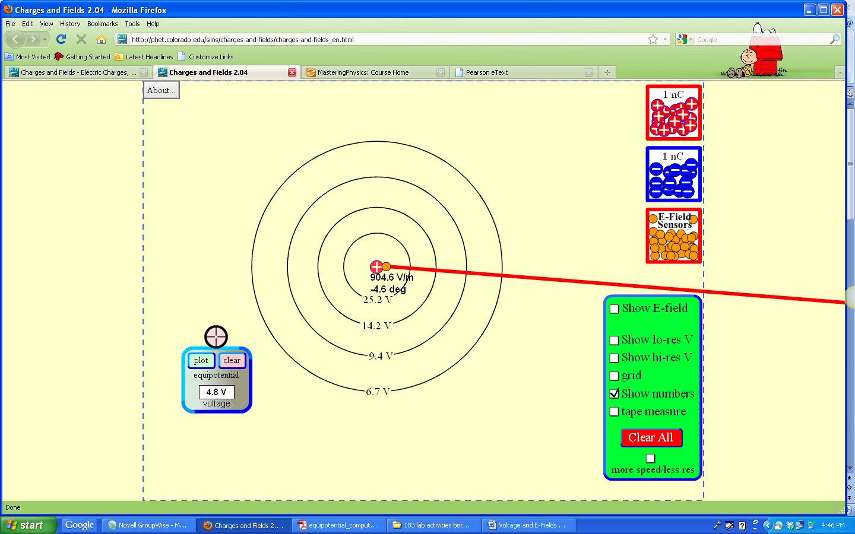

- Replace the positive point charge with a negative point charge. To remove charges, drag them back into their box. How does what the voltage probe box show differ with the negative charge? How is it the same?
Different:
Same:
- Voltage is another word for electric potential. Electric potential is a characteristic of the distribution of source charge, the+/- 1 nC point charge in the examples above. The electric potential expresses the work a source charge distribution does on a point charge as the point charge’s position changes. The electric field expresses the force a source distribution exerts on a point charge and work done is proportional to force exerted. Thus, electric potential is related to electric field.
- Determine the V vs. r relationship for a point charge. This means making a hypothesis, taking data from the simulation, making a graph on Excel (or similar), finding the best-fit relationship.
- (Click on show numbers and tape measure to measure the distances from a field-creating charge to a test charge. The tape measure can be dragged to a specific distance and placed anywhere on the field.)
If
then
A single positive charge
r (m) | Electric Potential (V)
because
Best fit relationship (be specific):
Theoretical support for this relationship (e.g., supporting formulae from the textbook):

How does this relationship compare to the E Field vs. distance relationship?
Part 2
In this part of the activity, you are going to develop a procedure to test the relationship between electric potential and E field strength. In other words, when you make equipotential curves that have an equal ∆V between them, how does their spacing relate to E field?
- First, explore by placing a 1 nC positive point charge in the middle of the screen. Move the voltage probe box to different locations near the charge and click Plot. Note that the electric potential is the same everywhere on each curve but different on different curves depending on how far the curve is from the 1 nC point charge. You can confirm this by moving the cross hairs of the voltage probe box around the curve and reading off the voltage value.
- Next, use charges, the voltage probe box, tape measure, and E field sensors to determine the relationship between the strength of the electric field in a region and the spacing of equipotential curves. For example, for a given ∆V between curves, are the equipotential curves farther apart in a region of a strong E filed compared to a weak one? Closer together? Is equipotential lines configuration independent of E field strength? Write the procedure with enough detail so someone familiar with PhET could duplicate your experiment with no additional directions.
Hypothesis
If
then
because
Procedure

Data for equipotential line configuration vs E field strength
Independent variable: | Dependent variable:

Results: What is the relationship you found?

Theoretical support for this relationship (e.g., supporting formulae from the textbook):

Everyone in your group should fill out this worksheet carefully, especially the Procedure section above. Please staple all of your group’s worksheets together along with one copy of the graphs and best fit relationships you made with Excel. I will randomly pick one worksheet from each group to grade. Everyone in the group who submitted a completed worksheet will share that grade.

