Physical Science II Name: _________________________
Energy Skate Park - Conservation of Energy Hour: _____ Date: ______________

Energy Skate Park Simulation - Conservation of Energy

Purpose: When Tony Hawk wants to launch himself as high as possible off the half-pipe, how does he achieve this? The skate park is an excellent example of the conservation of energy. The law of conservation of energy tells us that we can never create or destroy energy, but we can change its form.

In this lab, you will analyze energy transfer between gravitational potential energy, kinetic energy, and energy lost due to collisions or friction (thermal energy) as a skate boarder rides along a track.

Instructions: Go to the web address written below, and click the “Run Now” button (). The simulation will open in a moment.

http://phet.colorado.edu/en/simulation/energy-skate-park-basics

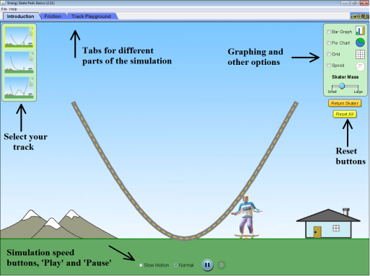

Take some time to play with the simulation. Turn on the ‘Bar Graph,’ ‘Grid,’ and ‘Speed’ options on the right side of the screen. Become familiar with the ‘Reset’ buttons on the right and how to change the speed of the simulation with the buttons on the bottom.

Part I: Introduction (Turn on the ‘Bar Graph,’ ‘Grid,’ and ‘Speed’ options.)
Set the skater 2 meters above the ground on the ramp and release him.

1. What type of energy does the skater have at the 2 meter mark?

2. How high does the skater get on the other end of the ramp?

3. Explain, in terms of the conservation of energy, why the skater will never go higher than your answer to question 2 at this point.

Hit the ‘Reset All’ button.

4. If you were to place the skater at the 5 meter mark, how high will the skater go on the other side of the track? Try it to confirm your prediction.

5. How does the skater’s kinetic energy change as he moves down the ramp?

_____________________________________________________________________________________

6. How does the skater’s kinetic energy change as he moves up the ramp?

_____________________________________________________________________________________

7. How does the skater’s potential energy change as he moves down the ramp?

_____________________________________________________________________________________

8. How does the skater’s potential energy change as he moves up the ramp?

_____________________________________________________________________________________

9. How does the skater’s total energy change as he moves down the ramp?

_____________________________________________________________________________________

10. How does the skater’s total energy change as he moves up the ramp?

_____________________________________________________________________________________

11. Describe the skater’s kinetic energy at the bottom of the ramp.

_____________________________________________________________________________________

12. Describe the skater’s potential energy at the bottom of the ramp.

_____________________________________________________________________________________

13. What happens when the skater is dropped onto the ramp from above? (Hint: look at the bar graph.)

_____________________________________________________________________________________

What happens to the total energy when the skater is dropped onto the ramp from above? (Again, look at the bar graph.)

_____________________________________________________________________________________

14. Observe the following situations. Draw the possible bar graphs for the situation shown. Compare your results with a nearby lab group, AFTER you have completed this section.

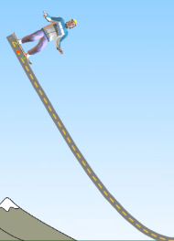  Top of the ramp, stopped for just an instance. | 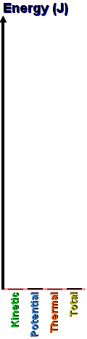 | 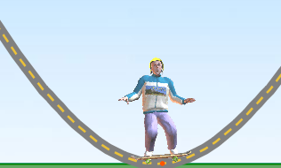  Bottom of the ramp, zooming past the middle.
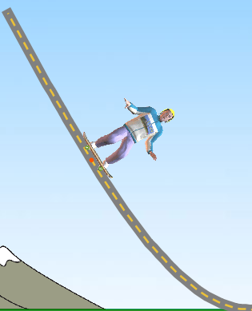  Mid-way down the ramp, moving about mid-speed. |  | 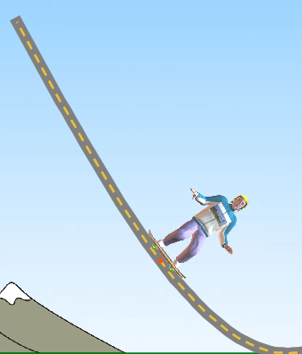  3/4 of the way down the ramp, moving pretty fast.

15. Draw where the skater might be based on the bar graphs shown. Compare your results with a nearby lab group, AFTER you have completed this section.

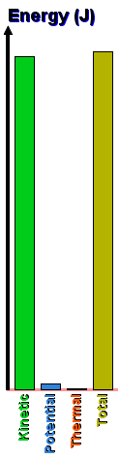 | 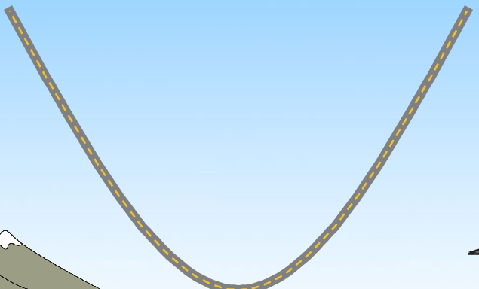 | 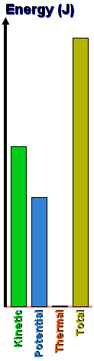
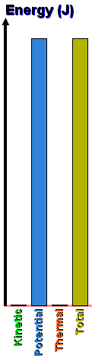 |  | 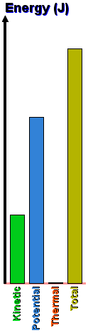

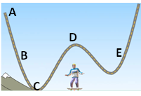 | 16. Consider this zany track. What point or points on this track would the skater have ...  The most kinetic energy? _____  The most potential energy? _____  The same kinetic energy (two points) _____ and _____

Part II: Track Playground

Click the ‘Track Playground’ tab at the top. Using the track pieces in the upper right of the page, build a track with a single loop, like the track shown in the picture below. Be sure the far left and far right of the track are higher than the loop.

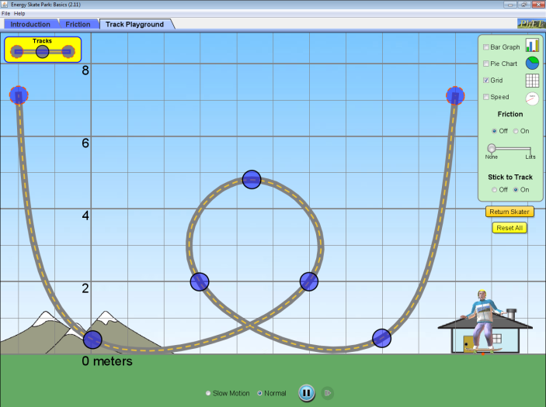

Turn on the ‘Bar Graph,’ ‘Grid,’ and options. For now, set the ‘Friction’ option to ‘Off,’ and the ‘Stick to Track’ option ‘On.’

Using the grid, what is the height of the top of the loop: _______________

Try placing your skater at different starting points on one side of the track.

17. What is the minimum height you can place the skater so that he makes it all the way around the loop?

_____________________________________________________________________________________

18. Explain, in terms of energy, why the skater must be at the height in question 17 to make it through the loop.
_____________________________________________________________________________________

19. With the friction off, does the kinetic energy ever get as high as the total energy? If so, when? If not, why?
_____________________________________________________________________________________

Set the ‘Friction’ option to ‘On.’

20. With the friction off, does the kinetic energy ever get as high as the total energy? If so, when? If not, why?
_____________________________________________________________________________________

21. Now with the friction on, what is the minimum height you can place the skater so that he makes it all the way around the loop? Is this different than if friction were turned off?
_____________________________________________________________________________________

_____________________________________________________________________________________

22. In one of the previous questions, we say you may have “lost,” or “dissipated” some energy. Where is this energy going according to your bar graph? What does this mean in real life?

_____________________________________________________________________________________

_____________________________________________________________________________________

23. Energy can be dissipated (or “lost”) in another way on this simulation. What is one more way that you can find that you will “lose” energy?
_____________________________________________________________________________________

Create a track of your own. Draw in in the diagram below. Label where on the diagram you have the greatest kinetic energy, the greatest potential energy, and two places that have the same potential energy.

