Learning Goals:

Content:

- Students will recognize the various forces acting on an object.
Process:

- Students will be able to determine direction of net force from acceleration and vice versa.
- Students will be able to determine direction of friction forces from direction of motion.
- Students will be able to determine the amount of net force from force applied and force of friction (F_{a} + F_{f} = ∑Force)
- Students will recognize that the greater the net force, the greater the acceleration.
- Students will recognize that when the forces are balanced, the model of motion is constant velocity; and when the forces are unbalanced, the model of motion is uniform acceleration.
Performance:
- Students will apply the content and process learning goals to a different context; in this case, a skydiver.

Background:
This lesson is geared for use in teaching unbalanced forces and how they relate to motion. Students’ prior knowledge should include:

1. A force is a push or a pull on an object by another object.
2. Force diagrams show the forces an object feels.
3. Balanced forces cause constant velocity and unbalanced forces cause uniform acceleration.
4. The ability to recognize and motion map constant velocity & uniform acceleration (with both velocity & acceleration vectors)

The process goals listed above serve as a starting point for students to:

1. Draw force diagrams for unbalanced force situations
2. Determine relationship between friction and normal forces
3. Solve for unknown masses, accelerations or net forces using Newton’s 2nd Law
4. Solve goal less problems involving unbalanced forces

Forces and Motion Teaching tips:

Lesson: My students have worked through units on constant velocity models, uniform acceleration models, and balanced forces models. This activity is one of the first I do in the unbalanced force unit. I do this immediately after an experiment using a half Atwood’s machine that determines Newton’s 2nd Law. It could be used before determining N2L.
For lower level classes, I put the name of the rule on the board and they look for the rule from the simulation. Having the students draw motion maps with both velocity and acceleration vectors (arrows) seems to really help them recognize the direction of acceleration.

Post lesson:

I continue on with unbalanced forces after this simulation. Knowing the rules for forces (and referring back to them often) makes diagramming and problem solving much easier!

Other simulations for this topic include:

http://phet.colorado.edu/en/simulation/ramp-forces-and-motion

I have students diagram different situations and share. After I am sure through multiple assessments that the students can:

1. Draw force diagrams for unbalanced force situations
2. Determine relationship between friction and normal forces
3. Solve for unknown masses, accelerations or net forces using Newton’s 2nd Law

I have them tackle some goal less problems wherein they apply all of their knowledge and skills to a problem in a new context.

Unbalanced Force Diagrams Practice
I can draw Force diagrams for unbalanced force situations.
1. For each of the situations below, draw a motion map, then the force diagram.
A. A rollercoaster accelerates downhill. Put friction in the system.  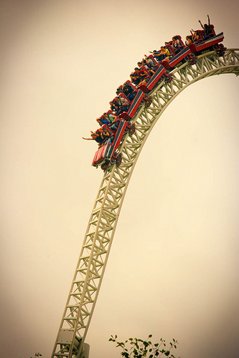 | 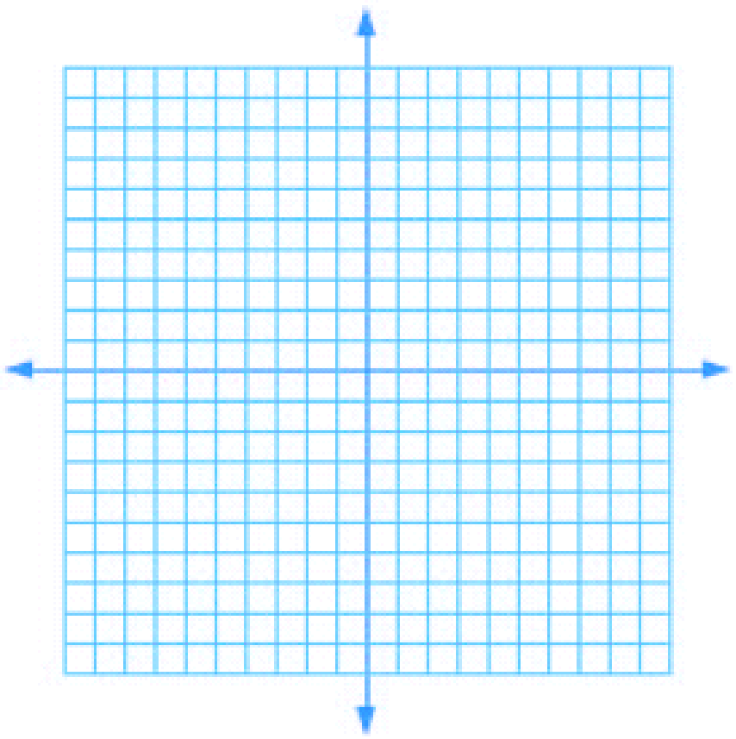 | What direction is the Net force?  What direction is the acceleration?
B. A skier speeds up downhill. Include friction in your force diagram.  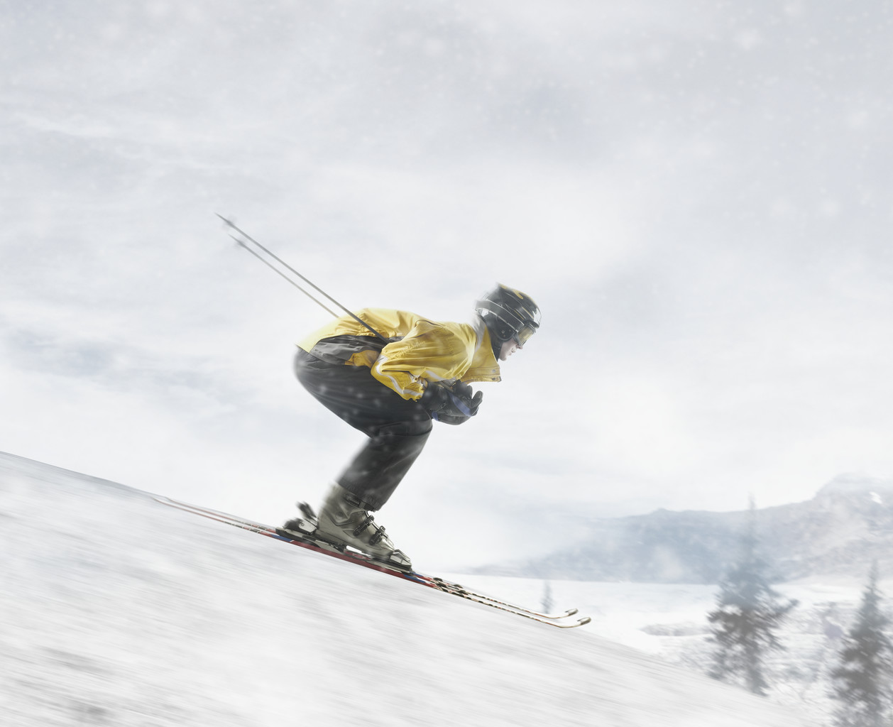 |  | What direction is the Net force?  What direction is the acceleration?
C. A football is moving upwards towards its peak after having been booted by the punter. Diagram the forces acting upon the football as it rises upward towards its peak. |  | What direction is the Net force?  What direction is the acceleration?
D. A car is coasting to the right and slowing down. Diagram the forces acting upon the car. |  | What direction is the Net force?  What direction is the acceleration?
E. A man slips on a wet floor and falls. His left foot is in the air, but his right foot is on the ground. Diagram the forces, include friction. |  | What direction is the Net force?  What direction is the acceleration?
F. The space shuttle takes off in Florida. Include Friction. Diagram the Forces acting on the Shuttle.  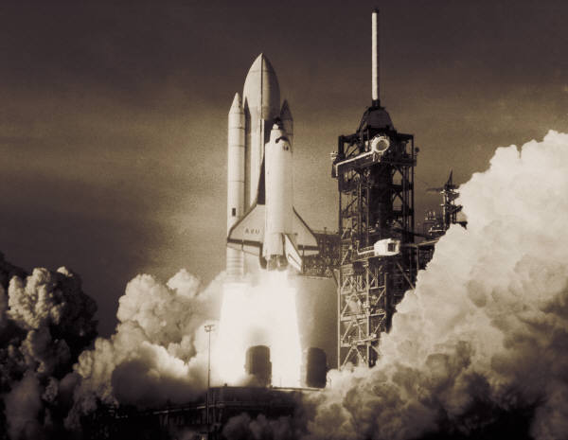 |  | What direction is the Net force?  What direction is the acceleration?

Newton’s Second Law Goal-less problems
1. What models apply to this situation and why?
2. Make sense of the model by drawing at least 3-4 diagrams, motion maps, and graphs.
3. Use your diagrams / graphs to find as many unknown quantities as possible.

1. A 1-kg ball is dropped 2m above the ground. Assume no air friction.

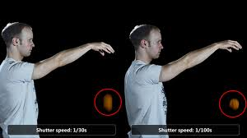

1. What models apply to this situation and why?
2. Make sense of the model by drawing at least 3-4 diagrams, motion maps, and graphs.
3. Use your diagrams / graphs to find as many unknown quantities as possible.
2. A 6kg ball rolls on frictionless ice at 2.5m/s for 4seconds.

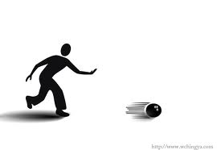

1. What models apply to this situation and why?
2. Make sense of the model by drawing at least 3-4 diagrams, motion maps, and graphs.
3. Use your diagrams / graphs to find as many unknown quantities as possible.
3. A bird with a weight of 10N encounters 4 N of air resistance.

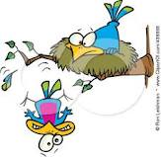

1. What models apply to this situation and why?
2. Make sense of the model by drawing at least 3-4 diagrams, motion maps, and graphs.
3. Use your diagrams / graphs to find as many unknown quantities as possible.
4. A feather with a mass of 0.05kg falls and feels 0.49N of air friction.



1. What models apply to this situation and why?
2. Make sense of the model by drawing at least 3-4 diagrams, motion maps, and graphs.
3. Use your diagrams / graphs to find as many unknown quantities as possible.
5. An apple with a weight of 1N is thrown straight up in the air at a velocity of +14.7m/s.


1. What models apply to this situation and why?
2. Make sense of the model by drawing at least 3-4 diagrams, motion maps, and graphs.
3. Use your diagrams / graphs to find as many unknown quantities as possible.
6. A tow truck exerts a force of 3,000N to the right on a truck, accelerating it 2m/s². There is 200N of friction.

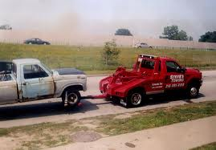

1. What models apply to this situation and why?
2. Make sense of the model by drawing at least 3-4 diagrams, motion maps, and graphs.
3. Use your diagrams / graphs to find as many unknown quantities as possible.
7. A 1,500kg truck feels 2,250N of friction, slowing it down at a rate of -1.5m/s².

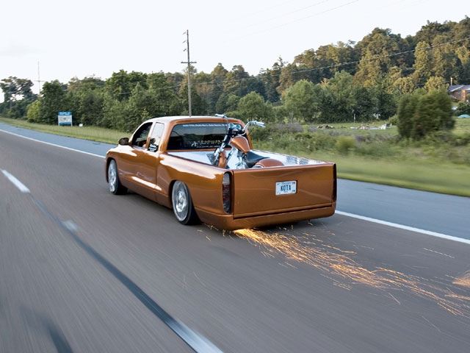
1. What models apply to this situation and why?
2. Make sense of the model by drawing at least 3-4 diagrams, motion maps, and graphs.
3. Use your diagrams / graphs to find as many unknown quantities as possible.
8. The maximum force that a grocery bag can withstand without ripping is 250 N. The bag is filled with 20.0 kg of groceries and lifted with an acceleration of 5.0 m/s²
. 

1. What models apply to this situation and why?
2. Make sense of the model by drawing at least 3-4 diagrams, motion maps, and graphs.
3. Use your diagrams / graphs to find as many unknown quantities as possible.
9. A crate with a mass of 90kg is pushed across a floor with a Net Force of 20 Newtons for 5 seconds. The coefficient of friction is 0.2
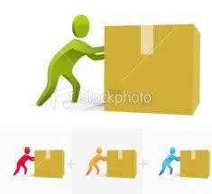

1. What models apply to this situation and why?
2. Make sense of the model by drawing at least 3-4 diagrams, motion maps, and graphs.
3. Use your diagrams / graphs to find as many unknown quantities as possible.
10. An angry bird with a mass of 0.5kg rolls on the grass and slows down from 9m/s to 3m/s in 3 seconds.


