First Name: ________________ Last Name: ____________________Grade 5. Class (circle one) A, B, C
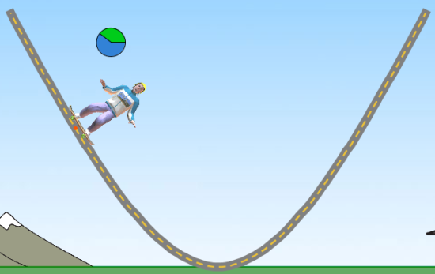
Energy Skate Park Pre-Lab
- In the next moment, the kinetic energy of the skater gets smaller.
For each quantity, write whether it will be increasing, decreasing, or staying the same.
Explain your answer in the box on the right.
Quantity | Increasing/Decreasing/Same | Explain your answer
Height of the skater
Potential energy of the skater
Speed of the skater
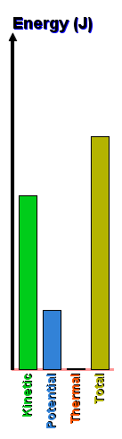
- The bar graph shows the energy of the skater.
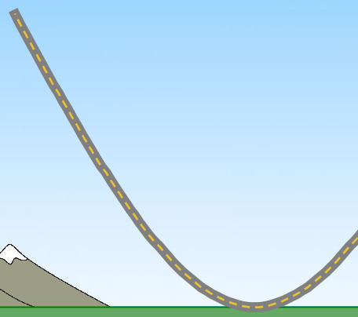
v
A
B
C
D
E

Where could the skater be on the track? ________

Explain your answer

________________________________________________________________________
- The skater starts moving to the right and then slows to a stop.
On the right, draw what the Energy Chart will look like when the skater is stopped.
DRAW

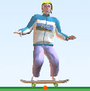
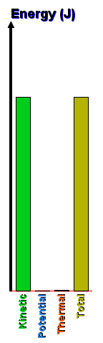
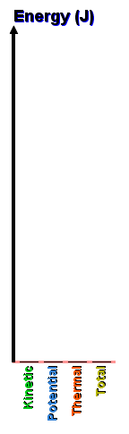
Stopped
Moving to the Right

Explain your answer

________________________________________________________________________

- Your friend plays soccer. Describe a situation in a soccer game where your friend would have:

High Kinetic Energy:

________________________________________________________________________
Low Kinetic Energy:

________________________________________________________________________

First Name: ________________ Last Name: ____________________Grade 5. Class (circle one) A, B, C
Energy Skate Park
Learning Objectives
- Explain the relationship between total energy and kinetic, potential, and thermal energy
- Explain how changing track friction affects kinetic, potential, and thermal energy.
- Design a skate park using the concepts of mechanical energy and energy conservation.

- Explore the simulation. Describe how the skater moves.

- Describe how the skater’s height is related to the skater’s speed at different points on the track.

- Go to the “Introduction” tab.
In the table below, write down whether each quantity increases, decreases, or stays the same.
Skater’s Movement |  | Potential Energy | Kinetic Energy | Total Energy
Up the hill | 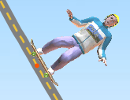  v
Down the hill | 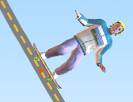  v

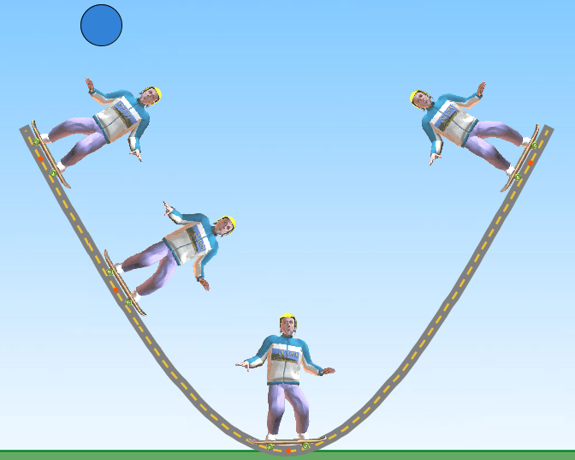
- The picture shows the skater starting at the top of the ramp (position 1). Draw the pie chart for the skater at positions 2, 3, and 4.
1
4

Explain your reasoning for each point:
2
2:________________________________________________________________________________
3
3:________________________________________________________________________________

4:________________________________________________________________________________
- Go to the “Friction” tab.
v
The skater is moving to the right along flat ground.
In the table below, write down whether each quantity is
increasing, decreasing, or staying the same.
Track Friction | Potential Energy | Kinetic Energy | Thermal Energy | Total Energy
Zero
Greater than Zero

- The skater is started at the top of the track. The table below shows Energy Bar Charts for the skater.
In the table, draw where you think the skater is on the track, and if you think friction is on or off.
 | 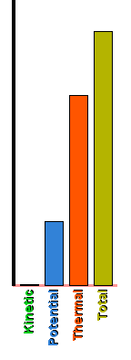 | 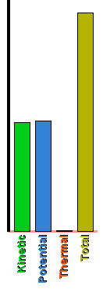 | 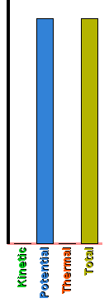 | 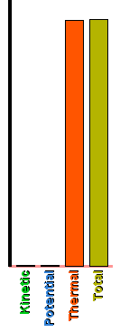
Draw  Skater Position | 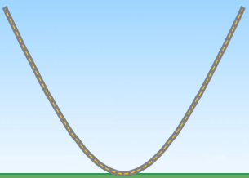
Friction on or off

- Design your own skate park! Draw your skate park on another sheet of paper.
First Name: ________________ Last Name: ____________________Grade 5. Class (circle one) A, B, C
Energy Skate Park Post-Lab
- In the next moment, the kinetic energy of the skater gets smaller.
For each quantity, write whether it will be increasing, decreasing, or staying the same.
Explain your answer in the box on the right.
Quantity | Increasing/Decreasing/Same | Explain your answer
Height of the skater
Potential energy of the skater
Speed of the skater
- The bar graph shows the energy of the skater.
v
A
B
C
D
E

Where could the skater be on the track? ________

Explain your answer

________________________________________________________________________
- The skater starts moving to the right and then slows to a stop.
On the right, draw what the Energy Chart will look like when the skater is stopped.
DRAW

Stopped
Moving to the Right

Explain your answer

________________________________________________________________________
- Your friend plays soccer. Describe a situation in a soccer game where your friend would have:

High Kinetic Energy:

________________________________________________________________________
Low Kinetic Energy:

________________________________________________________________________
- How useful for your learning was this science activity, compared to other science class activities? (circle)
More useful About the same Less useful
How enjoyable was this science class activity, compared to other science class activities? (circle)
More enjoyable About the same Less enjoyable
Why did you or did you not find it useful or enjoyable?

________________________________________________________________________

