Molecule Polarity

In this activity you will use a PhET simulation to explore molecule polarity.

Part I: What factors affect molecule polarity?

- Explore the Molecule Polarity simulation for a few minutes with a partner. In each of the three tabs, try to find all of the controls and figure out how they work.

Two Atoms tab

- Describe all of the ways you can change the polarity of the two-atom molecule.

- Explain how the representations below help you understand molecule polarity.
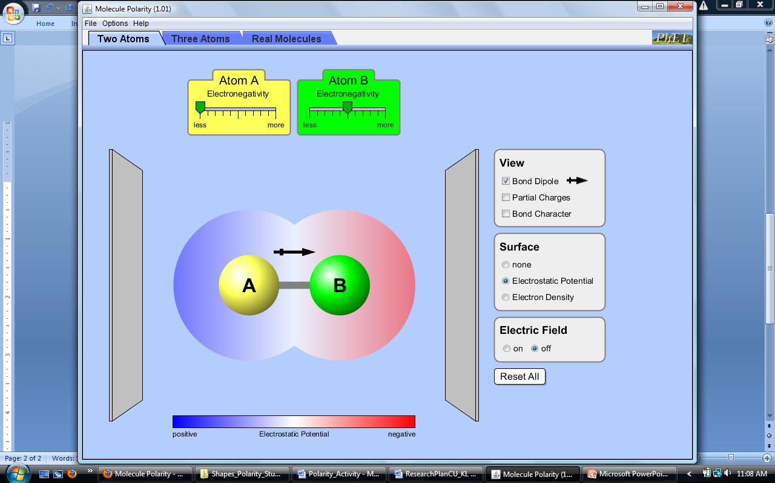
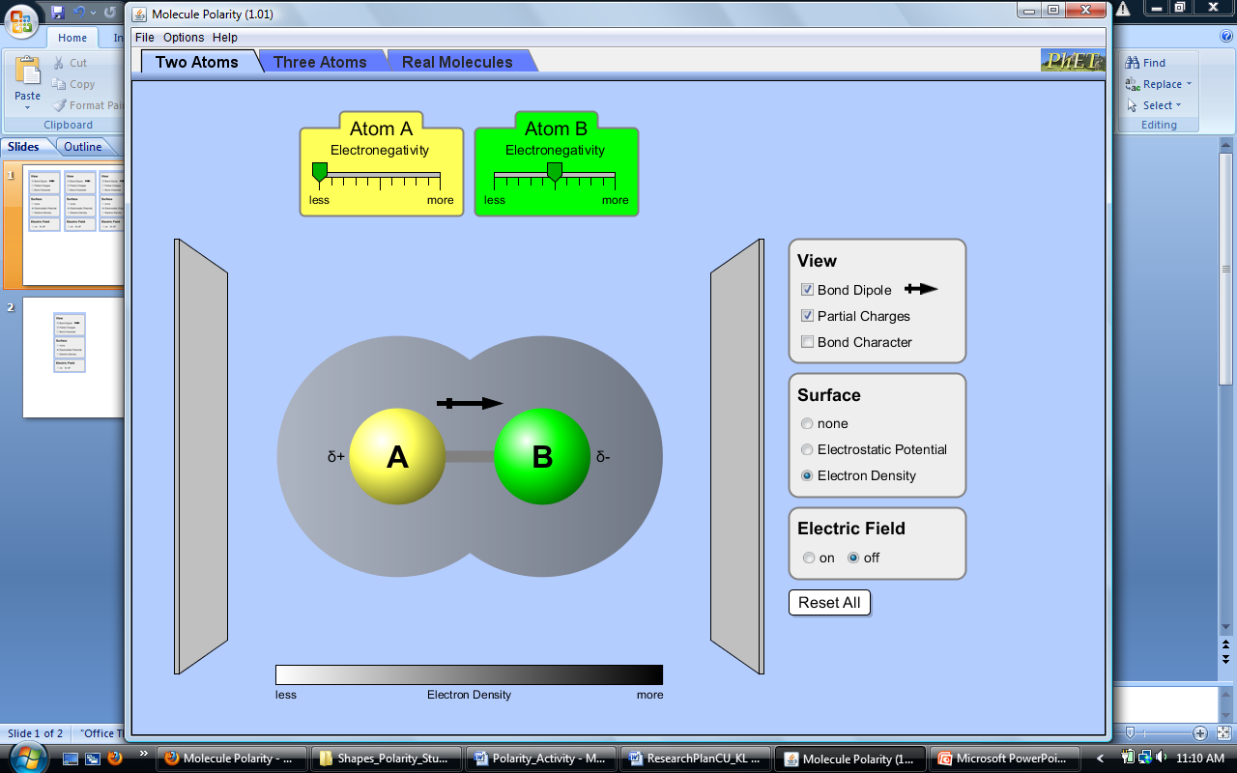

Three Atoms tab

- Describe any new ways you can change the polarity of the three-atom molecule.

- Explain the relationship between the bond dipoles and the molecular dipole.
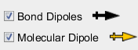

- Can a non-polar molecule contain polar bonds? Explain your answer with an example.

Real Molecules tab

- Predict the polarity of 6 real molecules. First, draw the molecules and any bond dipoles. Then draw any molecular dipoles. Explain your reasoning before you check your predictions with the simulation.

