The Human Cannonball
The first human cannonball was a 14 year old girl. She accomplished this feat in 1877 at the Royal Aquarium in London. She later toured with the P.T. Barnum Circus.
The current world record for the farthest human cannonball flight is by David Smith Jr. on March 10, 2011, at Milan in Italy, previously held by his father. The father David "Cannonball" Smith Sr made the previous record of 200 ft 4 in (61.06 m), on August 31, 2002, at The Steele County Free Fair, Owatonna, Minnesota in the United States. It is estimated Smith Sr. was travelling at over 70 miles per hour (110 km/h) during the flight.
More than 30 human cannonballs have been killed. The latest being in Kent, United Kingdom on April 21, 2011, where a human cannonball plunged to death due to failure of the safety net.

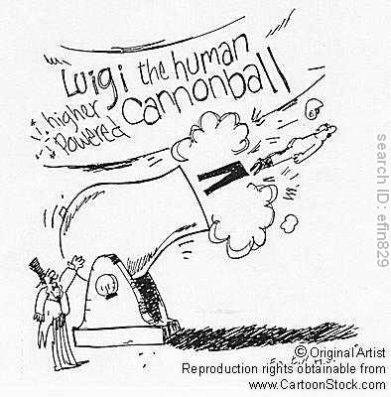

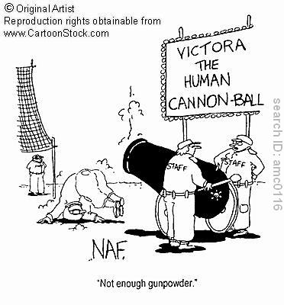

For this task you are going to the Reliant Astrodome in Houston. While your objective is to break the World Record (not your bones), you must know that the Astrodome has a roof. So, while you want as much height as possible (in order to minimize forward momentum), you do not want to plaster yourself against the ceiling either. Find the Astrodome height and then proceed with your jump.

Astrodome height:___________

Free Throw

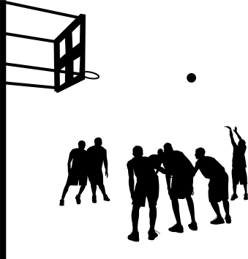

Dr. Tom Amberry Sets a Consecutive Free Throw Record
Unfortunately, there is no video of Dr. Tom setting his consecutive free throw record of 2,750. That would have been a lot of video but interesting to the free throw purist. It took Dr. Tom 12 hours to set his record. This is because he took three bounces and has a loop in his style and motion. He also took a 5 minute break every 25 minutes. He set his Guinness world record with the required number of witnesses. They closed the gym on him after he had passed Ted St. Martins record, by over 600 makes, so he ended his record on a make - perfect 2,750 for 2,750. Remarkable! Dr. Tom is not only one of the best free throw shooters of all time but he is also a great teacher and coach having developed 100's of great 90% or better shooters. (ps. Amberry was 71 years old when he set the record in 1994!).

I am not asking you to shoot 2,750 free throws. Just make one and then write the equation of the ball’s path. Remember you will want a nice arc to achieve that very satisfying “nothing but net” basket. The initial position is set at a height of 1.2 meters (about the height if you were shooting underhand). You may want to adjust this. To start you will need to find the height and distance of the basket. (while there is no basketball listed in the simulator you may use either the bowling ball or football).

Basket Height:_________

Basket Distance:_______

Missile launcher

You are in service to your country. Enemy forces have taken over Paris, France. You are pinned down by enemy fire on the Pont d’lena close to the Eiffel Tower. The enemy commanders are stationed in the Ecole Militaire a short distance away, with the Eiffel Tower directly in between.


Your mission is to use your missile launcher to wipe out the enemy commanders without destroying the Eiffel Tower. Use the task worksheet to write an equation for the path that your missile must take.

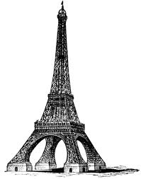

Tower Height:____________ Tower Range:___________

Enemy Range:____________

Water Balloon



While all the other tasks simply require you to deliver a projectile to an exact place, this little prank has a time element as well. Along with your water balloons you have a water balloon launcher. You and your friends are hiding in a tree. The balloon launcher is 10 meters higher up in the tree (total 11.2 meters from the ground). Your unsuspecting friend (and victim) will be at a range of 11.8 meters in exactly four seconds. Make your successful strike and then write the equation of the balloon’s path on the task worksheet.



Car Jump

Longest Jump in a Rally Car-Travis Pastrana sets world record
LONG BEACH, Calif., USA--On New Year's Eve 2009, action sports icon Travis Pastrana, 26, made history, launching his Subaru Impreza STI rally car off the Pine Avenue Pier in Long Beach at 91 miles per hour, soaring 269 feet over Rainbow Harbor and successfully landing on a floating barge-setting the new world record for the Longest Jump in a Rally Car.

Watch the video:
http://www.rallybuzz.com/pastrana-269-ft-jump-clip/

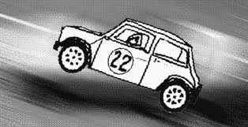

Your task here is to beat Pastrana’s record. Simply complete a jump of 270 feet or more. A suggestion, in order to minimize injury, your flight path should minimize altitude (height) while finding a balance with how fast you will need to go off the ramp (initial speed or velocity). Make this heroic jump and then write your equation of your car’s flight path on the task sheet.



