Learning Goals: Students to be able to
- Design experiments to describe how some types of electromagnetic radiation may interact with molecules found in large amounts in our atmosphere.
- Relate the amount of energy of the electromagnetic radiation to resulting molecular motion.
- Use ideas about radiation and molecular motion to explain some common phenomena.

Pre-lab homework:
- Using prior knowledge or research (cite references if used):
  - Describe the differences/similarities between the four types of radiation in Molecules and Light. Include terms like frequency, wavelength, energy, speed, etc
  - For all 4 types, give at least one example of how the radiation is relevant to your life.
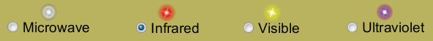

- For the 7 gases used in the simulation:
  - What do you notice about the differences/similarities between the gas molecules?
  - How is each relevant to your everyday life? (cite references if used)
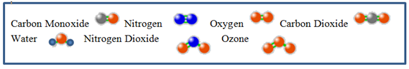
Directions using Molecules and Light :
- Below are scenes, in sequence, that you might see when infrared light is focused on a water molecule. Experiment with the sim to make similar “movie” scenes.
  - Describe what you did to make the movie.
  - Write what you think is causing the changes that occur from scene to scene. (You may change your thinking after more experimentation).

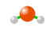

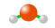
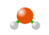
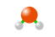
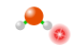

Southwestern Grilled Chicken SaladSouthwestern Grilled Chicken Salad
Southwestern Grilled Chicken SaladSouthwestern Grilled Chicken Salad
Southwestern Grilled Chicken SaladSouthwestern Grilled Chicken Salad
Southwestern Grilled Chicken SaladSouthwestern Grilled Chicken Salad
Southwestern Grilled Chicken SaladSouthwestern Grilled Chicken Salad
Southwestern Grilled Chicken SaladSouthwestern Grilled Chicken Salad
Southwestern Grilled Chicken SaladSouthwestern Grilled Chicken Salad
Southwestern Grilled Chicken SaladSouthwestern Grilled Chicken Salad
Southwestern Grilled Chicken SaladSouthwestern Grilled Chicken Salad
Southwestern Grilled Chicken SaladSouthwestern Grilled Chicken Salad
Southwestern Grilled Chicken SaladSouthwestern Grilled Chicken Salad
Southwestern Grilled Chicken SaladSouthwestern Grilled Chicken Salad

- Design experiments and data table(s) to determine and clearly describe what happens for each molecule with each type of radiation. Make sure to vary light brightness as well as wavelength.

- Examine your data table(s)
  - What patterns can you identify from your experiments?
  - What ideas do you have about relationships between radiation and molecular motion?
  - Did your ideas from 1b change? If so, explain.




- Use your understanding about radiation and gas molecules to answer these questions
  - How do you think microwaves ovens heat up food? Using your data, give some evidence to support your answer.

  - Which of the gases would be considered “greenhouse gases”? Using your data, give some evidence to support your answer.

  - Many people argue that the ozone layer is important. Using your data, give some evidence to support your answer.

