Learning Goals: Students to be able to
- Design experiments to describe how some types of electromagnetic radiation may interact with molecules found in large amounts in our atmosphere.
- Relate the amount of energy of the electromagnetic radiation to resulting molecular motion.
- Use ideas about radiation and molecular motion to explain some common phenomena.

Background: For my students, I will remind them from physics that electromagnetic waves can be thought of as waves or photons of energy. It is not likely that many students will remember this concept and many will not have even had physics. They will not have been introduced to the equations which relate photon energy to frequency or wavelength. The equations are in their chemistry texts and I plan to use the sim before assigning reading or practice problems using the equations because I want the students to develop conceptual understanding of light and molecule interaction using the sim. I believe the equations may be distractors. [The energy of radiation depends on the frequency E=hf or E= hc/λ ; h is Plank’ s constant 6.6x10⁻³⁴ Js.]

Pre-Lesson: The student directions include 2 questions that I plan to assign for howmework before the class time to use the sim.

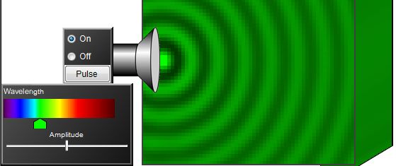
Molecules and Light Introduction: I plan to use Wave Interference and Color Vision to help students see both wave and particle views for visible light. On the Wave Interference Light tab, select Show Screen. Then vary the Wavelength and Amplitude and ask students what each does. You need to wait until the wave front hits the screen to see the effects. The image on the right shows the settings that easily demonstrate that wavelength changes color and amplitude changes brightness.
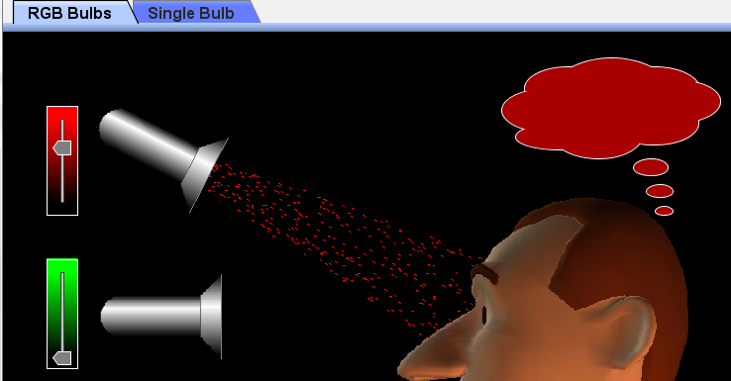
Then display Color Vision RBG tab which shows photons instead of waves for 3 colors of visible light. Ask students: What is the “screen” (the thought cloud)? What selects the wavelength (red, green, or blue sliders)? and What selects the amplitude (each color has a slider)? Once again it is important to provide sufficient wait time so that the changes on the sliders get onto the cloud.

I find the Tips for Teachers for Molecules and Light helpful to review before using the sim in class, but I do not share “Tips” with students because I want them in discovery mode. PhET research showed students did not have trouble using the sim.

Lesson: This activity could be done in class or as homework. I encourage my students to work in pairs and if I can schedule the computer lab, we use it for PhET activities because I find my support is helpful for many students. For question 4, I may have groups work on only one question and then have a share-out.

Post-Lesson: I plan to write clicker questions to use for follow-up discussion, but I want to see how my students react to the sim and activity before I write the questions. I do not grade the clicker responses.

Related PhET sim: Greenhouse Effect

