Name: _____________________________
Inside Balloons: Post-lab:
- If you could zoom in really far inside a balloon, what do you think the air inside would look like?

Use words to help describe this picture.
_____________________________________________________________________________________________________________________________________________________________________________________________________________________________________________________

Is the air being still or is it moving?
_______________________________________
_______________________________________

- How does the air inside the balloon apply pressure?

- Two other balloons are also filled with air, but one is filled with hot air and one box is filled with cold air.

All 3 balloons are at the SAME PRESSURE, and the SAME SIZE.

If you could zoom in, what would be different and what would be the same about the air inside each? Draw a picture and describe what is happening.

Room Temperature Filled with Hot Air Filled with Cold Air
________________________ _______________________ ________________________
________________________ _______________________ ________________________
________________________ _______________________ ________________________
________________________ _______________________ ________________________
________________________ _______________________ ________________________
- You and your classmates have a whole pile of tennis balls near a cement wall.

How could you and your classmates apply the most pressure on the wall using the tennis balls? (You are not allowed to touch the wall).
____________________________________________________________________________________________________________________________________________________________________________________________________________________________________________________________________________________________________________________________

What instructions would you give your classmates in order to achieve the most pressure?
______________________________________________________________________________________________________________________________________________________________
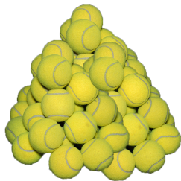
- How useful for your learning was this science activity, compared to other science class activities? (circle)
More useful About the same Less useful
How enjoyable was this science class activity, compared to other science class activities? (circle)
More enjoyable About the same Less enjoyable
Why did you or did you not find it useful or enjoyable?
____________________________________________________________________________________________________________________________________________________________________________________________________________________________________________________________________________________________________________________________

