Name: _____________________________
Grade: _____________________________
Inside Balloons
Pre-lab:
- If you could zoom in really far inside a balloon, what do you think the air inside would look like?

Use words to help describe this picture.
________________________________________
________________________________________
________________________________________________________________________________

Is the air being still or is it moving?
_______________________________________
_______________________________________

If you kept zooming in further and further,
would it look any different?
If so, draw what you think it would look
like in the picture to the right?

- What do you think the word “pressure” means?

Now give an example of using “pressure” in a sentence.

- Do you think air can apply pressure?
If so, how do you think it does it?

Name: _____________________________
Inside Balloons:
How does air exerts pressure?

Learning objectives:
- Students will be able to describe and draw what air looks like at a microscopic level.
- Students will be able to explain how air applies pressure and predict how various changes affect the pressure.

Activity:
- Discuss your ideas about “What the word pressure means?” with your partner.
Write down your ideas after discussion.

- Explore the Gas Properties Simulation.

Draw a picture of what you think the air inside this classroom looks like if you could zoom really, really close in on the air.

Use words to help describe what is happening in this picture.
______________________________________________________________________________________________________
__________________________________
__________________________________

- The air inside a balloon will apply pressure on the walls of the balloon.
The air inside the box in the Gas Properties Simulation is applying pressure on the lid.
Suppose you were inside the box in the simulation, pushing up on the lid. How is that similar to, or different than, what the air is doing?
____________________________________________________________________________________________________________________________________________________________________________________________________________________________________________________________________________________________________________________
- Balloons can pop!
How many different ways can you find to blow the top off of the container in the sim? _____

For each method (up to 3), record the reading on the pressure gauge when the top flew off, describe your method and your ideas about how the air is able to blow the top off.
Method  # | Describe your method | Describe what’s changed about the particles are hitting the lid
1
Pressure reading =
2
Pressure reading =
3
Pressure reading =

- Looking at your observations from Question #4, which factors do you think affect air pressure? Justify your answers with evidence from the simulation.

____________________________________________________________________________________________________________________________________________________________________________________________________________________________________________________________________________________________________________________
__________________________________________________________________________________________________________________________________________________________

- Compare the 4 cases and observations about pressure below.
The Comparisons
Starting condition | Hotter  particles | Particles in  smaller box | More,  hotter particles
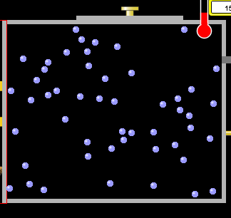 | 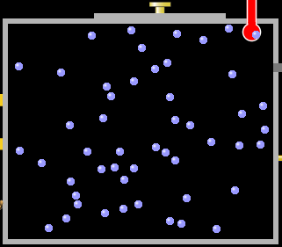 | 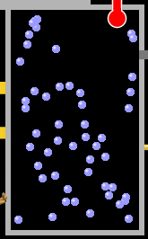 | 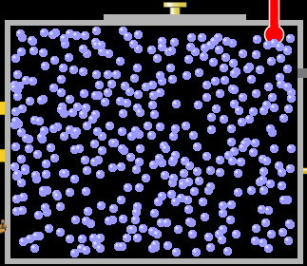
Low  Temperature | High  Temperature | Low  Temperature | High  Temperature
Regular size box | Regular size box | Half size box | Regular size box
The Observations
LOW  PRESSURE | MEDIUM  PRESSURE | MEDIUM  PRESSURE | VERY HIGH PRESSURE
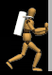 | 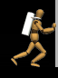 |  | 
Use the simulation to develop a General Explanation for
how air particles apply pressure
that can explain the differences in the cases above.
Write your general explanation here:

Use your general explanation to explain observations for each case:

Name: _____________________________
Inside Balloons: Post-lab:
- If you could zoom in really far inside a balloon, what do you think the air inside would look like?

Use words to help describe this picture.
_____________________________________________________________________________________________________________________________________________________________________________________________________________________________________________________

Is the air being still or is it moving?
_______________________________________
_______________________________________

- How does the air inside the balloon apply pressure?

- Two other balloons are also filled with air, but one is filled with hot air and one box is filled with cold air.

All 3 balloons are at the SAME PRESSURE, and the SAME SIZE.

If you could zoom in, what would be different and what would be the same about the air inside each? Draw a picture and describe what is happening.

Room Temperature Filled with Hot Air Filled with Cold Air
________________________ _______________________ ________________________
________________________ _______________________ ________________________
________________________ _______________________ ________________________
________________________ _______________________ ________________________
________________________ _______________________ ________________________
- You and your classmates have a whole pile of tennis balls near a cement wall.

How could you and your classmates apply the most pressure on the wall using the tennis balls? (You are not allowed to touch the wall).
____________________________________________________________________________________________________________________________________________________________________________________________________________________________________________________________________________________________________________________________

What instructions would you give your classmates in order to achieve the most pressure?
______________________________________________________________________________________________________________________________________________________________
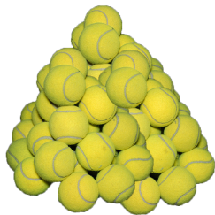
- How useful for your learning was this science activity, compared to other science class activities? (circle)
More useful About the same Less useful
How enjoyable was this science class activity, compared to other science class activities? (circle)
More enjoyable About the same Less enjoyable
Why did you or did you not find it useful or enjoyable?
____________________________________________________________________________________________________________________________________________________________________________________________________________________________________________________________________________________________________________________________

