Name: _____________________________
Static

Learning Objectives:
- Students will be able to determine the variables that affect how positive and negative objects interact.
- Students will be able to predict how positive and negative objects will interact.

1. You and the class just made some observations with balloons – sticking and repelling.

Discuss with your partner your ideas about why the balloons would stick to things (like hair) after rubbing on your head? And repel from each other?
Use words and pictures to describe your ideas about what might be going on.
______________________________________ ______________________________________
______________________________________
______________________________________
______________________________________

2. Let’s look at the Balloons and Static Electricity simulation.

- Explore the simulation.
How can you make the balloon stick to the sweater?
__________________________________________________________________________________________________________________________________________________________
What makes it stick weakly versus strongly?
__________________________________________________________________________________________________________________________________________________________

- How do the plus or minus symbols help you decide whether something attracts or repels?
__________________________________________________________________________________________________________________________________________________________

- Talk about how your observations support, change or add to your ideas from Question 1 and about what affects whether things attract or repel. Then revise your ideas from Question 1.

3. With you partner, test your ideas about attraction and repulsion using the Electric Field Hockey simulation in the Practice mode.

Play with the sim and talk with your partner about ideas that help you SCORE!

Now, develop strategies for the following challenges:
Make a GOAL where puck takes the  SHORTEST amount of time to get to the goal | Make a GOAL where puck takes the  LONGEST amount of time to get to the goal
Draw your strategy for placing  positives or negatives  in the picture below.  What rules are you using to determine  which direction the puck moves?  _______________________________  _______________________________  _______________________________  _______________________________  What rules are you using to determine  how fast the puck moves?  _______________________________  _______________________________  _______________________________  _______________________________  _______________________________ | Draw your strategy for placing  positive or negative pucks  in the picture below  What rules are you using to determine  which direction the puck moves?  _______________________________  _______________________________  _______________________________  _______________________________  What rules are you using to determine  how fast the puck moves?  _______________________________  _______________________________  _______________________________  _______________________________  _______________________________

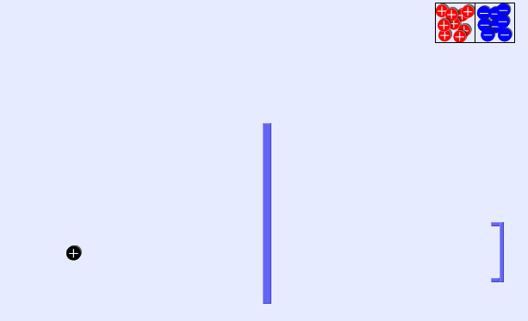
4. Draw where you might put pucks to get a goal with the fewest pucks.

Explain why this works:
____________________
____________________
____________________
____________________
____________________
____________________

5. Reflect on your ideas from Questions 1&2 and your data from Questions 3&4. How do your observations support, change or add to your ideas about…

…whether two objects will attract and repel?

…how strongly they attract or repel?

Revise your explanation from Question 1.

