Learning goals: Students will be able to
- Generate or interpret molecular representations (words and/or pictures) for acid or base solutions
- Provide or use representations of the relative amounts of particles in acid or base solutions to estimate strength and/or concentration
- Use common tools (pH meter, conductivity, pH paper) of acid or base solutions to estimate strength and/or concentration

Prelab:

Water molecules are not shown. Each beaker contains the same volume of solution;

Key: = HA (unreacted acid) = A⁻ = H⁺ (or H₃O⁺)
Beaker A
0.1 M HCl
Beaker B
Beaker C

Beaker D

1a.Which might be the label on Beaker C?
A. 0.01 M HC₂H₃O₂ B. 0.1 M HC₂H₃O₂ C. 0.3 M HC₂H₃O₂ D. 0.01 M HCl E. 0.3 M HCl

1b. Which beaker would have the lowest pH? A B C D

1c. Explain your reasoning: for both questions

- You have two beakers. One beaker contains 100 mL of NaOH (a strong base); the other contains 100 mL of aqueous Na₃PO₄ (a weak base). You test the pH of each solution. Which of the following statements is true?

100 mL 100 mL
NaOH_{(aq)} Na₃PO_{4(aq)}

- The Na₃PO₄ has a higher pH because it has more sodium ions than NaOH.
- It is possible for the solutions in each beaker to have the same pH.
- If the pH of the NaOH solution is 12.00, the pH of the Na₃PO₄ solution has to be greater than 12.00.
- If the pH of the NaOH solution is 12.00, the pH of the Na₃PO₄ solution has to be less than 12.00.

Explain your reasoning.

Lab: Visualizing acid strength, concentration, and pH
- Explore the simulation with your group and discuss these questions. Use the molecular view, pH, conductivity, and bar graphs.

- For an acid, what happens to the molecule when it is in a water solution?
- What is different about what happens to a weak acid molecule and what happens to a strong acid molecule?
- How do the representations of a weak acid reaction differ from a strong one?
- If you increase the concentration of an acid, what changes in both types of acids?

- These images (molecular view of solution/graph/pH/conductivity) depict a strong acid solution:
unreacted acid 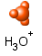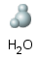Water molecules are not shown in molecular views
KEY:

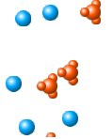
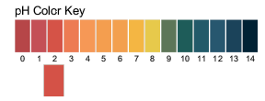
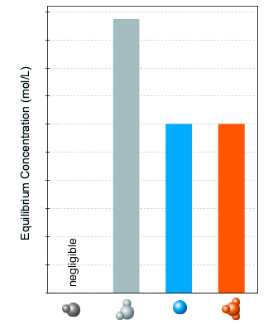
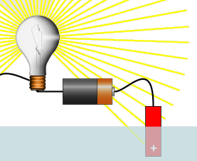

  - How does the Key change for a weak acid?
  - How would the images change for a weak acid solution of the same concentration? Draw the images as well as describing them in words.
  - Draw the images for a weak acid and a strong acid solution of the greater concentration? Make any notes that might help you remember.
  - Write the chemical reactions for a weak acid and a strong acid.
  - Is there one type of representation that might be the best one for you to remember information about weak and strong acids? Make any notes that might help you remember how to compare/contrast the two types.

- Repeat parts A and B for base solutions.

- If your lab partner explains to you that concentration and strength effect acid base solution representations the same way, are they right? Make notes of ideas that support the statement and those that contradict.

