Wave-on-a-String
Pre-lab Name: ____________________________
- A wave is created on this string by moving the wrench up and down.
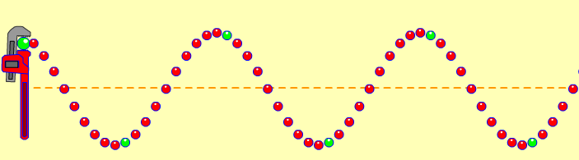
- What would change if the wave had a higher frequency? ____________________________
_____________________________________________________________________________

- What would change if the wave had a higher amplitude? __________________________
______________________________________________________________________________
3. How will increasing the frequency of this wave affect the wavelength?

- 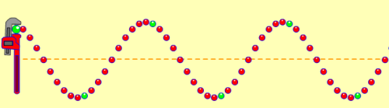 C. 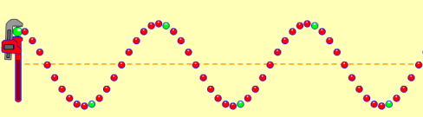
Wavelength will decrease wavelength will get taller
- 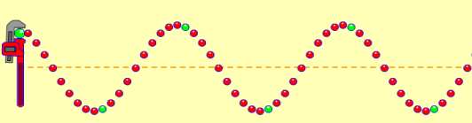 D. 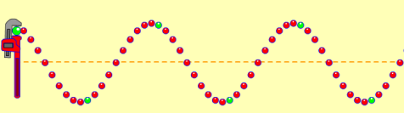
Wavelength will increase wavelength will get shorter

Wave-on-a-String Name: _____________________________
Post-lab
A wave is created on this string by moving the wrench up and down.
- What would change if the wave had a higher frequency? ____________________________
___________________________________________________________________________

- What would change if the wave had a higher amplitude? ______________________________
_____________________________________________________________________________
3. Which picture shows how increasing the frequency in the wave will affect the wavelength?

- C.

- D.
4. Some of your friends are confusing frequency and amplitude. How would you describe these terms in your own words or pictures to help your friends understand each one?
(please write your answer on the back

