Balancing Chemical Equations Student Guide Name: ___________
Start: 1.
Google: PhET Balancing Chemical Equations
2. Click on the first link
- Click on the button.
-  Explore the simulation. Be sure to click on everything.
- Try both 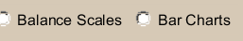
  - Talk about how they may be useful in the activity.
Tell me what the scale and bar charts are helping you do? What is the purpose of these tools?
_________________________________________________________________________
_________________________________________________________________________
Which one does your group prefer and why? ________________________________________
_________________________________________________________________________

  - Fill in the box-

6. Is this equation balanced? Explain. _________________________________
__________________________________________________________________
Change the coefficients in the equation until you get a !
What does this smiley face mean?
__________________________________________________________________
Teacher check-off
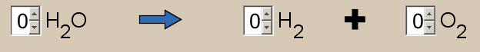
7. Is this equation balanced? Explain. _________________________________
__________________________________________________________________
Using the simulation- add coefficients so that the equation is balanced correctly.
______ H₂O ______ H₂ + ____ O₂
8.
Using the simulation- add coefficients so the equation is balanced correctly.
___ CH₄ + ___O₂ ___ CO₂ + ____ H₂O
List all reactants: List all products:
__________________ ___________________
__________________ ___________________
9. Discuss the maximum (highest number) of ammonia molecules the simulation will let you make? Draw them:
In the product, ammonia (2NH₃), What does the (2) tell you about the equation?

__________________________________________________________________
What does the (3) tell you?_____________________________________________
Teacher check-off/check-in… Go on to  tab...

