Name_____________________
Build a Molecule Post-Lab

1. We use chemical formulas to represent individual molecules and groups of molecules. Write the chemical formula below each molecule or groups of molecules.

a. 
_______________________
b. 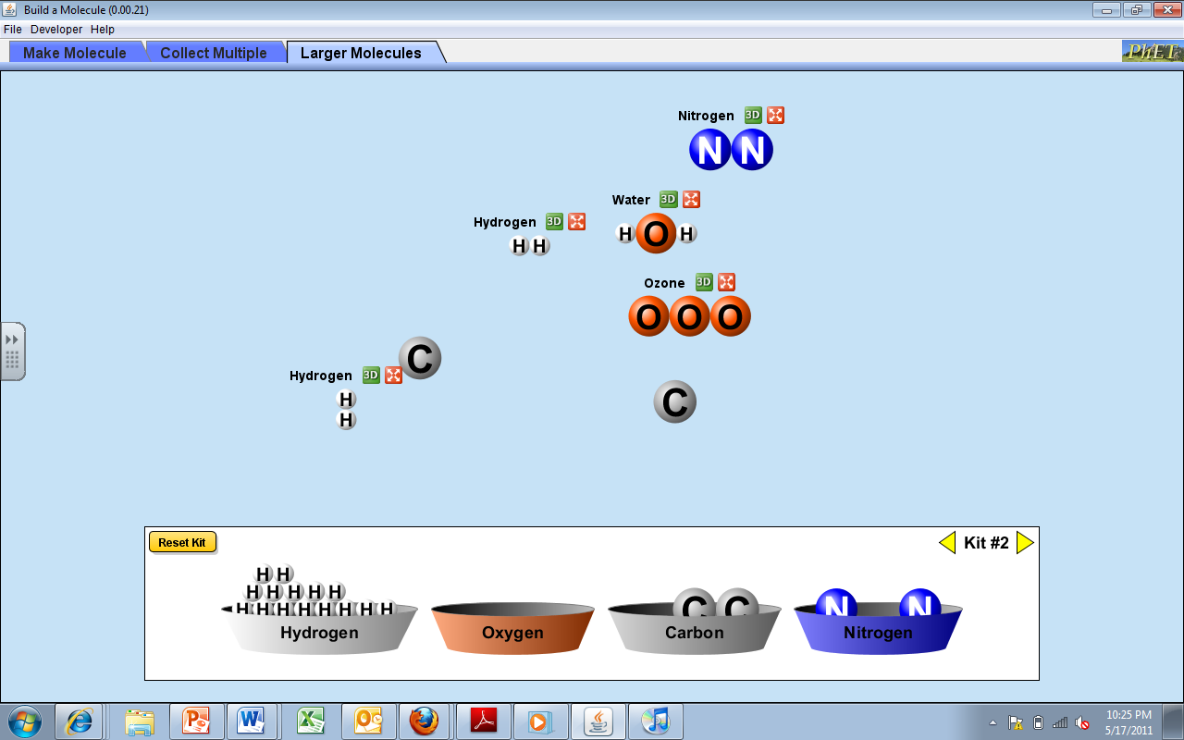
___________________
c. ___________________

d. 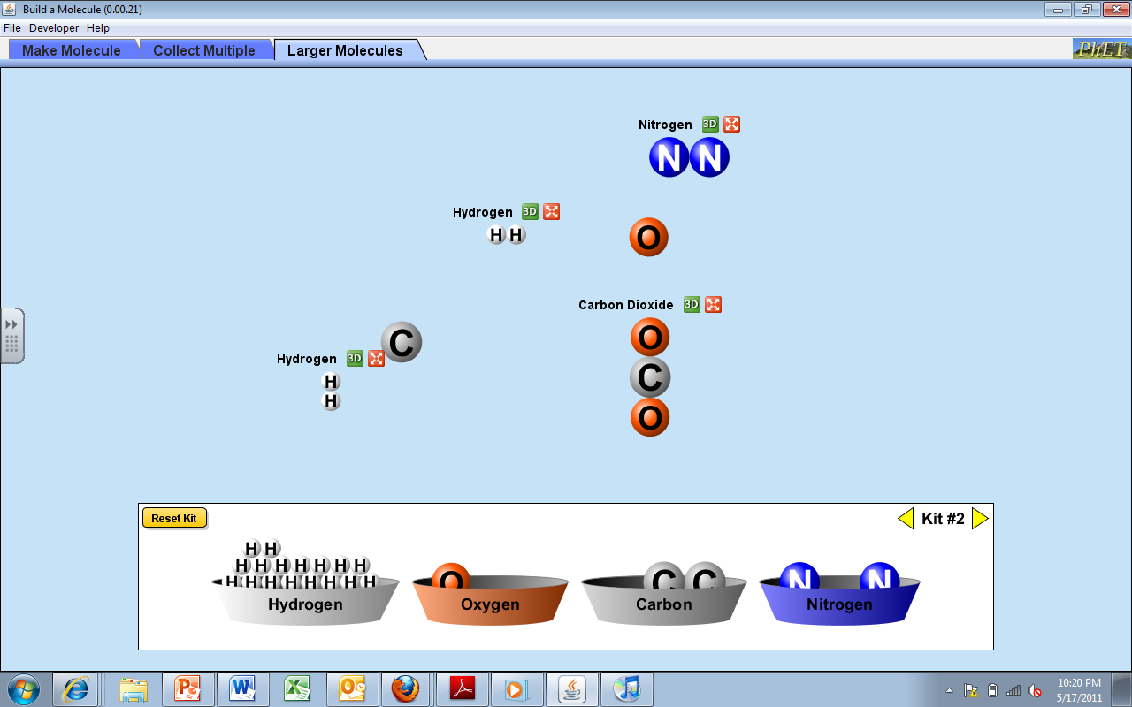 __________________________
e. _______________________
2. Try it!
- Draw 2CO₂
- Draw 3H₂O
- Draw 4N₂
- Draw 2NH₃

3. Molecule Names vs. Chemical Formulas
- Give an example of a molecule name: _________________________
- Give an example of a chemical formula: _______________________
- What is the difference between a molecule name and a chemical formula? _______________________
____________________________________________________________________________________

