Name:_______________________________ Physics

Scientific Question
Which atmospheric gas (CH₄, CO₂, H₂0, N₂, or 0₂) is the best absorber of infrared photons?
Rank these gases from worst absorber to the best absorber.

Lab Background Information
Table 1: Average composition of the Earth’s
atmosphere up to an altitude of 25 km.
Gas Name | Chemical Formula | Percent Volume
Nitrogen | N₂ | 78.08%
Oxygen | O₂ | 20.95%
*Water | H₂O | 0 to 4%
Argon | Ar | 0.93%
*Carbon dioxide | CO₂ | 0.0360%
Neon | Ne | 0.0018%
Helium | He | 0.0005%
*Methane | CH₄ | 0.00017%
Hydrogen | H₂ | 0.00005%
*Nitrous oxide | N₂O | 0.00003%
*Ozone | O₃ | 0.000004%
* variable gases

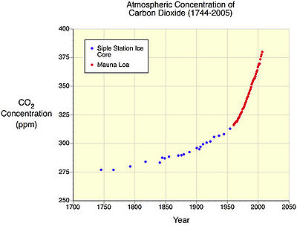
Figure 1:

- CH₄ is a very strong greenhouse gas. Since 1750, methane concentrations in the atmosphere have increased by more than 150%. The primary sources for the additional methane added to the atmosphere (in order of importance) are: rice cultivation; domestic grazing animals; termites; landfills; coal mining; and, oil and gas extraction.

- The volume of CO₂ has increased by over 35% in the last three hundred years. This increase is primarily due to human activities such as combustion of fossil fuels, deforestation, and other forms of land-use change. It is now fact—the increase is causing global warming through an enhancement of the greenhouse effect.

- H₂0 (water vapor) varies in concentration in the atmosphere both spatially and temporally. Water vapor has several very important functional roles on our planet. For example, the condensation of water vapor creates precipitation that falls to the Earth's surface providing needed fresh water for plants and animals. Additionally, it helps warm the Earth's atmosphere through the greenhouse effect.

- N₂ is removed from the atmosphere and deposited at the Earth's surface mainly by specialized nitrogen fixing bacteria, and by way of lightning through precipitation. The addition of this nitrogen to the Earth's surface soils and various water bodies’ supplies much needed nutrition for plant growth.

- O₂ is exchanged between the atmosphere and life through the processes of photosynthesis and respiration. Photosynthesis produces oxygen when carbon dioxide and water are chemically converted into glucose with the help of sunlight.

- Remember, infrared radiation is heat.

Creating an Experiment to Answer a Scientific Question
Check things off as you go!
Which atmospheric gas (CH₄, CO₂, H₂0, N₂, or 0₂) is the best absorber of infrared photons?
Rank these gases from worst absorber to the best absorber.

Step 1: Go to www.phet.colorado.edu

Step 2: Click on Play with sims
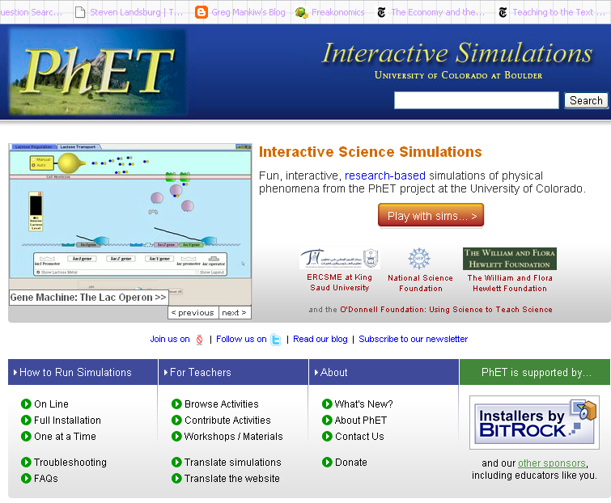

Step 3: Click on Physics
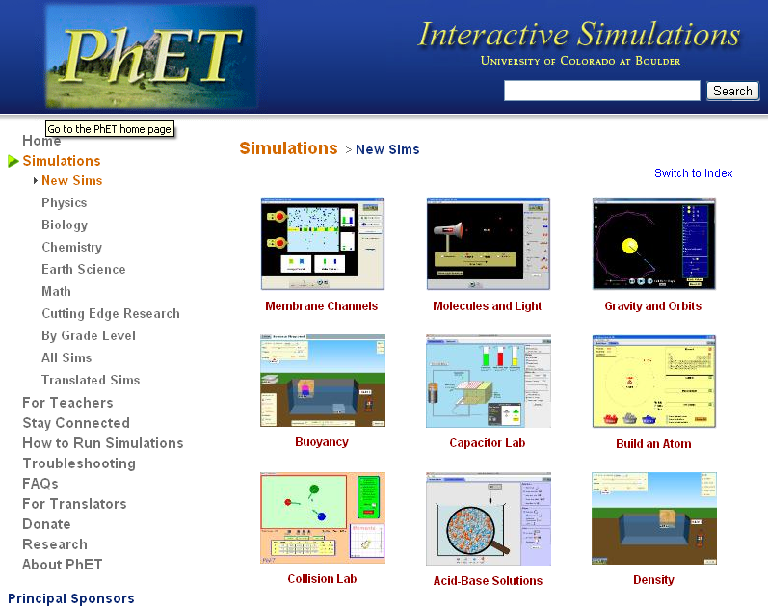

Step 4: Find The Greenhouse Effect Simulation and click on it.
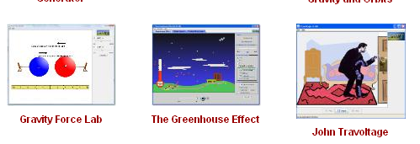
Step 5: Click on Run Now!

Step 5: Click on Run Now!
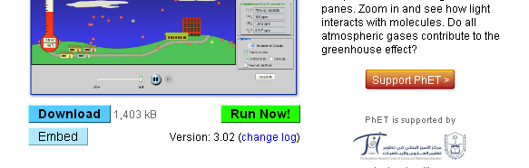

Step 6: Save and open the Greenhouse Effect Simulation

Step 7: Click on the Photon Absorption Tab
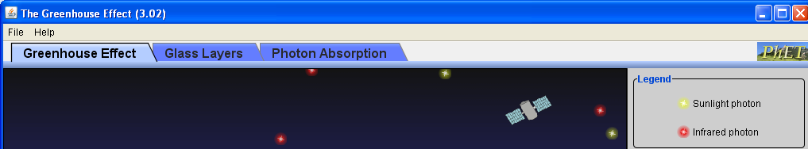

Step 8: Observe what happens when you move the slider on the photon emitter.
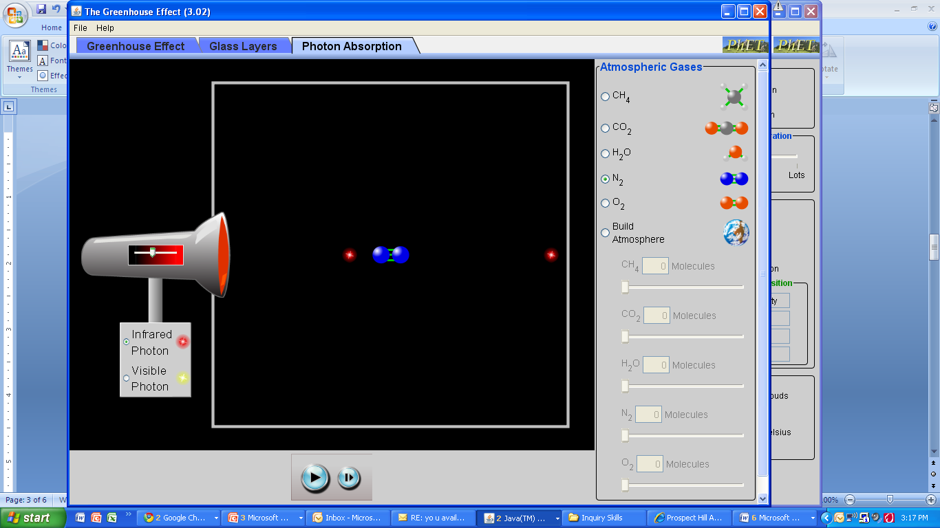

Step 9: Observe what happens when you change which atmospheric gas you are examining.

Step 10: After examining how this application works for a few minutes, you are now ready to begin your lab!

Task: Using the PHET Greenhouse Effect Simulation (specifically, the photon absorption application), you will be creating and conducting a lab that answers the scientific question: Which atmospheric gas (CH₄, CO₂, H₂0, N₂, or 0₂) is the best absorber of infrared photons? Rank these gases from worst absorber to the best absorber.

Below are the steps you must follow to create and conduct a perfect lab. Check things off as you go.

Note: For the purposes of this lab, you can assume that everyone has access to this PHET application. Therefore, you don’t need to explain how to get to it in your lab.

Planning Your Experiment

Step 1: Write a hypothesis that follows the hypothesis guidelines in the attached rubric. Make sure that it is specific and measurable and includes background information.

Step 2: Design an experimental that will directly answer the scientific question and follows all of the guidelines in the rubric. It is suggested that you sketch out your experiment by writing a rough draft before you begin writing your procedures.

Step 3: Write out your experimental procedures. These should be in a list format and should follow all of the guidelines given in the rubric. Consider including screen shots (there is more on this in Appendix 1.1 of this lab packet).

Conducting Your Experiment

Step 1: Create a data table. Make sure that it has a title.

Step 2: Follow your procedures, start collecting your data and record your results in your data table.

Writing Your Lab Report

Step 1: Closely examine the attached rubric and all of its parts.

Step 2: Create a title for your lab (you may want to do this last!).

Step 3: Write the background information section of your lab. Refer to the rubric and be sure to write at least one full paragraph. Additionally, you must include diagrams and label them as figures (you should start with Figure 1.1).

Step 4: Write your hypothesis.

Step 5: Write your experimental procedures.

Step 6: Present your data and results in an organized way. You must include a data table.

Step 7: In paragraph form, analyze your results. Refer to the rubric.

Step 8: In paragraph form, write your conclusions. Refer to the rubric. You must include a discussion of transmission, absorption, and reflection of electromagnetic waves. Importantly, be sure to explain the implications of your findings. What does this mean for the future of our planet? Use the given background information to help you!

Step 9: Be sure you’ve followed the formatting guidelines outlined in the rubric.

Step 10: Using the attached rubric, grade your own lab report. Be sure to record a total grade out of 100. Staple your lab report to the self-completed rubric.

Appendix 1.1
Using Print Screen to Make Following Procedures Crystal Clear

Suppose you’ve done something on your computer that you really want some else to replicate. Wouldn’t it be nice to actually show them what to click on, rather than explain it in words? Well, you’re in luck and below are the instructions on how to do this.

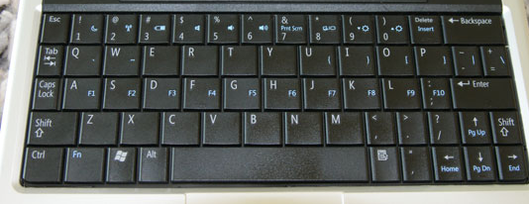
1.) Press and hold the fn button on your keyboard. This button is on the bottom left hand corner of your keyboard and is pictured below.

2.) Now, still holding the fn button, press the print screen button, which is in top right hand corner of your keyboard, and then let go.
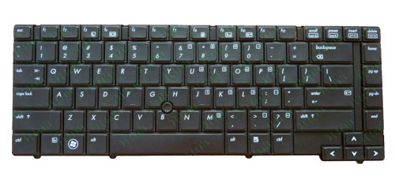

3.) Your computer has now “copied” your screen. Whatever was on your screen at the moment you pressed fn + print screen is now copied.

4.) Open up a Microsoft Word Document.

5.) Press and hold control and then press v, and then let go. This should have pasted this photo into Microsoft Word.

6.) You now will likely want to edit your image, to focus in on a specific part of your screen shot. Click on the picture so that it is selected. Now click on Format under Picture Tools.

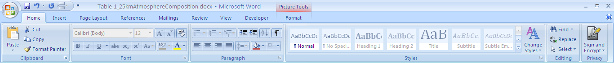

7.) Now, click on crop, which will allow you to change and cut out pieces of your screen shot.

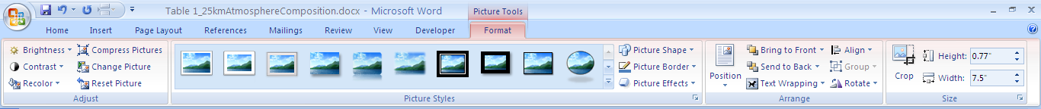

8.) Play around with the crop tool until you have a nice screenshot of what you’re trying to explain!

Infrared Absorbers Lab Report - Grading Rubric Name ________________________
Section | Excellent | Good | Fair | Poor | Points Possible | Points Earned
Title | Creative, relevant title  Includes your name and date | Relevant title, missing one piece of information | Missing two pieces of information | Missing 3 pieces of information | 4
Background Information  Overview of necessary information | - Begins with a strong topic sentence that introduces the major topic of the lab  - Explains many important scientific terms and concepts about wave behavior that are important for understanding the lab (must include explanation and diagram of transmission, absorption, and reflection.)  - Sentences and paragraphs connect with each other and flow logically | Includes all criteria under “excellent” but has room for improvement:  - Needs topic sentence  - Missing 1-2 key concepts or diagram  - Sentences connect but flow could be better | - Missing several key terms or concepts or diagram  - Lacks flow between sentences | - Lacks topic sentence  - Explains few concepts  - Lacking connections between sentences  - Has no diagram | 20
Purpose & Hypothesis  Reasons for experiment | Purpose stated and explained. Hypothesis stated correctly, including reasoning (hypothesis must include a specific prediction about the infrared absorbing abilities of the given gases.) | Purpose and hypothesis stated without reasoning, OR explanations are not clear. | Either purpose or hypothesis stated, no reasoning, OR explanations are very unclear/inaccurate | No purpose or hypothesis stated | 8
Procedure  Steps of your experiment | Procedure describes the steps you took to conduct the experiment and determine how well each gas absorbs infrared photons. | Procedure is generally complete but misses a few key steps. | Procedure includes some relevant steps but is missing a number of important details. | Procedure is drastically incomplete or missing. | 16
Data and Results  Present the results of the lab. | Data and results are complete and presented in an organized way (all data is labeled and easy to follow with a clear organizational table). | Data is complete but is disorganized, not labeled, or difficult to follow. | Data is incomplete and/or highly disorganized | Data and results are incomplete | 16
Analysis  Interpret your results. | In paragraph form, analyze your results. This should include analysis of how well each atmospheric gas absorbs infrared photons. Refer to specific evidence from your data! | Results are explained, but explanations are unclear or incomplete. | Incomplete explanation of what the results mean. | No analysis included | 12
Conclusions  Explain what you can conclude from the data | Describe the conclusions that you can draw from the data. This should include:  - Identify what type of gases are the best/worst absorbers.  - Reflect on whether your results support your hypothesis and explain why or why not  - Discuss how this lab relates to the transmission, absorption, and reflection of electromagnetic waves.  - Explain the implications of your findings. What does this mean for the future of our planet? | Conclusion is generally strong but missing one component  OR  All components included in the conclusion, but explanations unclear or missing details | Conclusion is missing two components  OR  Conclusion is complete but extremely unclear and missing many key details | Conclusion is drastically incomplete | 16
Formatting  Make your report look professional | Proper formatting includes:  - Times New Roman, size 12 font, double spaced  - Sections have clear headings and are in the correct order.  - Visual representations (graphs, tables) neat and professional.  - Spelling and grammar checked. | One element of improper formatting. | Two elements of improper formatting. | Three elements of improper formatting. | 8
Total Grade |  |  |  |  | 100

