Hwa Chong Institution (Singapore)
Year 5 Physics
Name: ______________________ Date: ___________
CT: _____________
Time: 60 mins (including time for discussion)
Learning Goal: To learn and understand how to add and resolve vectors.
- Go to http://phet.colorado.edu/sims/vector-addition/vector-addition_en.html (or go to http://phet.colorado.edu, click ‘Play with sims’, then click ‘Math’ ‘Tools’, and click the simulation ‘Vector Addition’, and click ‘Run Now!’) 
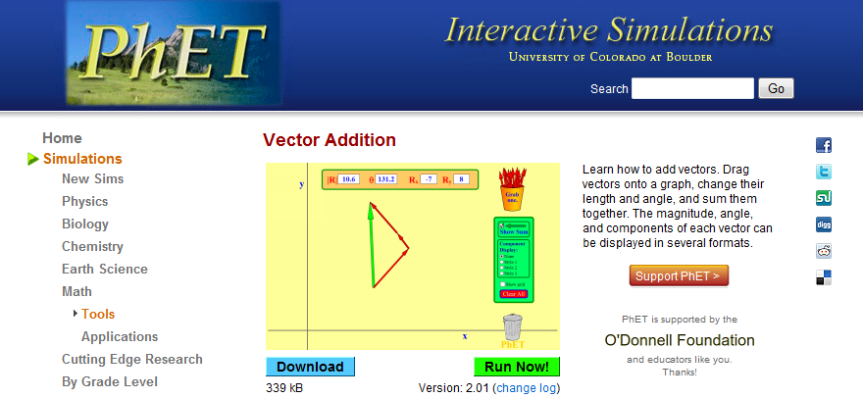

Check the box ‘show grid’ and explore the simulation. You will need to use the simulation to answer the questions in this exercise.

- Suppose you cycle 10.0 km to the east and 15.0 km north to get to a shopping mall from home. After doing your shopping, you cycle 5.0 km to the west and 14.1 km south-west to meet your friend for a drink.

If you have a homing pigeon (a trained pigeon that can find its way home directly), what is the direction should the pigeon fly and how far must it travel to get home in the shortest time? Use the stimulation to find out and sketch the vectors you have constructed on screen.

- A man exerts a force of 47.2 N on a box in the direction 32º North of East as shown in the figure.
- If two forces are exerted in two mutually perpendicular directions (the x- and y-direction), what would be the magnitude of these two forces (the x- and y-component) that would be equivalent to the single force of 47.2 N (ie the two forces produce the same acceleration as 47.2 N)? Use the simulation to find out.  X-component of the force: Fx=  y-component of the force: Fy= | x  y  47.2 N  32º
- Calculate the X- and Y-components mathematically and verify if the results are consistent with what you have obtained from the simulation in part a. Show your working clearly.

- If a force F is exerted on a ball at an angle θ to the horizontal, illustrate with a sketch the components of the force F and its relation with the force F and the angle θ, and express the components of the force in terms of F and θ.

- The diagram shows the top view of three motorboats crossing a river (left bank to right bank). All three move at the same speed of 5.0 m s⁻¹ but in different directions, and all experience the same current at 2.5 m s⁻¹ flowing down the river.
- Sketch the vectors representing the resultant velocity for the three motorboats on the figure to the right.  - Using the simulation, find the magnitude of the resultant velocity (ie the resultant speed) for each of the three motorboats.  Resultant speed of motorboat a =  Resultant speed of motorboat b =  Resultant speed of motorboat c = | 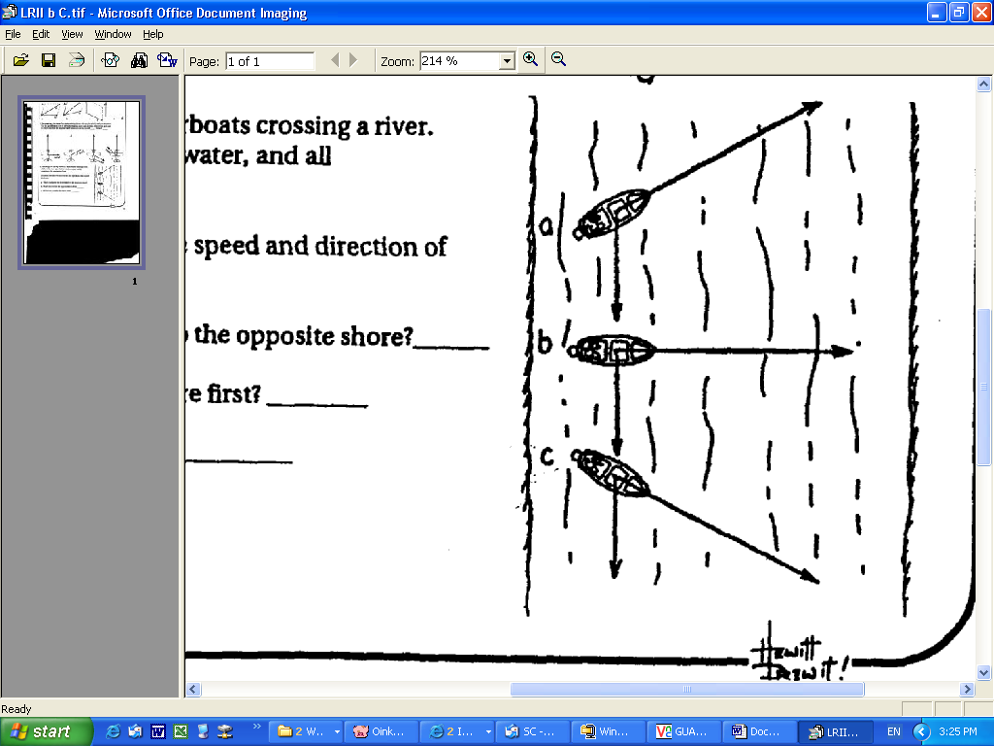  30º  30º
iii) Calculate the resultant speed for each of the three motorboats, and compare with your answers in part ii. Show your working clearly.

iv) Which motorboat will travel the fastest to reach the other side of the river? Explain.

- Which motorboat will take the shortest time to reach the other side of the river? Explain.

- Which motorboat will travel the shortest distance to reach the other side of the river? Explain.

