MOLECULES and LIGHT

Today you are going to use a sim to explore how light interacts with molecules in our atmosphere.

I. Explore the sim with a partner.

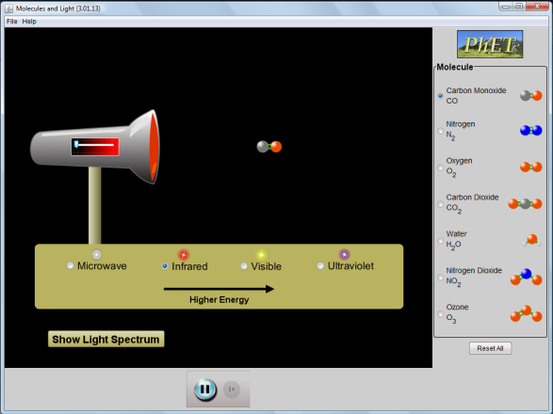
What are some of your observations?

II. Explore what happens for each type of light.

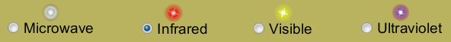

What patterns did you find? What ideas do you have about how the sim relates to your everyday life?

III. Explore what happens for each molecule.
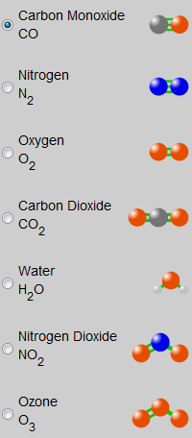
What patterns did you find?

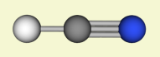
Based on your observations, how would you predict HCN to interact with microwaves?

IV. Look closer at how infrared light affects water in the sim or in the movie below.

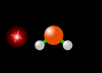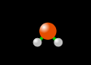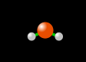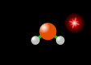

What do you think is happening?

V. Pick one of the topics below to study in more depth. Prepare to share your ideas with the class by making sense of what you discover.

1. Microwaves
How do microwave ovens work?
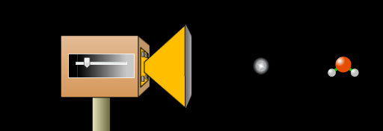

2. Greenhouse effect
What is a greenhouse gas?
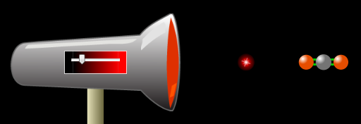

3. Ozone layer
Why is the ozone layer important?
