Batteries in series and parallel
Build the two circuits shown below:

circuit 1  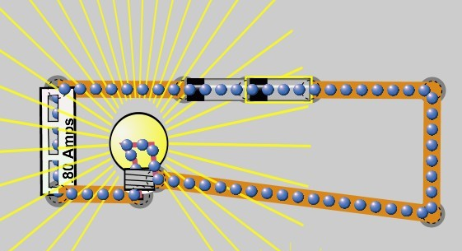 | circuit 2  

- Right click on each battery and light bulb and select “show value”.

For circuit 1:
- Look at the values of current, voltage and resistance. Using Ohm’s Law, calculate the voltage across the light bulb.

- How does the voltage across the light bulb compare to the voltage given by the two batteries together?

- Why would you ever you use two batteries connected in series?

For circuit 2:
- Look at the values of current, voltage and resistance. Using Ohm’s Law, calculate the voltage across the light bulb.

- How does the voltage across the light bulb compare to the voltage given by the two batteries together?

- How is the current through the light bulb in circuit 2 compared to the current through the light bulb in circuit 1?

- Why would you ever use two batteries connected in parallel?

- In terms of current and voltage provided by batteries connected in series or parallel, when would you use one or the other?

- Change the voltage of one of the batteries to 1 V instead of 9 V. What happens? Explain why.

