EXPLORING VOLTAGE in a SERIES CIRCUIT
To interactively explore some of the concepts you have learned so far please go to the Physics Education Technology Web site (http://phet.colorado.edu/). Click on the “Play with sims.” button and under Simulations (on the left side of the window) select Physics -> Electricity, Magnets, and Circuits and from the main window click on the Circuit Construction Kit (DC only). Select “Run” and wait for the simulation window to pop up. It should look like the window shown below:
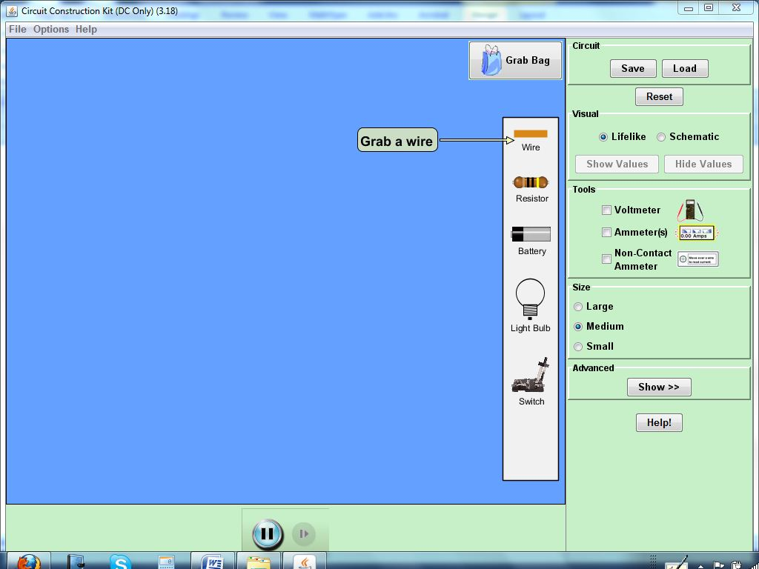

Using your mouse, you can place any circuit element into the main window by clicking, holding down the mouse and dragging the element. Release the mouse once the circuit element is in the main window.

- Place a battery and a resistor in the main simulation window, without connecting them. Select the button for the voltmeter. Once you select it, a voltmeter will show up in the main window. Place the black terminal of the voltmeter on the right contact point of the battery and the red one on the left contact point of the battery. Measure the voltage of the battery and write it below.

- What does voltage mean for you? How would you explain voltage to your students?

- What do you think, does the resistor have voltage? Predict and then measure it the same way as you measured the voltage across the battery: place the black and red terminals of the voltmeter on the two contact points of the light bulb. What was the measured voltage for the resistor?

- After measuring the voltage of the resistor, would you like to change your definition of voltage?


Now, connect the light bulb and the battery using the wires available on the right side of the simulation window. To break a contact made in the circuit, right click on the contact and select “split junction”. Make sure you also include a switch that is initially open. Your circuit should look similar to the one shown.

- Is there any current flowing through the circuit when the switch is open?

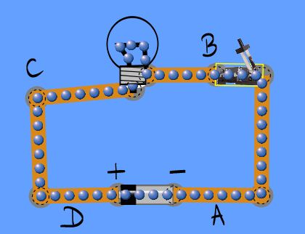
- With the switch open, measure the voltage of the battery and of the resistor and record it below. Pick the following pairs of two points in your circuit and measure the voltage between those points. Record the measured values in the table below.
Across the battery (between the + and – terminals)
Between – and A
Between A and B
Across the resistor (between B and C)
Between C and D
Between D and +

- Have any of the voltages read changed from the previously read values? Why or why not?

- Close the switch. Place the black terminal of the voltmeter on the right side of the battery (the negative end of the battery) and the red one on the left side of the battery (the positive end of the battery). Measure the voltage of the battery and of the resistor and record it below. Pick the following pairs of two points in your circuit as in question 6 and measure the voltage between those points. Record the measured values in the table below.
Across the battery (between the + and – terminals)
Between – and A
Between A and B
Across the resistor (between B and C)
Between C and D
Between D and +

- Have any of the voltages read changed from the previously read values? Why or why not?

- Plot the voltage across the various points in your circuit on the graph provided below:

- Is your definition of voltage still valid? Would you like to change it?

Build a series circuit with 2 light bulbs (should look like the one below):

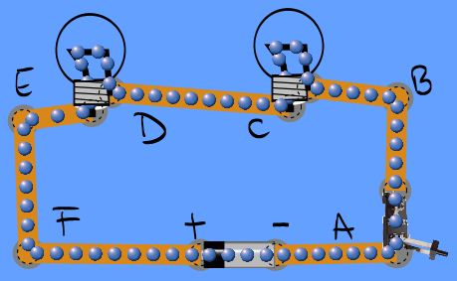

- Close the switch. Place the black terminal of the voltmeter on the right side of the battery (the negative end of the battery) and the red one on the left side of the battery (the positive end of the battery). Measure the voltage of the battery and of the resistor and record it below. Pick the following pairs of two points in your circuit as in question 6 and measure the voltage between those points. Record the measured values in the table below.

Across the battery (between the + and – terminals)
Between – and A
Between A and B
Across the resistor (between B and C)
Between C and D
Across the second resistor (between D and E)
Between E and F
Between F and +

- Have any of the voltages read changed from the values read for the circuit with one single bulb? Why or why not?

- Plot the voltage across the various points in your circuit on the graph provided below:

- Why do you think the voltage across one of the light bulbs in the 2 light bulb circuit (circuit 2) is different than the voltage across the light bulb in the one light bulb circuit (circuit 1)?

- Can you find a relationship between the voltage between different points in a series circuit and the voltage of the battery? In other words, how are the battery voltage and the light bulb voltage connected?

- If in circuit 2 you are to use two resistors with different resistance, would the voltage across them still be the same? If not, which one do you think would have a greater voltage? Explain your answer.

