RECITATION 11: LIMITING REACTANTS
Concept Areas 1-2

Today you are going to use the “Reactants, Products and Leftovers” simulation to explore how many products you can make given the initial amounts of two reactants.

You need to: 1) find a partner, and 2) click on the “RPAL” icon to open the sim.

CONCEPT AREA 1: MAKING SANDWICHES

1. If you have 6 pieces of bread and 4 slices of cheese, predict how many cheese sandwiches of type A you can make. Then predict how many of type B you can make.

A: 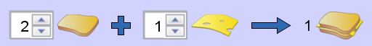 B: 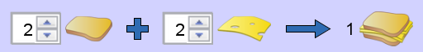

How did you figure this out?

Now check your predictions using the “Sandwich Shop” tab. Do the results make sense? Revise your answers or reasoning as needed.

In case A, the bread could be called the “limiting reactant.” How would you define a “limiting reactant”?

What is the limiting reactant for case B and why? What is leftover when all the sandwiches are made?

CONCEPT AREA 2: MAKING AMMONIA

2. Consider the chemical equation: 1 N₂ + 3 H₂ → 2 NH₃

For the 3 scenarios below, predict which one will produce the most ammonia, and predict which ones will have leftovers.

A: 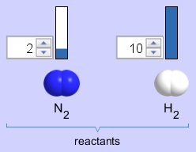 B: 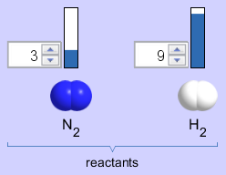 C: 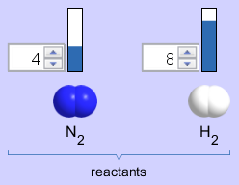

Explain your reasoning:

Now check your predictions using the “Real Reaction” tab. Do the results make sense? Revise your answers or reasoning as needed.

How did the “Real Reaction” tab relate to the “Sandwich Shop” tab?

3. Play at least one “Game!” at each level with your partner (estimated time = 5 minutes per game).

Record your best score for each level in the table below.

Level | Best Score
1
2
3

How did you solve the problems? Write your strategy in the space below. Did your strategy change as you played the game? If so, write how it changed.

