Learning Goals: Students will be able to:
- Given a function, sketch the derivative or integral curves
- Explain what the effect of a discontinuity in a function has on the derivative and the integral curves
- Explain the difference between smooth versus piecewise continuous function curve
- Be able to describe in words with illustrations what the derivative and integral functions demonstrate I.e.: the derivative is the “rate of change” and the integral is the accumulation of the area of the function
- Students generalize the idea of a graph [F(x) vs x] or [x(t) vs t] can represent the same thing.

Background: This is written with the beginning as an in-class activity with students working in pairs or small groups with the simulation. Then, there is an assignment to be done outside of class. Then, there is a follow-up for the next class meeting called a “Post-Lesson”
There is another simulation called Moving Man by PhET that could be used to help the students see a real-world application. I have an activity that could be helpful: activity using Moving Man.
at: http://phet.colorado.edu/teacher_ideas/view-contribution.php?contribution_id=5.

Lesson: There is a slide presentation to help with the first 2 questions and the post lesson, but I have included all the questions in this document to help clarify the sequence.
- Start with the teacher providing this question to students who are working in small groups:
  - Given this function, talk with your group about what you think the derivative and integral curves will look like and sketch
F(x)
$$\int_{0}^{x}{F\left(x^{'}\right)dx'}$$

$$\frac{df}{dx}$$

  - Have the groups play with the sim and confirm or correct their sketches.
  - Discuss large group the results and make sure to point out that the integral graph could have different starting points on the y axis depending on the constant. ANSWERS IN BLUE
F(x)
$$\frac{df}{dx}$$

$$\int_{0}^{x}{F\left(x^{'}\right)dx'}$$

- Do one more example to demonstrate that 1) the graphs need to align vertically and 2) each graph has ZOOM ability that is independent of the other graphs. Start with the teacher providing this question to students who are working in small groups:
  - Given this function, talk with your group about what you think the derivative and integral curves will look like and sketch
F(x)
$$\int_{0}^{x}{F\left(x^{'}\right)dx'}$$

$$\frac{df}{dx}$$

  - Have the groups play with the sim and confirm or correct their sketches.
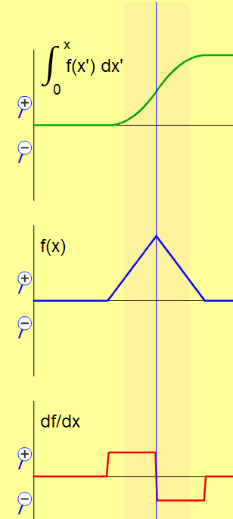
  - Discuss large group the results and make sure to point out that the integral graph could have different starting points on the y axis depending on the constant. This is ZOOMED on the integral graph to magnify the relevant portions.

- Then give the students independent time to practice using the Student Directions handout. This will probably require time outside of class.
Post-lesson: After the students have completed the “Student Directions”. There are slides for this part. The teacher should make sure to demonstrate how shifting and tilting effects graphs. This is best done with the simulation, but I have included examples of typical graphs.
- Given this derivative graph, what would the function graph look like?
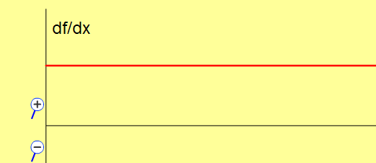
Make sure to demonstrate that this is just a straight line graph with constant slope; the line can be SHIFTED to many places. All must have same slope, so TILT will not give same derivative.
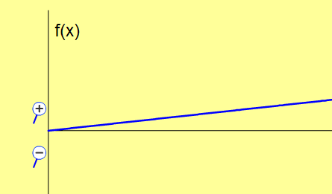
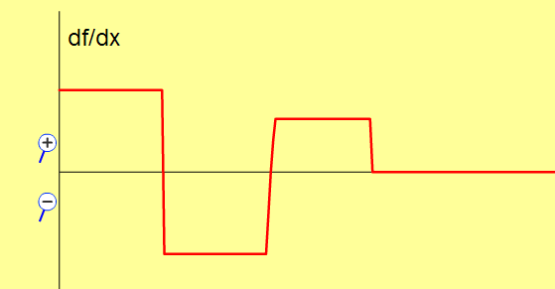
- Given this derivative graph, what would the function graph look like?

Make sure to demonstrate that this is just a straight line graph with constant slope; the line can be SHIFTED to many places All must have same slope, so TILT will not give same derivative.
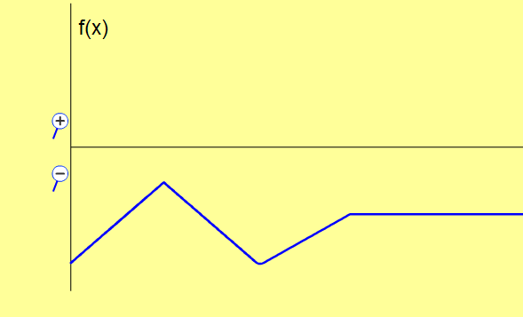
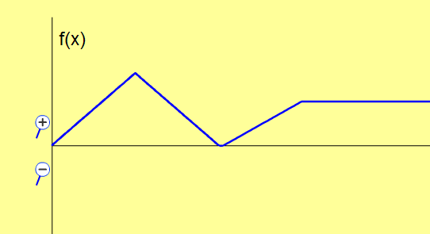

- There are concept questions included in the Power Point presentation that could be used to help with the goal: Students generalize the idea of a graph [F(x) vs x] or [x(t) vs t] can represent the same thing
Answers to STUDENT DIRECTIONS have not been included in this lesson plan.

Below are some images that you may find useful if you are writing your own lesson
All three graphs grouped
F(x)
$$\int_{0}^{x}{F\left(x^{'}\right)dx'}$$

$$\frac{df}{dx}$$

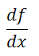
Each graph as a grouped image:
$$\int_{0}^{x}{F\left(x^{'}\right)dx'}$$

F(x)

