PhET Simulation
Exploration – Models of the Hydrogen Atom
http://phet.colorado.edu/simulations/sims.php?sim=Models_of_the_Hydrogen_Atom
Tie to Planck and Quanta
Overview
One of the most tantalizing puzzles at the beginning of the 1900s for scientists was to describe the make-up of the atom. As I explained in class, light was used to investigate the make-up of the atom.

In this activity, you will first observe a simulated light spectrum of hydrogen gas. This is the same spectrum that you observed in class. You will then look at spectra predicted by different models of the atom. The models you will test include:
- John Dalton’s Billiard Ball model
- J.J. Thomson’s Plum Pudding model
- Ernest Rutherford’s Classical Solar System model
- Niels Bohr’s Shell model
- Louis deBroglie’s Electron Wave model
- Erwin Schrodinger’s Quantum Mechanical model

You will need a stopwatch to complete this exercise.
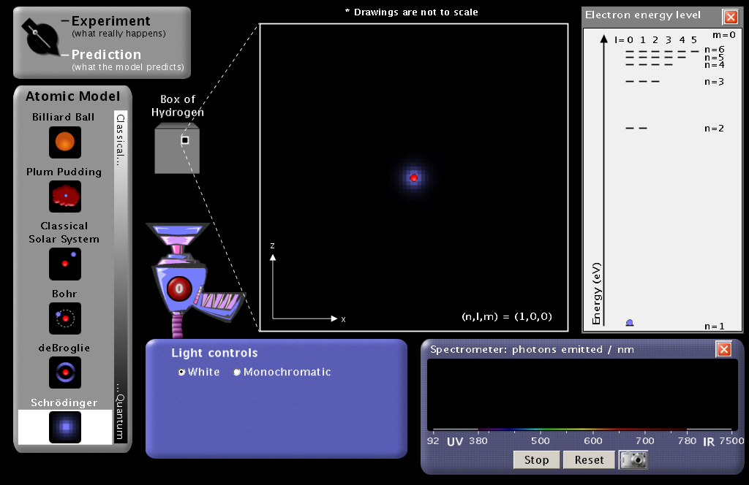

Procedure and questions
- Access the PhET website.
- Search for Models of the Hydrogen Atom and run it.
- Click on the Expand box in the top right corner of the simulation so that the simulation completely fills the screen.
- Turn on the White light gun. The white light is shining into a transparent box containing hydrogen gas molecules.
  - Explain why, with white light, the light photons passing up through the box have different colors.

- Check the Show Spectrometer box. Notice that the color of the photons passing up through the box corresponds to a wavelength of UV, visible, or IR radiation.
- In the Light Controls, click on Monochromatic. Notice that the incoming photons are now all the same color. A spectrum slider appears that allows you to change the energy of the incoming photons. Move the slider across the spectrum from ultraviolet (UV) down to the infra-red (IR). Notice the color of the lamp and the photons moving up the screen. Decide how you can distinguish between UV and IR photons. Record that information below.

- Switch the Light Controls back to White light
- Move the Slow…Fast slider all the way over to Slow
- Watch the photons carefully. Most of the light gun photons pass through the box of hydrogen unaffected. Occasionally a photon is absorbed by something in the ? box and a new photon of the same energy (color) leaves the box.
  - Describe what is going on in the ? box.

- Move the Slow…Fast slider all the way over to Fast, Reset the Spectrometer, and let the simulation run for 1 minutes.
- After 1 minutes, click on the Spectrometer camera to take a snapshot of the Experiment.
- Describe what is happening to the spectrum below. Include in your description the colors, estimated wavelengths, and relative numbers of stacked colored balls. These colored balls correspond to photons emitted by the ? box.

- Slide the snapshot off to the right of the screen for later comparison with the models.
- Close the Show Spectrometer box
- Remember that John Dalton proposed that an atom was simply a very tiny hard ball. To see this simulated, in the top left corner, switch from Experiment to Predict and highlight the Billiard Ball model.
- Move the Slow…Fast slider all the way over to Slow and describe what is happening below.

- Below, sketch your idea of what the spectrum will look like for Dalton’s model.

- Move the Slow…Fast slider all the way over to Fast, reset the Spectrometer, and let the simulation run for 1 minutes.
- Click on the Spectrometer camera to take a snapshot of the Billiard Ball. Compare it to the Experiment. Slide these snapshots off to the right for later comparisons.
  - Does the spectrum for the Billiard Ball model match that of the experimental (real) hydrogen spectrum?

- Switch to Thomson’s Plum Pudding model, close Show Spectrometer, and move the Slow…Fast slider all the way over to Slow. (your snapshot will disappear as well. Don’t worry, it will come back when you open Show Spectrometer again). Describe what is happening within the atom below.

- Move the Slow…Fast slider all the way over to Fast, reset the Spectrometer, and let the simulation run for 1 minutes.
- Click on the Spectrometer camera to take a snapshot of the Plum Pudding model. Compare it to the Experiment. Slide the snapshot off to the right for later comparisons.
  - Does the spectrum for the Plum Pudding model match that of the real hydrogen spectrum?

- Just for fun, switch to the Classical Solar System model. This was Rutherford’s model that assumes the atom is like our solar system. Describe what happens below.

- Switch to the Bohr model, click on Show electron energy level in the upper right hand corner, and set the speed to Slow.
NOTE: These three next steps are critical to you understanding the Bohr atom model
  - Describe what you see in the atom diagram.

  - Describe what you see in the energy level diagram

  - Describe how the atom diagram and energy level diagrams are related.

- Move the Slow…Fast slider all the way over to Fast, reset the Spectrometer, and let the simulation run for 1 minutes.
- Click on the Spectrometer camera to take a snapshot of the Bohr model. Compare it to the Experiment. Slide the snapshot off to the right for later comparisons.
  - How well does the Bohr Shell model spectrum match the experimental (real) hydrogen spectrum? Explain in detail.

In the Bohr Shell model, electrons can exist only at certain energy levels (also called shells), not at any energy levels between them. Shells in this energy diagram go from 1 to 6. An increase in energy level (say from 1 6) can only occur if a photon of incoming light is absorbed. A decrease in energy level (say from 2 1) is accompanied by the emission of a photon as the excited electron releases its excess energy.

- In the Help menu, select Transitions to see all possible transitions.

- Move the Slow…Fast slider all the way over to Slow
- Set the Light Controls to Monochromatic.
- Set the monochromatic light source to 122 nm by clicking on the slider box and type in “122.” This provides photons of just the right energy to raise (excite) the electron from n=1 to n=2 shell (1 2 transition). Describe the atom diagram and the energy level diagrams. Notice that the electron decays are colored. What is the meaning of the colors?

- Set the light source to 103 nm. This provides photons of just the right energy to raise (excite) the electron from n=1 to n=3 shell (1 3 transition). Describe the atom diagram and the energy level diagrams. How do the transitions differ from 12?

- Just to make sure you understand this model, set the light source to 97 nm. This provides photons of just the right energy to raise (excite) the electron from n=1 to n=4 shell (1 4 transition). Describe the atom diagram and the energy level diagrams. How do the transitions differ from 12 and 13 ?

- Set the light source to 656 nm. This corresponds to a transition from 23. What happens? Explain.

Luis de Broglie was the first atomic theorist to incorporate the ideas of Planck and Einstein that electrons can be both waves and particles. He developed the de Broglie hypothesis stating that any moving particle or object had an associated wave (wave-particle duality). De Broglie thus created a new field in physics called wave mechanics, uniting the physics of light and matter. For this he won the Nobel Prize in Physics in 1929. Among the applications of this work has been the development of electron microscopes.

- Set the Light Controls back to White. Switch to the de Broglie Electron Wave model. Describe what is the same and different about the de Broglie and Bohr models of the hydrogen atom.

- Move the Slow…Fast slider all the way over to Fast, reset the Spectrometer, set Light Controls to White, and let the simulation run for 1 minutes.
- Click on the Spectrometer camera to take a snapshot of the de Broglie model. Compare it to the Experiment. Slide the snapshot off to the right for later comparison with other models.
  - How well does the de Broglie Electron Wave model spectrum match the real hydrogen spectrum?
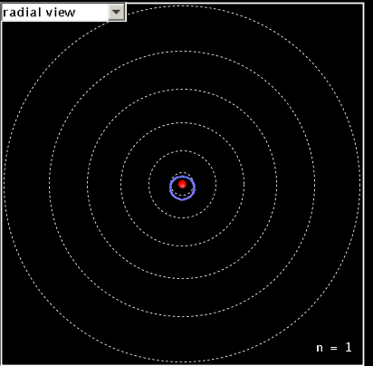
- In the top left corner of the atomic view, change the radial view to 3-D view. Describe what you see.

Erwin Schrödinger began thinking about wave mechanics in 1925. His interest was sparked by a footnote in a paper by Albert Einstein. Like de Broglie, he began to think about explaining the movement of an electron in an atom as a wave. By 1926 he published his work, providing a theoretical basis for the atomic model that Niels Bohr had proposed based on laboratory evidence. The equation at the heart of his publication became known as Schrödinger's wave equation.

- Switch to the Schrödinger model with White light and speed set to Fast. Describe what you see in the atom diagram and the energy level diagram. Don’t worry about all the details. Just capture the big picture ideas.

- Move the Slow…Fast slider all the way over to Fast, reset the Spectrometer, set Light Controls to White, and let the simulation run for 1 minutes.
- Click on the Spectrometer camera to take a snapshot of the Schrödinger model. Compare it to the Experiment. Slide the snapshot off to the right for later comparison with other models.
  - How well does the Schrödinger Electron Wave model spectrum match the real hydrogen spectrum?

- Spread the Experimental snapshot and the model snapshots across the screen. Push the “Print Screen” key at the top of the keyboard. This puts a snapshot of the screen on the computer’s clipboard. Paste it into a Word document and print out two copies (one for each partner).

