Masses and Springs: Conservation of Mechanical Energy Remote Lab
(This‌ ‌lesson‌ is designed ‌for‌ ‌a‌ ‌student‌ ‌working‌ remotely‌.)‌

This lab uses the Masses and Springs simulation from PhET Interactive Simulations at University of Colorado Boulder, under the CC-BY 4.0 license.
https://phet.colorado.edu/sims/html/masses-and-springs/latest/masses-and-springs_en.html

Learning Goals: Students will be able to explain the Conservation of Mechanical Energy concept using kinetic, elastic potential, and gravitational potential energy

Develop your understanding: Open the Energy screen, then explore to develop your own ideas about how energy changes as a mass oscillates while hanging on a spring.

Try using the tools to help with your sense making.
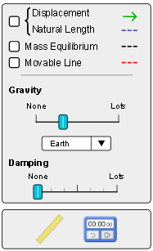

Below are a couple of simulation use tips:
- The Movable line has a handle that lets you drag it to different positions.
- The ruler and the timer are tools that you drag onto the lab area.
- The Pause, Play and Step buttons will help you take screen captures. 
- The speed buttons can help you observe in slow motion. 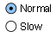
- If you press the Stop Oscillation button, you will need to grab the mass and move it to make the motion go again.

Explain your understanding: Use your own words and captured images from the simulation to answer each question.

For this lab, you want to have “ideal equipment”so that mechanical energy is conserved. This is similar to having no friction for an object moving on a surface. Set Damping to none.
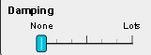

- By investigation, determine when the Elastic Potential Energy is zero. Make sure you test your idea with several masses and spring constants.
  - How do you determine the zero location(s) of a mass on a spring?

  - Explain why the position for zero makes sense.

  - Why did you need to use varying conditions?

- By investigation, determine when the Kinetic Energy is zero. Make sure you vary the conditions for your experiment. Write down how you determined the zero location(s) and explain why the position for zero makes sense. Simulation hint: The KE will not be calculated when you are moving the cylinder with the mouse.

- Put a mass on a spring and observe the total energy graph as it oscillates. Pay attention to details of the energy distribution. Think about why the energy is distributed differently for several situations. For example: When is there only kinetic energy? What makes the elastic energy increase?
- Design a lab to test your ideas with varying conditions; write down your observations and conclusions. Remember to include evidence to support your conclusion.

Expand Your Understanding
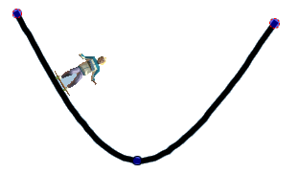
- Suppose you have a skater going back and forth on a ramp like this. How does his energy distribution as he rides compare and contrast to that of the mass moving on a spring? You can run the Energy Skate Park Basics simulation to test your ideas.

Test Your Understanding
For each question, write your answer and give your reasoning with evidence from the simulation (use screen captures)
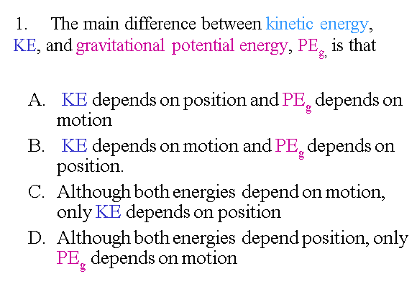
- Your answer and reasoning here

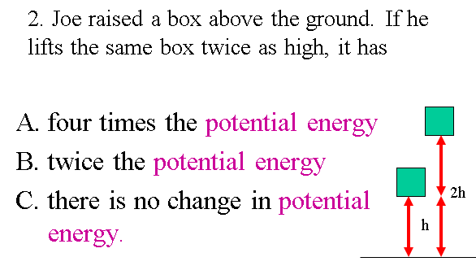
- Your answer and reasoning here

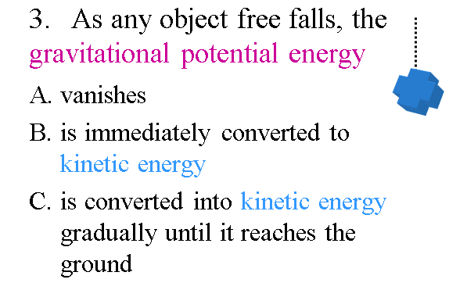
- Your answer and reasoning here

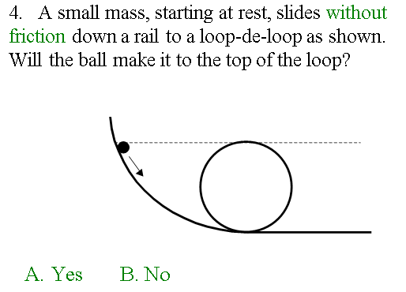
- Your answer and reasoning here

5-8 Use the situation described below to answer each question. Include reasoning with evidence from the simulation.

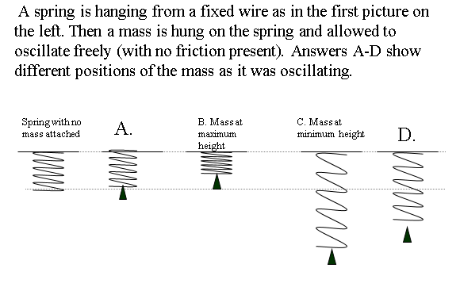
- Where does the spring have maximum elastic potential energy?

- Where is the gravitational potential energy the least?

- Where is the kinetic energy zero?

- Where is the elastic potential energy zero?

